dRofus management plan
Template [PROJECT NAME]

HIQ-PLN-00007

Version History
Version tracking
Project teams to track the version of drafts and released versions of the project-specific dRofus Management Plan in the table below. Delete unused lines
.Edition | Author | Version description | Release date | Approved for release by
0.1 |  | Initial draft release
0.2 |  | Minor release
1.0 |  | Major release

Copyright

Queensland Health - dRofus Management Plan template
Published by the State of Queensland (Queensland Health), February 2026

This document is licensed under a Creative Commons Attribution 3.0 Australia licence. To view a copy of this licence, visit creativecommons.org/licenses/by/3.0/au
© State of Queensland (Queensland Health) 2026
You are free to copy, communicate and adapt the work, as long as you attribute the State of Queensland (Queensland Health).
For more information contact:
Health Infrastructure Queensland, Department of Health, GPO Box 48, Brisbane QLD 4001, email hiqdesigninnovationandassurance@health.qld.gov.au, phone (07) 3328 9310.
An electronic version of this document is available at https://www.health.qld.gov.au/system-governance/health-infrastructure/resources/building-information-modelling or via the Queensland Health Design Collaboration site.
Disclaimer
The content presented in this publication is distributed by the Queensland Government as an information source only. The State of Queensland makes no statements, representations or warranties about the accuracy, completeness or reliability of any information contained in this publication. The State of Queensland disclaims all responsibility and all liability (including without limitation for liability in negligence) for all expenses, losses, damages and costs you might incur as a result of the information being inaccurate or incomplete in any way, and for any reason reliance was placed on such information.

Contents
Copyright 1
Terms 7
Introduction 9
About this document 9
Document structure 10
Part A: Requirements 10
Part B: Delivery 10
A.1 Commercial 11
A.1.1 Health Infrastructure Queensland dRofus objectives 11
A.1.1.1 Furniture, fixtures and equipment planning and validation 11
A.1.1.2 Schedule of accommodation management and validation 11
A.1.1.3 Benchmarking of projects across Health Infrastructure Queensland 11
A.1.1.4. Assist in commissioning 11
A.1.1.5 Management of asset information 12
A.1.2 Shared resources 12
A.1.2.1 Queensland Health building information modelling framework 12
A.1.2.2 Health Infrastructure Queensland item control schedules/guidelines 12
A.1.2.3 Australian health facility guidelines references 13
A.1.3 dRofus modules in use 15
A.1.4 Health infrastructure Queensland standard project template 16
A.1.4.1 Health Infrastructure Queensland room templates 16
A.1.4.2 Health Infrastructure Queensland health planning units 16
A.1.4.3 Health Infrastructure Queensland item numbering and naming 17
A.1.5 Key administrative contacts 18
A.1.5.1 Health Infrastructure Queensland project director 18
A.1.5.2 Health Infrastructure Queensland building information modelling/digital asset lead 18
A1.5.3 dRofus lead 18
A.1.5.4 Discipline lead 18
A.2 Management 19
A.2.1 Database management 19
A.2.1.1 Setup of the project database 19
A.2.1.2 Archiving a project 19
A.2.1.3 Updates to the standard Health Infrastructure Queensland database content 19
A.2.1.4 Database availability 20
A.2.1.5 Backups 20
A.2.1.6 Splitting the project 20
A.2.1.7 Transition to new dRofus lead 20
A.2.1.8 Handover 21
A.2.2 User management 21
A.2.2.1 Collection of personal data 21
A.2.2.2 Initial setup 21
A2.2.3 Additional users/change of permissions 21
A.2.2.4 Remove users/inactive users 22
A.2.2.5 Access from overseas 22
A.2.3 dRofus leads meetings 22
A.2.3.1 Members 22
A.2.3.2 Frequency 22
A.2.4 Project milestones and deliverables 23
A.2.4.1 Project initiation 23
A.2.4.2 Concept design 23
A.2.4.3 Schematic design 24
A2.4.4 Detailed design 26
A.2.4.5 Construction documentation 27
A.2.4.6 Construction and handover 29
A.2.5 Quality assurance process 31
A.2.5.1 Health Infrastructure Queensland/external building information modelling auditor 31
A2.5.2 Delivery team 31
A.2.6 End of milestone tasks 31
A.2.6.1 Notification 31
A.3 Technical 32
A.3.1 Schedule of accommodation 32
A.3.1.1 Responsibilities 32
A.3.1.2 Room function structure 32
A.3.1.3 Briefed areas 33
A.3.1.4 Setup of schedule of accommodation 34
A.3.1.5 Changes to the schedule of accommodation 34
A3.1.6 Functions data 34
A.3.2 Change logs 34
A.3.2.1 Automatic change log 34
A.3.2.2 Tracking changes and AusHFG deviations 34
A.3.3 Room template coding 37
A.3.3.1 Standard rooms 37
A.3.3.2 Repeated rooms 37
A.3.4 Room coding 37
A.3.5 Managing rooms 38
A.3.5.1 Room codes during project lifecycle 38
A.3.5.2 Properties of rooms 38
A.3.5.3 Deviations and change management 38
A.3.5.4 Adding/removing rooms 39
A.3.5.5 Changes to a room template or room 40
A.3.6 Item Lists 41
A.3.6.1 Australasian health facility guidelines items 41
A.3.6.2 Health Infrastructure Queensland-specific items 41
A.3.6.3 Device catalogues 42
A.3.6.4 Assets: non-furniture, fixtures and equipment items 42
A.3.6.5 Item code status in dRofus 42
A.3.6.6 Item coding rules 42
A.3.6.7 New item codes 44
A.3.6.8 Inactive item codes 44
A.3.7 Item budget group 45
A.3.7.1 Budget groups 45
A.3.8 Managing items 45
A.3.8.1 Package items 45
A.3.8.2 Creation of new items 46
A.3.8.3 Transfer items 46
A.3.8.4 Item responsibilities 46
A.3.9 Modelled and non-modelled items 46
A.3.9.1 Predefines settings in health infrastructure dRofus database 46
A.3.9.2 General 46
A.3.9.3 Budget group one—and sub-groups 47
A.3.9.4 Budget group two—and sub-groups 47
A.3.9.5 Budget group three—and sub-groups 47
A.3.9.6 Budget group four—and sub-groups 47
A.3.9.7 Placeholder items in BIM 47
A.3.10 Links 47
A.3.10.1 Rooms 47
A3.10.2 Items 48
A.3.11 Reports 48
A.3.11.1 Schedule of accommodation 49
A.3.11.2 Room data sheets 49
A.3.11.3 Room layout sheets 50
A.3.11.4 Furniture, fixtures and equipment lists 50
A.3.11.5 Quality assurance lists 51
A.3.11.6 Handover and commissioning 52
A.3.12 dRofus training and support 52
A.3.12.1 Concept design training modules 52
A.3.12.2 Schematic design training modules 53
A.3.12.3 Detailed design training modules 53
A.3.12.4 Construction documentation training modules 53
B.1 Commercial 55
B.1.1 Amendments to Part A 55
B.1.2. Project details 55
B.1.2.1 Project Schedule 55
B1.2.2 Project code 55
B.1.2.3 Project summary description 55
B.1.2.4 Project stages 55
B.1.3 dRofus project database 56
B.1.3.1. Project dRofus modules 56
B.2 Management 58
B.2.1 Roles and responsibilities 58
B.2.1.1 dRofus lead/project admin 58
B.2.1.2 Discipline leads for dRofus 58
B.2.1.3 Other contacts 58
B.2.1.4 User roles and permissions 59
B.2.1.5 Organisations without direct access to the dRofus platform 60
B.2.1.6 Update workflows 60
B.2.2 dRofus leads meeting schedule 60
B.2.3 dRofus training 61
B.2.4 User group communication processes 61
B.3 Technical 62
B.3.1 Briefed areas management 62
B.3.1.1 Intra-departmental circulation rate 62
B.3.2 Rooms management 62
B.3.2.1 Room number convention 62
B.3.3 Items management 62
B.3.3.1 New items 62
B.3.3.2 Package items 62
B.3.3.3 Item status processes 62
B.3.3.4 Transfer item process 62
B.3.4 Model synchronisation/building information modelling plug-in 62
B.3.4.1 Rooms synchronisation schedule 63
B.3.4.2 Items synchronisation schedule 63
B.3.4.3 Health Infrastructure Queensland attribute configurations 63
B.3.5 Project database documentation 68
B.3.5.1 Schedule of accommodation exports 68
B.3.5.2 Room data sheet exports 68
B.3.5.3 Room layout sheet documentation 68
B.3.5.4 Furniture, fixtures and equipment list exports 68
B.3.6 Quality assurance 68
B.3.6.1 Quality assurance list exports 68
B.3.7 Handover and commissioning 68
B.3.7.1 Handover and commissioning list exports 68
Appendix A 69
Appendix B 73
Appendix C 78
Appendix D 83
Appendix E 84

Terms

Abbreviated term | Definition
Appointed party | A provider of information for the project, including services and typically has a lead party such as an architect or managing contractor.
Attribute configuration | Defines how data is synchronised between dRofus and external software for Building Information Modelling (BIM) by establishing a unique key attribute for matching objects and mapping specific dRofus attributes and BIM parameters for bi-directional data transfer during a sync.
BIM Execution Plan (BEP) | A detailed plan, created from the Queensland Health BEP template, that documents the use of BIM on a project. It outlines who is responsible for what in the BIM process, when in the process they are responsible for it, and how they will execute Queensland Health requirements as specified in the Project Information Requirements (PIR) and Capital Infrastructure Requirements (CIR).
BEP template | The standard Queensland Health BEP template is to be used by delivery teams. Refers to Design BEP (DBEP) and Construction BEP (CBEP).
Building Information Modelling (BIM) | The use of a shared digital representation of a built asset to facilitate design, construction and operation processes to form a reliable basis for decisions.
Building Information Models (BIM/s) | Means all models that any contributing party (or its sub-contractors) is required to produce and deliver in accordance with the BEP, PIR and CIR.
BIM manager | A delivery team provided resource to manage the BIM and asset information creation processes on the project.
Delivery team | A collection of appointed party contributing to the capital works project, the composition of which may change according to the project requirements and schedule, but typically comprises design consultants, Contractor and sub-Contractors, as per AS ISO 19650. For the purposes of this document, the delivery team excludes Queensland Health and its internal project managers as its representatives.
Federated model | An assembly of discipline/trade BIM/s combined for uses such as coordination, collaboration, and exchange with the appointing party.
Item | Items are elements within a room, such as equipment or furniture. They are categorised by type and can be used across multiple rooms and projects.
Model element | An individual component within a BIM (e.g. wall, floor, nurse call device, room, diffuser, column, etc.).
Occurrence | When one of the Items within an ‘Item group’ is placed somewhere in the project, it creates an occurrence of that Item.
Project Information Requirements (PIR) | Queensland Health information requirements and exchange processes to enable the creation and management of the PIM to support the ongoing AIM (this document).
Project director | A Queensland Health assigned resource to ensure the delivery team complies with the PIR and BEP, enabling the creation of the PIM and AIM. The project director's responsibility is to manage the scope, time, cost, quality, resources, communications, and risk aspects of the project.
Spatial planning platform | Queensland Health use dRofus as their spatial planning tool, integrated with BIM. dRofus is used with a HIQ template for clinical planning, FFE management, and asset data consolidation and quality control, amongst other functions.
Acronyms
Abbreviated terms | Definition
3D | Three-dimensional digital model
AHD | Australian Height Datum
API | Application Programming Interface
AusHFG | Australasian Health Facility Guidelines
BIM | Building Information Modelling
BIM/s | Building Information Models
BEP | BIM Execution Plan (refers to DBEP and CBEP)
CAD | Computer Aided Design/Drafting
CBEP | Construction BIM Execution Plan
CIR | Capital Infrastructure Requirements
DIA | Design, Innovation and Assurance team within HIQ
DBEP | Design BIM Execution Plan
dMP | dRofus Management Plan
FDB | Functional Design Brief
FFE | Furniture, Fixtures and Equipment
FFEP | HIQ FFE Procurement
GUID | Global Unique Identifier
HIQ | Health Infrastructure Queensland
HHS | Hospital and Health Service
HPU | Health Planning Unit
ICS | Item Control Schedule
IDC | Intradepartmental circulation
IFC | Industry Foundation Classes
OUT | Outdoor areas
PIR | Project Information Requirements
RASCI | Responsible, Accountable, Supportive, Consulted and Informed matrix
RDS | Room Data Sheets
RLS | Room Layout Sheets
SoA | Schedule of Accommodation
T+E | Travel and Engineering
UCA | Unenclosed Covered areas

Introduction
The Queensland Health BIM framework is governed by the Project Information Requirements (PIR), which functions as the principal specification document. The PIR forms the basis for the development of the dRofus management plan. It is the responsibility of the supply chain to maintain and update this plan to clearly define their methodologies for fulfilling Queensland Health’s information requirements. The dRofus management plan template, derived from the Queensland Health PIR, must be completed in Microsoft Word by the tendering delivery team for the specified project.
Track changes must be used to highlight any changes between the original document and all subsequent revisions. Once agreed by the delivery team and Queensland Health, accept changes and record a summary in the version history table on page three.

About this document
The dRofus Management Plan (dMP) must outline the delivery team’s proposed approach to using dRofus, Building Information Modelling (BIM), and information management practices for the project stages the delivery team are engaged to perform.
Before the start of a new major project stage (schematic design, detailed design, construction documentation, etc.) the dMP shall be reviewed, revised and agreed with the Queensland Health project management, confirming the approach for that stage.
The data in dRofus will be used by other appointed parties and Health Infrastructure Queensland (HIQ) teams to inform their systems and processes. The delivery team is to use any of the following information sources to assist in the creation of this document:
- Queensland Health Capital Infrastructure Requirements (CIR)
- Queensland Health Project Information Requirements (PIR)
- Queensland Health BIM Execution Plan templates
- Queensland Health asset equipment lists
- Queensland Health BIM data uploader template
- Any existing conditions HHS BIM/s
- Existing 2D drawings, reports and schedules
- HHS critical asset information requirements (e.g. naming, coding, classifications)
- Functional design brief and any space planning information
- AusHFG codes and guidelines.
The dMP must be developed by the nominated dRofus lead, taking into consideration the needs of the delivery team, BIM Execution Plans (BEP), the Queensland Health PIR and other guidelines. The dMP will be used as part of the assessment criteria for determining a preferred delivery team for the project.

Document structure
This document is structured in two parts: Part A: Requirements, and Part B: Delivery.

Part A: Requirements
Specifies the requirements for how the Health Infrastructure Queensland (HIQ) dRofus project database is to be used by each appointed party, for each delivery stage. This document must be read in conjunction with the Project Information Requirements (PIR) and the BIM Execution Plans (BEP) for this project.

Part B: Delivery
Forms the delivery team response to Part A and articulates how the delivery team intends to provide information in the project database and how the corresponding BIM models (BIM/s) shall be structured, managed and delivered by each appointed party contracted by Queensland Health. The content of this section of dMP must be reviewed and approved by the HIQ project director and HIQ BIM/digital asset lead.

Instructional text (hidden blue text) for the lead appointed party
Instructional text is provided to assist the delivery team’s dRofus lead in developing this document using Microsoft Word. If you do not see any blue text below, then enable visibility in:
File > Options > Display > check Hidden Text (blue text should be visible below).
Note: Hidden text should be turned off prior to publishing the document and placeholder text [in square brackets] must be deleted.
DELETE THIS INSTRUCTIONAL NOTE BEFORE FINALISING THIS dMP.

DOCUMENT USE —Instructional text is shown in this way.

PIR section reference
DO NOT DELETE instructional text as it contains the section references to the PIR which will aid you in completing this document. Hide instructional text prior to issue to Queensland Health. To hide it, go to File > Options > Display > Hidden Text and uncheck the box. The final BEP may be issued to the wider delivery team as a PDF

Text in [square brackets]
All text in [square brackets] indicates placeholder text where input is expected. It must be replaced with the appointed party or delivery team approach.

Part A: dRofus requirements

A.1 Commercial

A.1.1 Health Infrastructure Queensland dRofus objectives
Queensland Health is committed to the implementation of dRofus and the achievement of its defined objectives. All project stakeholders and delivery teams are required to utilise dRofus in accordance with these objectives to ensure consistent data management, structured information delivery, and compliance with Queensland Health and industry standards.
The Queensland Health dRofus objectives are detailed in the following sections.

A.1.1.1 Furniture, fixtures and equipment planning and validation
dRofus provides a structured and centralised platform for Queensland Health to manage Furniture, Fixtures, and Equipment (FFE) throughout the project lifecycle. By linking requirements, design intent, and procurement data within a single environment, Queensland Health can plan, track, and validate FFE.

A.1.1.2 Schedule of accommodation management and validation
dRofus serves as the central platform for managing the project’s Schedule of Accommodation, providing a single source of truth for the entire project team. The platform enables the capture of deviation comments, maintains a complete audit trail of all changes, and ensures all stakeholders are working from the latest information. Queensland Health can configure access and permissions by user, organisation, or project role, with the ability to assign discipline-specific editing rights to room data properties where required.

A.1.1.3 Benchmarking of projects across Health Infrastructure Queensland
dRofus provides Queensland Health with the platform to make benchmarking easier by giving project teams access to detailed, consistent data from past and current projects. Queensland Health aims to enable teams to quickly compare room types, equipment, finishes, and quantities, identifying what works well, spotting inefficiencies, and making smarter design and procurement decisions. By using this information to guide planning, dRofus helps improve consistency, reduce costs, and deliver better outcomes across multiple projects, turning lessons learned into practical improvements for future work.

A.1.1.4. Assist in commissioning
dRofus will make commissioning easier by keeping all project data, such as equipment, specifications, and installation details, centralised and up to date. Teams can quickly check that systems are installed and functioning as intended, identify and resolve issues early, and streamline handover processes. This saves time, reduces errors, and ensures that Queensland Health facilities are fully operational and ready for use with confidence.

A.1.1.5 Management of asset information
dRofus makes managing asset information straightforward by keeping all data on equipment, fixtures, and systems in one central database. Through identification, location and classification,
Queensland Health can progressively capture asset information, helping during operations to plan replacements, monitor performance, and support ongoing asset management. With the asset information housed within the dRofus database, errors are reduced, manual data entry time is saved, and both project teams and HHS’s have quick, reliable access to the information they need throughout the asset’s lifecycle.

A.1.2 Shared resources
This document must be read with the relevant Queensland Health requirements, reference materials, and project scope documents. It does not remove the delivery team’s obligation to comply with Queensland Health, local, and embedded standards, including:

A.1.2.1 Queensland Health building information modelling framework
PIR Section 2 (e) + 3.2
Appointed party to nominate the dRofus Platform lead and collaboratively develop the dRofus Management Plan (dMP).
Refer to the Queensland Health PIR for details of:
- Responsibilities of the delivery team and BIM manager.
- Purpose of the dMP.
- Production, development and implementation of the dRofus platforms.
- Updating the dMP prior to the commencement of a new project stage or when a material change affects the contents of this document as per Section 3.2 of the PIR.
The use of the dRofus platform is incorporated into the design and construction BEP created for this project. This includes the below items:
- BIM coordination meetings are being used to actively review and track progress of the content on dRofus.
- Frequency of synchronisation to/from the BIM software to dRofus. This includes the Schedule of Accommodation (SoA), rooms and items.
- Software used on the project/integration of tools with the dRofus platform.
- Communication of updates between the disciplines/stakeholders.
- Validation and verification of data in dRofus.
- Responsibilities throughout the project.

A.1.2.2 Health Infrastructure Queensland item control schedules/guidelines
Refer to the reference documents in Section A.1.2 Shared resources for further details around FFE coding, creation of new codes and item grouping, which may include:
- QH item control schedule(s)
- FFE management plan
- Standardised FFE groupings framework
- Principles for new code creation
- Data device catalogues.
The HIQ project director must submit/confirm the schedules, guidelines and catalogues that will be used on the project before the dRofus database can be established in Section A.1.2.4 Reference documents.

A.1.2.3 Australian health facility guidelines references
HIQ standards are based on the Australian Health Facility guidelines (AusHFG) website reference documents. The following references apply:

A.1.2.3.1 Standard components
Standard components are a core element of the AusHFG, defining commonly utilised rooms and spaces within healthcare projects. Each standard component consists of a Room Data Sheet (RDS) and a Room Layout Sheet (RLS).

A.1.2.3.2 Item control schedule
The Item Control Schedule (ICS) catalogues all items within the AusHFG item library, including current and, where relevant, previous names and codes. For items used in standard components and modelled in the AusHFG Revit resource, the ICS specifies the corresponding Revit family and type name. It also outlines documentation and naming conventions for managing the item library, together with guidance on its integration with other AusHFG resources.

A.1.2.3.3 Australian health facility guidelines building information modelling, model Revit resource
This Revit file, along with the corresponding .ifc file, includes all currently modelled AusHFG standard components and items. It does not provide a Revit family for every item in the AusHFG Item, but only for those included in AusHFG standard component rooms.

A.1.2.3.4 Health planning units
Standard clinical Health Planning Units (HPU) are a central element of the AusHFG, providing detailed guidance on common clinical departments and services in hospitals and other healthcare facilities. Each HPU includes service descriptions, operational and design considerations, and a comprehensive SoA, specifying the required area, number of each room type, and any applicable standard components.A.1.2.4 Reference documents
HIQ project director to complete.
The first table indicates the version of the guideline and template documents agreed on this project. The second table shall reference other project-specific documents that have been developed.

The current revision of the Queensland Health capital delivery documents is recorded below.
Document | Version | Date
AusHFG item control schedule | [enter version] | [DD/MM/YYYY]
AusHFG standard component file | [enter version] | [DD/MM/YYYY]
QH FFE item control schedule | [enter version] | [DD/MM/YYYY]
HIQ FFE management plan | [enter version] | [DD/MM/YYYY]
*ICT item list* | [enter version] | [DD/MM/YYYY]
*ICT catalogue name* | [enter version] | [DD/MM/YYYY]
Queensland Health PIR | [enter version] | [DD/MM/YYYY]
DBEP template | [enter version] | [DD/MM/YYYY]
CBEP template | [enter version] | [DD/MM/YYYY]
Queensland Health asset equipment lists | [enter version] | [DD/MM/YYYY]
Queensland Health BIM data uploader template | [enter version] | [DD/MM/YYYY]
[add documents as required] | [enter version] | [DD/MM/YYYY]
Table 1: Reference documents
Document | Version | Date
DBEP | [enter version] | [DD/MM/YYYY]
CBEP | [enter version] | [DD/MM/YYYY]
Table 2: Project documents
Reference any other dMP here that are related to this document, e.g. other project stages.
Document name | Author | Company | Date/version
Table 3: Cross-reference to other dMP

A.1.3 dRofus modules in use
The functionality of dRofus is based around a series of modules.
Module | In use | Comments
Rooms | Yes | Must be used to maintain the project's SoA, room data and item lists.
Templates | Yes | Must be used to manage AusHFG standard component rooms as well as other repeatable rooms that are specific to the project.
Items | Yes | Must be used to manage all items allocated to room item lists. Items with a corresponding model element in the project's building model must be linked to the corresponding dRofus item for RLS validation.
Systems | No
Procurement | No
Delivery | No
Reports | Yes | Must be used to produce individual departmental breakdown SoA for each project stage as well as the RDS.
dRofus Web | No | A version of dRofus that can be accessed without having to download the dRofus desktop software.  Mostly suited to infrequent users for review of information or a narrow scope of data authorship.
dRofus Application Programming Interface (API) | Yes | The application programming Interface enables access to dRofus data from an external software application, such as Power Bi.  There are various use cases for dRofus API to streamline workflows and data access that may be developed during the project.
Table 4: dRofus modules in use

A.1.4 Health infrastructure Queensland standard project template
The HIQ standard project template is regularly updated to reflect the latest content, for example, updates to the AusHFG. It also incorporates established and emerging HIQ standards and guidelines available for use across projects. Each HIQ project database is generated as a copy of this template, ensuring it is pre-loaded with the relevant AusHFG and HIQ design guidelines references.
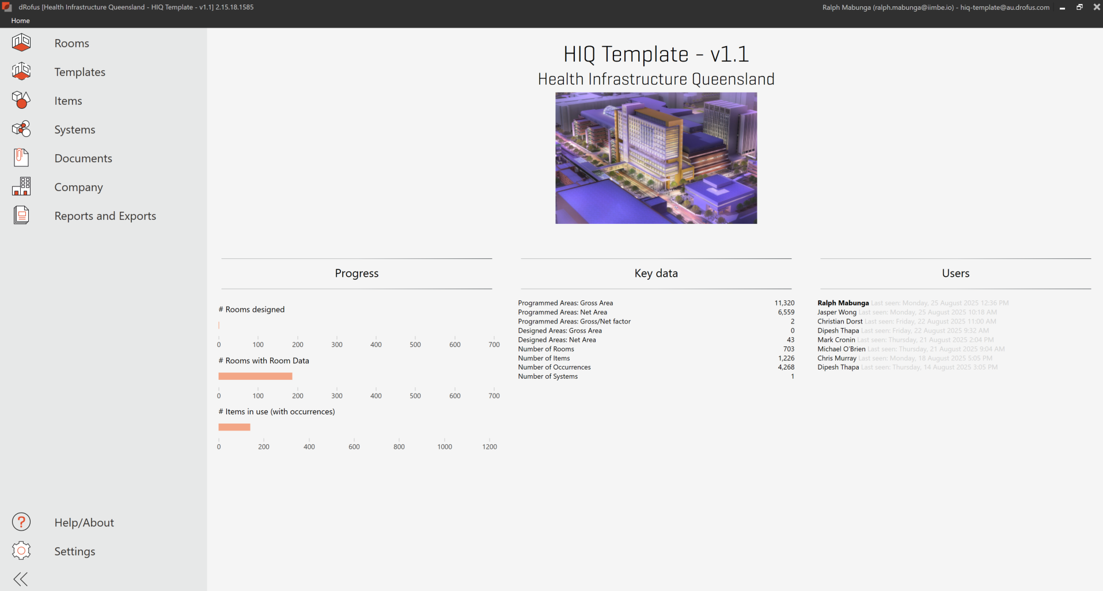
Figure 1: HIQ standard dRofus project template

A.1.4.1 Health Infrastructure Queensland room templates
The room templates content matches the AusHFG standard component RDS at the time the project database is set up.
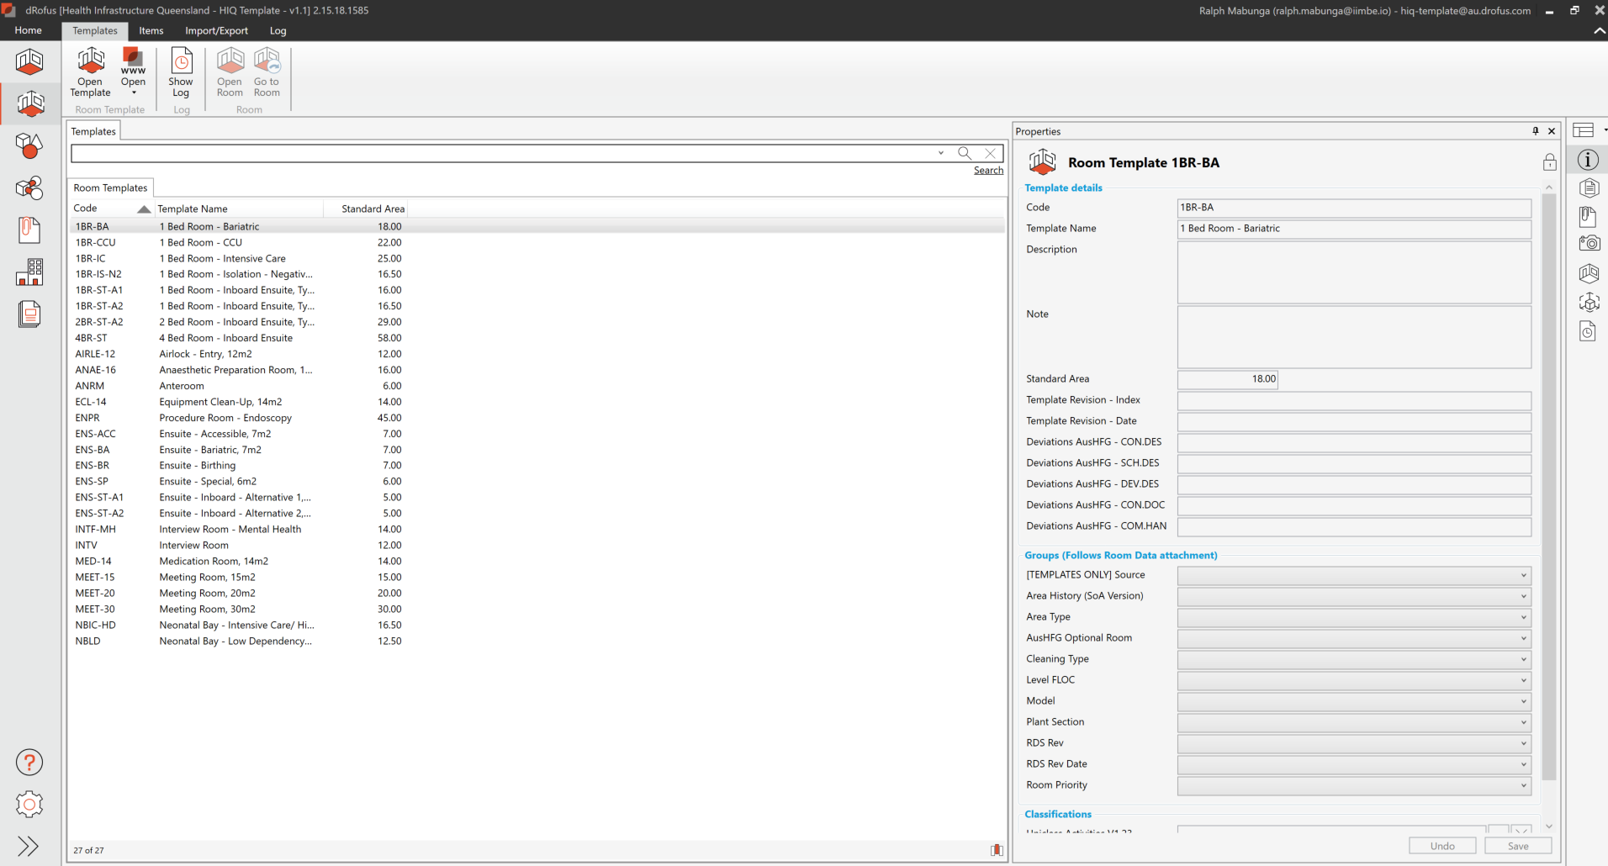
Figure 2: HIQ room templates

A.1.4.2 Health Infrastructure Queensland health planning units
HIQ approved HPU room schedules as published in the AusHFG at the time the project database is set up are included, with relevant standard component templates pre-applied.
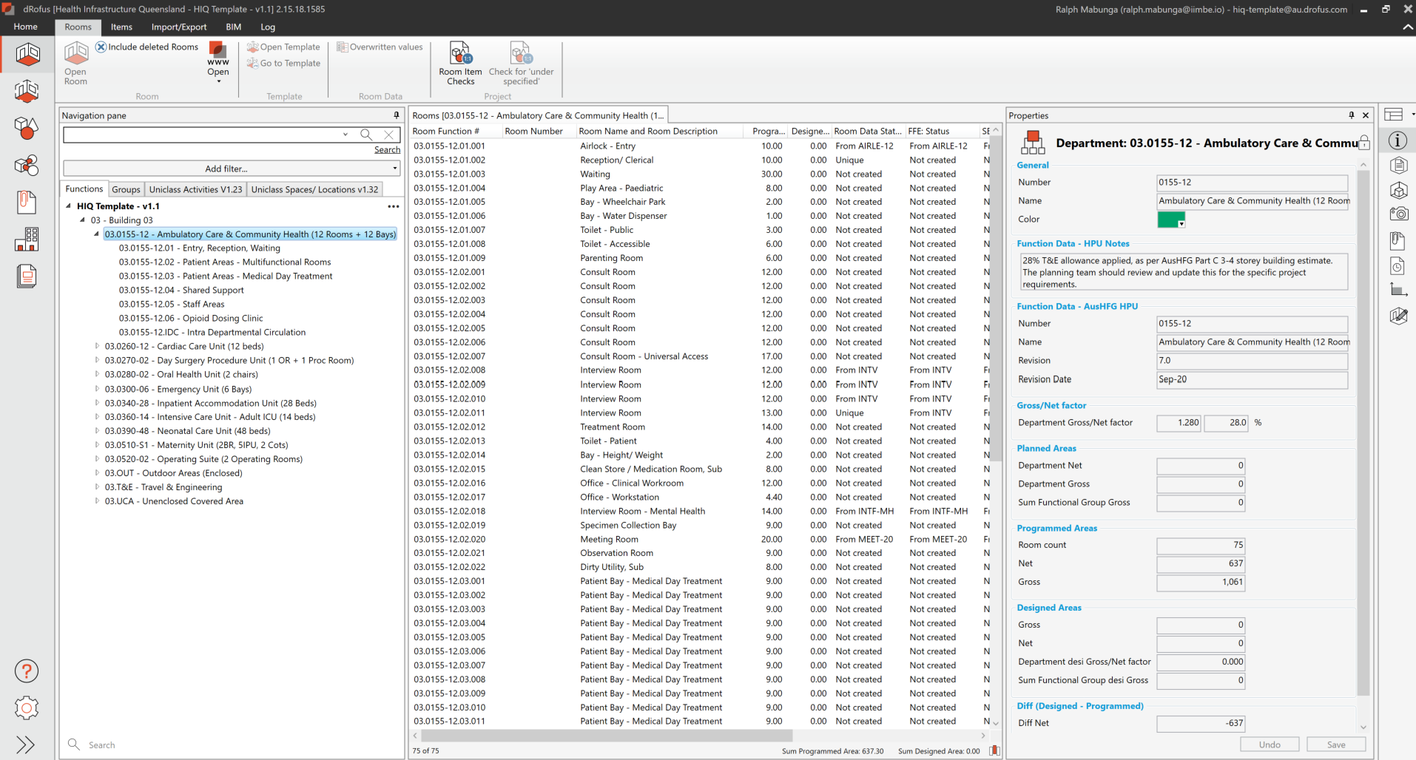
Figure 3: HIQ health planning units
The HIQ project database, once set up from the HIQ standard project template, shall serve as the consistent baseline and benchmark from which design progresses. The appointed party are responsible for checking, validating, updating, and providing assurance that the data remains accurate and fully aligned with the design requirements at each project stage, as set out in this management plan.

A.1.4.3 Health Infrastructure Queensland item numbering and naming
The HIQ standard project template adopts the numbering and naming conventions of the AusHFG Integrated Components Schedule (ICS) and the QH ICS (if agreed). Where items are available in the ICS, those items shall be used to ensure consistency across projects and to maintain alignment with the AusHFG Standard components for reference and comparison.
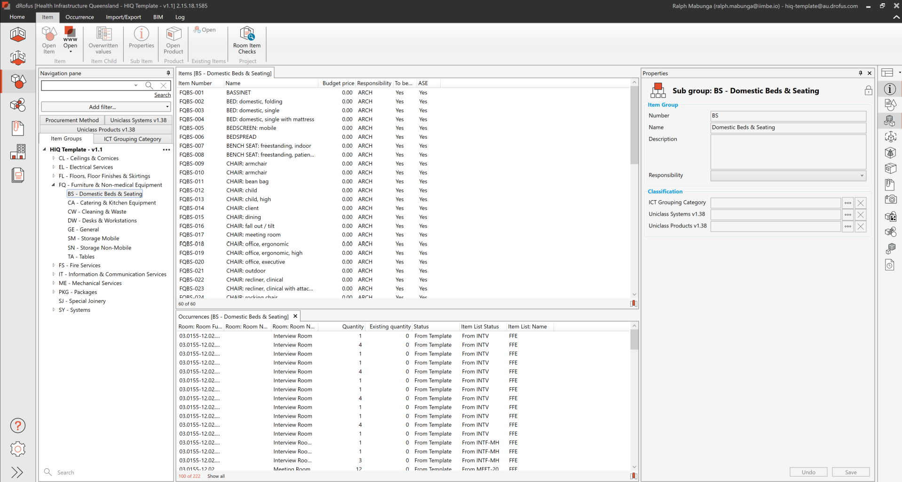
Figure 4: HIQ item numbering and naming

A.1.5 Key administrative contacts
Roles, responsibilities, and accountabilities for the activities outlined in this specification are defined in Appendix C. Known as the RASCI (Responsible, Accountable, Supporting, Consulted, and Informed) it provides detailed information on which parties are responsible for each task. Project participants shall refer to the RASCI matrix to confirm their obligations and to ensure alignment of responsibilities across all project stages.
The key administrative roles and associated responsibilities are detailed below.

A.1.5.1 Health Infrastructure Queensland project director
A Queensland Health senior-level leader overseeing the project, responsible for initiating the setup of the project database, reviewing and approval of the dMP.

A.1.5.2 Health Infrastructure Queensland building information modelling/digital asset lead
A Queensland Health appointed dRofus specialist user responsible for administering all Queensland Health’s dRofus project database, including the setup of a new project database, managing users and project database milestone records.

A1.5.3 dRofus lead
A nominated representative from the lead appointed party responsible for developing the project dMP, leading the delivery team’s use of the dRofus project database and coordinating the project database information deliverables throughout the project lifecycle.

A.1.5.4 Discipline lead
A nominated representative from each appointed party, responsible for developing and leading their appointed party project database information deliverables throughout the project lifecycle.

A.2 Management

A.2.1 Database management

A.2.1.1 Setup of the project database
Prior to project commencement, the HIQ project director shall initiate the setup of the dRofus project database together with the HIQ BIM/digital asset lead. The HIQ project team must also nominate what guidelines/standards will be used in which version. The HIQ project director or HIQ BIM/digital asset lead must document the reference documents (e.g. AusHFG documents, QH ICS, etc.) in Section A.1.2 Shared resources.
The project database will be established with read-only permissions for initial users. The project team can agree to start with a basic database in dRofus to only set up the SoA (e.g. if item lists can’t be specified at the start of a project).
Before editing permissions are given to consultants and/or contractors, a kick-off meeting must be scheduled by the HIQ project director to discuss standards, workflows and communication within the project team.
Attendance from the nominated dRofus lead (lead consultant/managing contractor), the HIQ FFE team, the ICT team, the HHS project team (clinical planning and FFE lead) and the HIQ BIM/digital asset lead is required.
At the end of this kick-off meeting, this management plan must be updated with the strategies discussed and approved by the HIQ project director.

A.2.1.2 Archiving a project
The HIQ project director shall notify the HIQ BIM/digital asset lead once a project can be archived.

A.2.1.3 Updates to the standard Health Infrastructure Queensland database content

A.2.1.3.1 AusHFG guidelines
Database-wide changes due to an update of the AusHFG guidelines (e.g. major update of the item control schedule) and supporting documents will only be incorporated into the project database by the dRofus lead up to schematic design.
Any database-wide updates after this stage shall be made by exemption only and requires consultation with the HIQ project director and HIQ BIM/digital asset lead.
This does not apply to updates to single rooms, room templates or items.

A.2.1.3.2 QH item control schedules
Changes due to an update to the QH ICS will only be incorporated into the project database by the dRofus lead up to schematic design.
Any updates after this stage shall be done by exemption only and requires consultation with the HIQ project director and HIQ BIM/digital asset lead.

A.2.1.3.3 Project information requirements
Changes due to an update to the PIR will be incorporated into the project database by the dRofus lead up to schematic design.
Any updates after this stage shall be done by exemption only. Any updates to the project database require consultation with the HIQ project director and HIQ BIM/digital asset lead.

A.2.1.4 Database availability
The project database may not be available temporarily due to scheduled or unscheduled downtime (e.g. server updates, security patches, restore a database snapshot, etc.). In this case, dRofus will notify users if scheduled downtime is required during normal business hours.
All dRofus users must ensure that they coordinate their works on the project database accordingly.

A.2.1.5 Backups

A.2.1.5.1 Snapshop backups
The dRofus project database will be automatically backed up once a week. The HIQ BIM/digital asset lead can restore a previous snapshot on request.
Restoring a database snapshot may require approval and/or assistance from other teams or the platform vendor and can only be done during standard buisness hours.

A.2.1.5.2 End-of-milestone backup
At the completion of each project stage milestone, a full backup of the dRofus project database shall be created. The backup shall capture all data, configurations, and associated records current at the milestone date to provide a complete and auditable record of project information. The dRofus lead shall ensure the backup is exported in a compressed zip file format, securely stored in the common data environment, and made accessible to the client and other authorised stakeholders as required.
A copy of the database shall be archived at the following milestones:
- End of concept design
- End of schematic design
- End of detailed design
- Issue of construction documentation
- Practical completion.

A.2.1.6 Splitting the project
If stages are not known at the time of the database creation, a project database can be split up later. This requires careful planning and can only be done after consultation between the dRofus lead, the HIQ BIM/digital asset lead, the discipline leads and the HIQ project director/project manager.
If a new database is being created, the new database and project strategy will also have to be documented in this management plan.

A.2.1.7 Transition to new dRofus lead
If a new dRofus lead is nominated after the initial setup of a dRofus project database, this management plan will have to be updated immediately and submitted to the HIQ project director for review and approval. The current dRofus lead remains responsible for the content of the database/s until the handover to the new dRofus lead is completed.

A.2.1.8 Handover
The dRofus lead shall coordinate the timing of a dRofus project database handover with the HIQ project director for the stages upon which they are engaged. The handover shall coincide with the end-of-milestone back-up as detailed in Section A.2.1.5.2 End-of-milestone backup.
The HIQ project director will arrange the closing/archiving of the project database as per Section A.2.1.2 Archiving a project.

A.2.2 User management

A.2.2.1 Collection of personal data
Each discipline lead is responsible for informing all users of their organisations invited to the dRofus project database about the collection of personal data on the dRofus platform, and to document this in a collection notice (refer to the Queensland Privacy Principles (QPP) 5). Every user of the platform must be aware:
- What personal data is being stored on the dRofus platform.
- What this data will be used for.
- Who can access/see this data.
- How to view and update personal data on the platform.
- The responsibility to keep personal data up to date.
- That personal data could be disclosed for a secondary reason.
- That a user shall not login to the HIQ dRofus database(s) from overseas (if so, the user will be removed from the project database immediately).

A.2.2.2 Initial setup
The HIQ BIM/digital asset lead will invite users (as provided by the delivery team) to the project database and set permission levels as defined in Section B.2.1 Roles and responsibilities.

A2.2.3 Additional users/change of permissions
Requests to create additional user accounts during the project or change existing permission levels are to be requested by the discipline lead and be directed to the HIQ BIM/digital asset lead. The request shall include the following:
- Full Name
- Organisation
- Email address
- Role in project
- Confirmation that a collection notice (see Section A.2.2.1 Collection of personal data) was provided to the users.

A.2.2.4 Remove users/inactive users
The discipline lead of any appointed party on the project must ensure that the HIQ BIM/digital asset lead will be immediately informed if a user leaves a project or the organisation.
If the change involves the discipline lead, a new person shall be nominated at the same time. Users may be removed from a project by the HIQ BIM/digital asset lead after six months of inactivity.

A.2.2.5 Access from overseas
All discipline leads on the project must ensure that none of the users within their discipline will be using the HIQ dRofus database(s) from a device overseas.
The HIQ team will immediately remove any users attempting to login from outside Australia.

A.2.3 dRofus leads meetings
Before the initial setup of the dRofus project database and throughout the project, regular coordination meetings are required to ensure the consistent use of the project database and ensure data on the platform is reliable and in accordance with this management plan.
These meetings shall be used to discuss the initial dMP for the project, any required changes to it and issues in the project directly related to this management plan.
The dRofus leads meeting can’t be used to discuss any questions or issues related to design or construction issues (e.g. FFE item coding, budget groups, coordination of disciplines, etc).

A.2.3.1 Members
The dRofus lead meetings shall include at least:
- HIQ BIM/digital asset lead or HIQ senior BIM/digital asset coordinator
- dRofus lead
- dRofus discipline leads (if known at the time of the meeting)
- HIQ project director or project manager (as required)
- HIQ FFE/ICT teams (as required).

A.2.3.2 Frequency
The first meeting of the dRofus leads must occur before editing permissions for the dRofus project database are given to consultants/contractors (as part of a kick-off meeting with the wider HIQ project team).
After this initial kick-off meeting, a monthly meeting between all dRofus key users shall be organised by the dRofus lead.
These monthly meetings should aim to discuss item responsibilities, preparing deliverables, database audit results, resolving issues, etc.

A.2.4 Project milestones and deliverables
The following project database tasks and deliverables set out in this section are required by HIQ at certain milestones of the project. Refer to the PIR for required deliverables per milestone.

A.2.4.1 Project initiation
This stage marks the formal initiation of the dRofus project database. HIQ is responsible for establishing the project database using its standard template, which incorporates AusHFG and HIQ design guidelines. The HIQ project director shall confirm versions of reference documentation as defined in Section A.1.2 Shared resources and establish the dRofus project database in consultation with the HIQ BIM/digital asset lead.
The HIQ BIM/digital asset lead shall then set up the project database, with the HIQ project director carrying overall accountability for establishing the project database and ensuring compliance with Queensland Health requirements.
The dRofus lead, appointed from the lead consultant or managing contractor, assumes responsibility for developing the dMP based on this HIQ template, supported by discipline leads and consulted by the HIQ BIM/digital asset lead. This plan is then reviewed and formally approved by the HIQ project director, with input from the HIQ FFE, ICT, and BIM teams, as well as the HHS representatives.
A kick-off meeting is organised by the HIQ project director, supported by the dRofus lead and attended by the wider project stakeholders. User access is coordinated between the dRofus lead and HIQ BIM/asset lead, ensuring permissions and responsibilities are clearly assigned from the outset.

A.2.4.2 Concept design
Once the project database has been established, the lead appointed party’s nominated dRofus lead assumes primary responsibility for administering and authoring the project database and associated deliverables. A project kick-off session is conducted between HIQ and the nominated dRofus lead to confirm expectations and address training requirements as detailed in Section A.3.12 dRofus training and support.
During the concept design stage, the health facility planner plays the lead role in developing the project’s SoA. The dRofus lead shall be appointed from the lead consultant or managing contractor, depending on project appointments. The health facility planner is directly responsible and accountable for specifying rooms, assigning intradepartmental circulation and travel and engineering areas, and establishing departmental schedules, with the dRofus lead providing support and the project director consulted throughout.
Throughout this stage, the health facility planner remains responsible for documenting room templates, room data, and variations from standard rooms or briefed areas, ensuring that changes are accurately captured.
Reports such as departmental SoA and initial quality assurance outputs are generated by the dRofus lead, reviewed by the HIQ project director, and shared with all stakeholders.
At the concept design milestone, the HIQ BIM/asset lead shall lock stage-specific fields and archive the project database, while the HIQ project director shall authorise progression to the next stage, as defined in section A.2.6 End of milestone tasks.

A.2.4.2.1 Quality assurance
Quality assurance reports are generated monthly, as defined in section A.3.11.5 Quality assurance lists, with the dRofus lead accountable for quality and compliance.
The dRofus lead shall perform the following duties during this stage, ensuring the information is delivered within the project database upon completion of the concept design stage.
- Review room function structure—refer section A.3.1.2 Room function structure
- Review room properties—refer Appendix B
- Review Intradepartmental Circulation (IDC) and Travel and Engineering (T+E) rates—refer section A.3.1.3 Briefed areas
- Number of total rooms versus template rooms versus repeated rooms versus unique rooms.

A.2.4.2.2 Concept design project database
Refer to Appendix C for concept design project database roles and responsibilities, which are itemised for each appointed party in the RASCI. The table below is representative of the project database deliverables, defined in section A.3.11 Reports, at the completion of concept design.
Deliverable | Responsible | Required input from
Schedule of Accommodation (SoA) per Department | Health facility planner | Architect (if appointed)
Schedule of Accommodation (SoA) all departments | Health facility planner | Architect (if appointed)
Transfer items list | Health facility planner | HIQ FFE
Database extract | Health facility planner | Architect (if appointed)
Table 5: Concept design project database deliverables

A.2.4.3 Schematic design
In this stage, the role of the dRofus lead transitions to the architect.
A handover meeting between HIQ, the health facility planner and the architect shall be conducted to ensure continuity and understanding of the database contents from concept design. This session shall also be used to confirm expectations and address training requirements for any new appointed party during this stage, as detailed in section A.3.12 dRofus training and support.
The dRofus lead is accountable for maintaining and updating room templates, room data, and synchronisation with the BIM/s, while discipline leads provide direct input to ensure accuracy of their respective room and item data sets.
Item lists and room templates in dRofus are reviewed jointly by the health facility planner and dRofus lead, while the HIQ BIM/asset lead and specialist HIQ teams provide additional oversight. Where ICT packages or specialised FFE groupings are required, the dRofus lead sets these up with support from ICT and FFE teams.
Requests for new item codes or changes are coordinated by the dRofus lead but require project director approval, with input from HIQ FFE, ICT, and BIM leads.
The HIQ project director remains accountable for approving new item codes (not for group 1 items) and reviewing changes, with support from HIQ FFE and ICT teams. The dRofus lead shall also manage the ‘Existing Items’ module to track reused or relocated assets, supported by specialist teams. Transfer items are identified at this stage, requiring input from the HHS and review by HIQ FFE and ICT specialists.
Synchronisation between dRofus and the BIM/s is led by the dRofus lead, discipline leads, and the delivery team’s BIM manager and BIM leads, ensuring designed rooms, spaces and items parameters are mapped in accordance with Appendix A.
At the schematic design milestone, the HIQ BIM/digital asset lead shall lock stage-specific fields and archive the project database as, while the HIQ project director shall authorise progression to the next stage as defined in Section A.2.6 End of milestone tasks.

A.2.4.3.1 Quality assurance
Quality assurance reports are generated monthly as defined in Section A.3.11.5 Quality assurance lists, with the dRofus lead accountable for quality and compliance. The dRofus lead shall perform the following duties during this stage, ensuring the information is delivered within the project database upon completion of the schematic design stage.
- Review room function structure
- Review room properties
- Review IDC and T+E rates
- BIM synchronisation occurred
- Number of total rooms versus template rooms versus repeated rooms versus unique rooms
- Number of total items versus transfer items
- Number of items in a room versus number of items in template room
- Duplicated item codes in a room
- Compare item lists to previous milestones
- Review of change log versus change comments.

A.2.4.3.2 Schematic design project database deliverables
Refer to Appendix C for schematic design project database roles and responsibilities which are itemised for each appointed party in the RASCI. The table below is representative of the project database deliverables at the completion of schematic design.
Deliverable | Responsible | Requires input from
SoA per department | Architect
SoA all departments | Architect
BIM/s synchronisation | All appointed party
Occurrence discrepancy | Architect
Room items comparison to template | Architect | All appointed party, HIQ FFE, ICT
Budget group control list | Architect | All appointed party, HIQ FFE, ICT
Room data sheets (templates and rooms) | Architect | All appointed party, HIQ FFE, ICT
Room layout sheets (templates and rooms) | Architect | All appointed party, HIQ FFE, ICT
FFE/ICT list | Architect | All appointed party, HIQ FFE, ICT
FFE specification information | Architect | HIQ FFE
Transfer items list | Architect | HIQ FFE
Database extract | Architect
Table 6: Schematic design project database deliverables

A2.4.4 Detailed design
At the commencement of design detail, a dRofus leads’ meeting shall be held between HIQ, the dRofus lead, and discipline leads to confirm expectations and address training requirements for any new appointed party during this stage, as detailed in Section A.3.12 dRofus training and support.
During this stage, the dRofus lead is accountable for maintaining and updating room templates, item data, and synchronisation with the BIM/s, while discipline leads continue to provide direct input to ensure accuracy of their respective data sets. The dRofus lead shall integrate and deliver information on room function structures, room properties, room data tabs, intradepartmental circulation and Item data for any new rooms or Items produced during this stage. The discipline leads shall deliver information for their respective room data tabs and Item data for any new project-specific items produced during this stage. The Item data responsibilities are defined in Appendix D.
The HIQ project director remains accountable for approving new item codes (not for group 1 items) and reviewing changes, with support from HIQ FFE and ICT teams. The dRofus lead shall continue to manage the ‘existing items’ module to track reused or relocated assets, supported by specialist teams. Any additional transfer items that are identified at this stage require input from the HHS and review by HIQ FFE and ICT specialists.
Synchronisation between dRofus and the BIM/s is led by the dRofus lead, discipline leads, and the delivery team’s BIM manager and BIM leads, ensuring designed rooms, spaces and items parameters are mapped in accordance with Appendix A.
At the detailed design milestone, the HIQ BIM/asset lead shall lock stage-specific fields and archive the project database, while the HIQ project director shall authorise progression to the next stage.

A.2.4.4.1 Quality assurance
Quality assurance reports are generated monthly as defined in Section A.3.11.5 Quality assurance lists, with the dRofus lead accountable for quality and compliance.
The dRofus lead shall perform the following duties during this stage, ensuring the information is delivered within the project database upon completion of the detailed design stage.
- Review room function structure
- Review room properties
- Review IDC and T+E rates
- BIM synchronisation occurred
- Number of total rooms versus template rooms versus repeated rooms versus unique rooms
- Number of total items versus transfer items
- Number of items in a room versus number of items in template room
- Duplicated item codes in a room
- Compare item lists to previous milestones
- Review of change log versus change comments.

A.2.4.4.2 Design detail project database
Refer to Appendix C for detailed design project database roles and responsibilities, which are itemised for each appointed party in the RASCI. The table below is representative of the project database deliverables at the completion of detailed design.

Deliverable | Responsible | Required input from
SoA per department | Architect
SoA all departments | Architect
BIM/s synchronisation | All appointed party
Occurrence discrepancy | Architect
Room items comparison to template | Architect
Budget group control list | Architect
RDS (templates and rooms) | Architect | All appointed party, HIQ FFE, ICT
RLS (templates and rooms) | Architect | All appointed party, HIQ FFE, ICT
FFE/ICT list | Architect | HIQ FFE
FFE specification information | Architect | HIQ FFE
Transfer items list | Architect | HIQ FFE
Database extract | Architect
Table 7: Design detail project database deliverables

A.2.4.5 Construction documentation
In this stage, the dRofus lead role may transitions to the managing contractor or a different lead consultant.
A handover meeting between HIQ, the architect and the managing contractor shall be conducted to ensure continuity and understanding of the database contents from detailed design. This session shall also be used to confirm expectations and address training requirements for any newly appointed party during this stage.
At the meeting, the HIQ project director and/or HIQ BIM/assets lead shall present the dRofus project database and deliverables from the previous stage to formally hand over the dRofus database to the nominated dRofus lead.
During construction documentation, the creation and management of room templates and room data remain the responsibility of the dRofus lead, while consulting with the HIQ project director. The dRofus lead shall integrate and deliver information on room function structures, room properties, room data tabs, intradepartmental circulation and Item data for any new rooms or Items produced during this stage. The discipline leads shall deliver information for their respective room data tabs and Item data for any new project-specific items produced during this stage. The Item data responsibilities are defined in Appendix D.
The ‘existing items’ module is maintained by the dRofus lead in collaboration with HIQ FFE and ICT specialists and the responsible HHS, ensuring all transferred and reused items are accounted for.
The dRofus lead continues to be responsible for managing item data, particularly for budget groups one and two (and subgroups), ensuring procurement and installation requirements are accurately reflected.
For budget group three items (and subgroups), accountability sits with the HIQ FFE team, supported by the dRofus lead. All ICT-related items are overseen by the ICT team, again with support from the dRofus lead.
Synchronisation with BIM/s continues, with the dRofus lead, discipline leads, and the delivery team’s BIM manager and BIM leads, responsible for maintaining alignment between digital and physical works.
At the construction documentation milestone, the HIQ BIM/asset lead shall lock stage-specific fields and archive the project database, while the HIQ project director shall authorise progression to the next stage.

A.2.4.5.1 Quality assurance
Quality assurance reports are generated as required/ as requested as defined in Section A.3.11.5 Quality assurance lists, with the dRofus lead accountable for quality and compliance.
The dRofus lead shall perform the following duties during this stage, ensuring the information is delivered within the project database upon completion of the construction documentation stage.
- Review room function structure
- Review room properties
- Review IDC and T+E rates
- BIM synchronisation occurred
- Number of total rooms versus template rooms versus repeated rooms versus unique rooms
- Number of total items versus transfer items
- Number of items in a room versus number of items in template room
- Duplicated item codes in a room
- Compare item lists to previous milestones
- Review of change log versus change comments.

A.2.4.5.2 Construction documentation project database
Refer to Appendix C for construction documentation project database roles and responsibilities, which are itemised for each appointed party in the RASCI. The table below is representative of the project database deliverables at the completion of construction documentation.
Deliverable | Responsible | Required input from
SoA per department | Managing contractor
SoA all departments | Managing contractor
BIM/s synchronisation | All appointed party
Occurrence discrepancy | Managing contractor
Room items comparison to template | Managing contractor
Budget group control list | Managing contractor
RDS (rooms) | Managing contractor | All appointed party, HIQ FFE, ICT
RLS (rooms) | Managing contractor | All appointed party, HIQ FFE, ICT
FFE/ICT list | Managing contractor | HIQ FFE
Product list | Managing contractor | HIQ FFE
Transfer items list | Managing contractor | HIQ FFE
Database extracts | Managing contractor
Table 8: Construction documentation project database deliverables

A.2.4.6 Construction and handover
During construction through to handover, the dRofus lead continues to be responsible for managing item data, for example, budget groups one and two (and subgroups), ensuring procurement and installation requirements are accurately reflected.
For budget group three, items (and subgroups), accountability sits with the HIQ FFE team, supported by the dRofus lead. ICT related items are overseen by the ICT team, again with support from the dRofus lead.
The creation and management of room templates and room data remain the responsibility of the dRofus lead, while consulting with the project director.
The ‘existing Items’ module is maintained by the dRofus lead in collaboration with HIQ FFE and ICT specialists and the Responsible HHS, ensuring all transfer and reused items are accounted for.
Synchronisation with the BIM/s continues, with the dRofus lead, discipline leads, and the delivery team’s BIM manager and BIM leads, responsible for maintaining alignment between digital and physical works.
At the handover milestone, the HIQ BIM/asset lead shall lock stage-specific fields and archive the project database, while the HIQ project director shall authorise progression to project close-out.

A.2.4.6.1 Quality assurance
Quality assurance reports are generated monthly as defined in Section A.3.11.5 Quality assurance lists, with the dRofus lead accountable for quality and compliance.
The dRofus lead shall perform the following duties during this stage, ensuring the information is delivered within the project database upon completion of the construction/ handover stage.
- Review room function structure
- Review room properties
- Review IDC and T+E rates
- BIM synchronisation occurred
- Number of total rooms versus template rooms versus repeated rooms versus unique rooms
- Number of total items versus transfer items
- Number of items in a room versus number of items in template room
- Duplicated item codes in a room
- Compare item lists to previous milestones
- Review of change log versus change comments.

A.2.4.6.2 Construction and handover project database
Refer to Appendix C for the handover project database roles and responsibilities, which are itemised for each appointed party in the RASCI. The table below is representative of the project database deliverables at the completion of handover.
Deliverable | Responsible | Required input from
SoA per department | Managing contractor
SoA all departments | Managing contractor
BIM/s synchronisation | All appointed party
Occurrence discrepancy | Managing contractor
Room items comparison to template | Managing contractor
budget group control list | Managing contractor
RDS (rooms) | Managing contractor | All appointed party, HIQ FFE, ICT
RLS (rooms) | Managing contractor | All appointed party, HIQ FFE, ICT
FFE/ICT list | Managing contractor | HIQ FFE
Product list | Managing contractor | HIQ FFE
Transfer items list | Managing contractor | HIQ FFE
Database extracts | Managing contractor
Table 9: Construction and handover project database deliverables

A.2.5 Quality assurance process

A.2.5.1 Health Infrastructure Queensland/external building information modelling auditor
The HIQ Design, Innovation and Assurance (DIA) team will perform an internal audit of the dRofus project database and the corresponding BIM/s at least at the end of each milestone. HIQ may use an external BIM auditor to assist with those reviews.
Any issues found during these audits will be communicated in the next dRofus leads meeting and reported to the relevant HIQ teams.

A2.5.2 Delivery team
It is expected that the dRofus lead and all discipline leads perform regular audits of the database and communicate and resolve any issues immediately.
The dRofus lead shall undertake a monthly audit of the project database during the stages they are engaged for, ensuring the project database is compliant with the requirements of this dMP, and are prepared in readiness for handover back to HIQ.
A report containing the lists detailed in Section A.3.11.5 Quality assurance lists, shall be produced by the dRofus lead for action by the relevant appointed party and their dRofus discipline leads, to ensure all corrective actions are completed in a timely manner, within a nominated timeframe.

A.2.6 End of milestone tasks
It is critical that HIQ can track the development of a project throughout the project lifecycle. Therefore, HIQ will perform quality assurance checks at the end of each milestone and archive the database. Also, stage-specific room and item data (e.g. areas, deviations, etc.) will be locked before the next stage can commence.

A.2.6.1 Notification
At the end of each project stage, the HIQ project director shall complete and submit the ‘dRofus End of milestone form, and submit it to the HIQ BIM/digital asset lead.
The dRofus lead will be informed as soon as the ‘dRofus End of milestone form’ was completed by the HIQ project director and the milestone tasks were completed by the HIQ BIM/digital asset lead. The dRofus project database shall not move to the next project stage if this notification has not been issued.

A.3 Technical

A.3.1 Schedule of accommodation

A.3.1.1 Responsibilities
The projects SoA is being established by using AusHFG standard rooms, project-specific standard rooms and unique rooms. The SoA will be established and maintained in the dRofus project database as per the below table:
Task | Responsible | Milestone
Specify rooms and areas | Health facility planner | Before end of concept design
Specify areas for circulation and travel + engineering | Health facility planner | Before end of concept design
Specify standard rooms (linked to standard rooms or unique) | Health facility planner | Before end of concept design
Setup SoA and departmental reports | Health facility planner | Before end of concept design
Ongoing documentation of changes to the SoA | Architect | Schematic design onwards
Ongoing SoA and departmental reporting | Architect | Schematic design onwards
Table 10: Schedule of accommodation responsibilities

A.3.1.2 Room function structure
The project will use a room function structure based on the AusHFG HPU’s. The project team will use the below grouping/naming convention to setup the Schedule of Accommodation (SoA).
- First level: Building code (three digits)
Example: B04
- Second level: HPU or department (three characters)
Example: CCU
- Third level: Room group code (two digits)
Example: 01
- Fourth level: Room code (three digits)
Example: 001
The different levels of function code are to be separated by a ‘.’ delimiter.
Example: room function # ‘B04.CCU.01.001’ would refer to room number 001, in room group 01 (e.g. patient areas), in the Cardiac Care Unit (CCU) in project Building 04 (B04)
Room group codes will also be used to specify other areas in the SoA, as per below:
- Intradepartmental Circulation: IDC
- Travel and Engineering: T+E
- Unenclosed Covered Area: UCA
- Outdoor areas: OUT
Example: room function # ‘B04.CCU.IDC’ would contain a factor for intradepartmental circulation in the Cardiac Care Unit (CCU) in project Building 04 (B04)

A.3.1.3 Briefed areas

A.3.1.3.1 Intradepartmental circulation
Each item on level three of the room grouping structure must allow extra space for Intradepartmental circulation (IDC). An agreed factor must be applied to the fields ‘functional group gross comp as % of net’ and ‘functional group gross/net factor’ in the dRofus project database. The project will use the recommended IDC rates from the below guideline/s:
Guideline | Version
[AusHFG, Part C] | [Update November 2021]
Table 11: Intradepartmental circulation rates

A.3.1.3.2 Intradepartmental circulation as function group
Each HPU/department must contain a room group (third level of the room function structure) for spaces relevant to IDC. This room group will be used to link designed rooms from the BIM/s associated with IDC (e.g. a corridor). No additional factor to be applied to the ‘functional group gross comp as % of net’ and ‘functional group gross/net factor’ for this room group.

A.3.1.3.3 For Travel and engineering areas
A ‘T+E’ unit must be created on the second level of the room grouping structure to capture travel and engineering spaces.
Briefed area to be ‘0’: T+E areas do not require an additional IDC.

A.3.1.3.4 For unenclosed covered areas
An Unenclosed Covered Area (UCA) unit must be created on the second level of the room grouping structure to capture unenclosed covered areas.
The briefed area is set to briefed value, and UCA areas do not require an additional IDC.

A.3.1.3.5 For Outdoor areas
An Outdoor Area (OUT) unit must be created on the second level of the room grouping structure to capture all outdoor areas.
The briefed area is set to briefed value and UCA areas do not require an additional IDC.

A.3.1.4 Setup of schedule of accommodation
Once the room grouping structure is established, rooms will be created underneath the room groups (level three).
All rooms in the project must remain linked to a corresponding room template (not unique rooms)
Project-specific repeated rooms shall be linked to a newly created room template (copy of standard template or created from scratch).
At the time of the creation of any project-specific rooms (unique or repeated), a comment must be added in the room’s properties for all those rooms. Please see Section A.3.1.5 Changes to the schedule of accommodation what information needs to be captured.

A.3.1.5 Changes to the schedule of accommodation
Any changes due to an update of the project’s SoA throughout the project lifecycle must be documented in the room template and room properties. The latest SoA must be uploaded into the documents module (‘SoA’ category) in the dRofus project database. Please see Section A.3.5 Managing rooms for processes and conventions around change management.

A3.1.6 Functions data
The dRofus lead is responsible to populate and manage data on a functional level (e.g. department). This includes for example general project information and departmental gross/net factors.

A.3.2 Change logs

A.3.2.1 Automatic change log
Changes made in the dRofus project database will automatically be tracked in a change log. This applies to changes to any kind of data on the platform. The automatic change log will also save the username, date/time and old/new value of a changed field (if applicable).

A.3.2.2 Tracking changes and AusHFG deviations
The HIQ dRofus template database doesn’t enforce the use of change lists.
The user must manually track any of the following changes by adding a comment (as described in the table below) in the room data, room properties or item list.
It is mandatory that change comments follow the format described in A.3.2.2.1.
Change reason | Change tracking | Deviation AusHFG
Changes to FFE/ ICT
Inclusion of engineering items not typically noted in guidance material  example: adding temperature sensor | manual comment  on item occurrence level in item list | No
Decrease in quantity of group 3 FFE  and services to a room  example: deletion of two chairs in a dining room | manual comment  on item occurrence level in item list | No
Inclusion of an ‘optional’ element  (as per AusHFG)  example: television within a patient dining space | manual comment  on item occurrence level in item list | No
Change to quantity of FFE/ICT for  single room (no functional impact)  example: replace drug safe with pyxis unit | manual comment  on item occurrence level in item list | Minor
Change of item code (group 2, 3 and 4 items)  example: item replaced with child item | manual comment  on item occurrence level in item list | No
Change of services requirement of an item  example: item now requires data connection | automatically tracked on item level  (change log) | No
Change of budget group of an item  example: item changes from budget group 1 to 2 | automatically tracked on item level  (change log) | No
Room fabric changes (impact to functionality)  example: change floor finish from vinyl to carpet | to be tracked in the milestone-specific AusHFG deviation fields in the room data or room properties  Please see section A.3.5 Managing rooms | Major
Changes to room templates/ rooms
Change in briefed room area (, less than 10%, no functional impact) due to architectural/ structural considerations  example: protruding columns | automatically tracked on room level  (change log)  Please see section A.3.5 Managing rooms | No
Change in briefed room area/ layout changes (less than 10%, no functional impact) due to constraints of existing space within a refurbishment  example: irregular shape of room |  | No
Change in briefed room area  (less than 10%, no functional impact) of a room  example: two additional sqm to a clean utility |  | Minor
Design changes due to QH policies, guidelines and notes  example: ICT cabling standards | Not tracked in dRofus | No
Change in briefed room area consistently  across multiple rooms (room template)  example: increase area of all  single patient bedrooms | to be tracked in the milestone-specific AusHFG deviation fields in the room data or room properties  Please see section A.3.5 Managing rooms | Major
Change in briefed room area  (more than 10% or impact on functionality) of one room  example: reduction of area with distance between items reduced |  | Major
Additional functionality,  such as combining room functions  example: combining a dirty utility and  a disposal room |  | Major
Changes with impact on FFE/ ICT and room
Change to FFE/ICT and/ or room requirements (impact on functionality)  example: change battery clocks to master clock system in all single patient bedrooms | to be tracked in the milestone-specific AusHFG deviation fields in the room data or room properties  AND  a manual comment on item occurrence level in item list  Please see section A.3.5 Managing rooms | Major
Table 12: Change/ deviation tracking in HIQ dRofus databases

A.3.2.2.1 Format of comments
All comments in the change logs must contain a reference to relevant correspondence/ meetings (e.g. Aconex mail #, meeting type/date, etc.) and a short description of the change/ deviation.
No previous comments shall be deleted or overwritten

A.3.3 Room template coding
Every room template will be identified by the field ‘code’ in dRofus. This code must follow the naming convention described below.
A room template must be used or created for every standard or repeated room
in the project.

A.3.3.1 Standard rooms
All room templates based on an AusHFG standard component/rooms must use the corresponding room code (in room template properties field ‘code’) from the standard, e.g. ‘1BR-BA’ (AusHFG standard component).
As soon as a standard room in the dRofus project database is being modified, this code must be changed to a unique or repeated room code (see below).

A.3.3.2 Repeated rooms
Any non-standard room templates with more than one occurrence in the project must be identified with the same code for a repeated room.
The following naming convention must be used for repeated room templates in the project:
- Room code (as short as possible):
Code to indicate the room type, e.g. ‘1BED’ for a one bed bedroom, or ‘DISP’ for a disposal room. Room codes to be consistent across all repeated and unique rooms across the project.
- Separator _
- Suffix project code (three digits or letters):
Code to indicate the project, consistent across the project.
e.g. ‘NHB’ for ‘New Hospital Building’. Refer to Section B1.2.2 Project code for more details.
Example: 1BED_NHB for a project-specific single bedroom in the ‘New Hospital Building’ project.

A.3.4 Room coding
Rooms are often identified by multiple codes throughout the project lifecycle. Room codes available in the dRofus database:
- QH_Brief room Code (‘SoA Ref Number’ in dRofus)
The reference used in the initial SoA by the health facility planner or lead consultant.
- default BIM authoring software room number (‘Room number’ in dRofus)
The room number used by the lead consultant on drawings and other documents during the project. See the PIR for guidance.
This number and/or the room function number shall be the only references to a room on any document/drawing produced during design and construction stages.
- QH_Room FLOC (‘QH FLOC’ in dRofus)
The approved ‘Functional location code’ for the room.
The FLOC is a unique identifier for rooms/spaces in Queensland Health-wide asset management platforms. Usually available in a later stage of the project. To be requested from the responsible HHS.
- User room number (in dRofus)
A room number assigned by the operational team of an asset. To be completed/or requested from the responsible HHS.
- dRofus will also automatically assign a ‘Room function #’, based on the room function structure, described in Section A.3.1.2 Room function structure.
The dRofus fields ‘User room number’ and ‘Additional number’ are not actively used on this project.
All types of coding will have to be maintained throughout the project if available (including handover documentation) to allow cross checks between briefed, designed and constructed spaces.

A.3.5 Managing rooms

A.3.5.1 Room codes during project lifecycle
See Section A.3.4 Room coding for more information around room coding and room numbers.

A.3.5.2 Properties of rooms
Refer to Appendix B for a list of room template/room properties included in the HIQ dRofus databases. Properties of room templates/rooms must be maintained by the dRofus lead throughout the project.
The Queensland Health PIR may contain additional parameters to be used in the BIM/s.

A.3.5.3 Deviations and change management
AusHFG deviations must be documented by adding a comment to the room property field ‘Major deviation AusHFG – xxx’ (depending on the current milestone) or to the fields for major and minor AusHFG deviations in the room data (e.g. for deviations across multiple rooms/ a room template).
Please refer to the table in section A.3.2.2 Tracking changes and AusHFG deviations
It is not required to track the status of a deviation and update deviation comments ‘live’. The deviations comments shall be up to date by completion of the relevant project stage.
Fields in the change logs are available for room templates (prefix ‘TEMPLATE’) and for rooms (prefix ‘ROOMS’). It is enough to make the comment on room template level or room level. It’s important to follow the steps described below when any changes/updates are being made to rooms.
No previous comments shall be deleted or overwritten
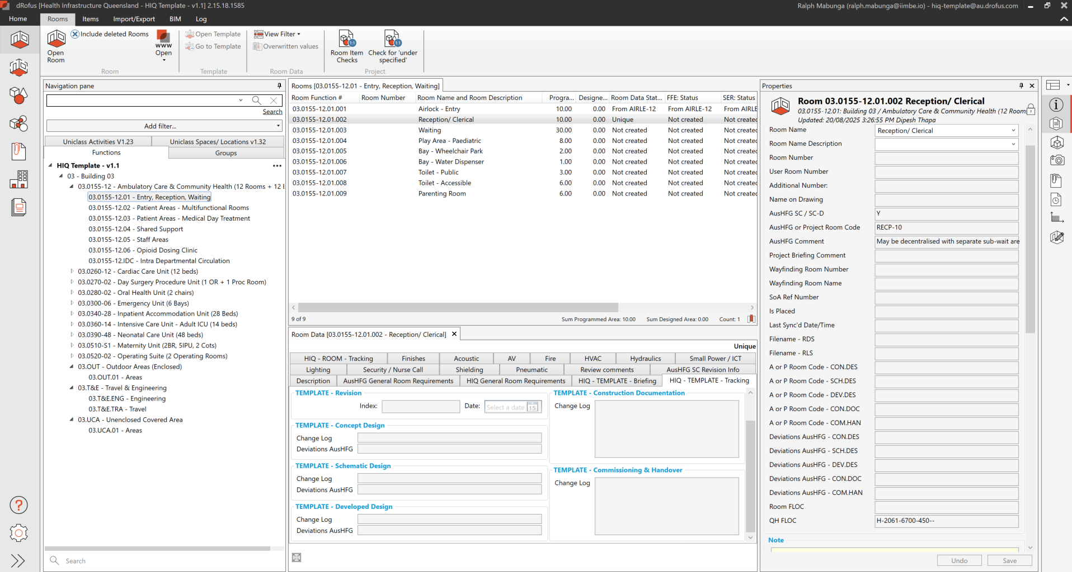
Figure 5: Change management for rooms

A.3.5.4 Adding/removing rooms
Any changes to the SoA, room templates and rooms require approval from the HIQ project director.

A.3.5.4.1 Room deletion
Deleted rooms shall not be deleted from the dRofus project database. This will allow the project team to re-activate rooms and/or keep track of changes.
The steps required to ‘delete’ a room from the dRofus project database:
- Add a comment to the room-specific change log for the relevant stage. Comments shall be captured using conventions described in Section A.3.2.2.1 Format of comments.
- If a new SoA was issued, upload the new version to the documents module of the dRofus project database.
- Set the rooms programmed area to ‘0’
- Make sure the status of the room changed to ‘deleted’, but not permanently removed.

A.3.5.4.2 Room addition
Any rooms added after the SoA was established require documentation of this decision in the room’s deviation comments for the relevant stage.
The steps required to add a room to the dRofus project database:
- Add a new room to the project database.
- If a new SoA was issued, upload the new version to the documents module of the dRofus project database.
- Link the new room to a room template (create a new template if required).
- Review all properties of the room template and the room and update as required e.g. areas, service requirements, etc.
- Add a comment to the room-specific change log for the relevant stage. Comments shall be captured using conventions described in Section A.3.2.2.1 Format of comments.

A.3.5.4.3 Merging rooms
To merge two rooms into one, delete one of the two rooms by following the steps described in section A.3.5.4.1 Room deletion. Following the deletion of one of the rooms, review the properties of the remaining room as described in section A.3.5.4.2 Room addition. Ensure the process is documented in the relevant deviation comments of the updated and deleted rooms.

A.3.5.4.4 Splitting rooms
To split a room into two or more other rooms, add new rooms by following the steps described in sectionA.3.5.4.2 Room addition. Following the creation of new rooms, review the properties of the original room as described in section A.3.5.4.2 Room addition. Ensure the process is documented in the relevant deviation comments of the updated and created rooms.

A.3.5.4.5 Moving rooms
To move a room from one HPU to another, the original room must be marked as deleted by following the steps described in Section A.3.5.4.1 Room deletion. Add the room as a new room (in the new location/HPU) by following the steps described in Section A.3.5.4.2 Room addition. Ensure the process is documented in the relevant deviation comments of the updated and created rooms.

A.3.5.5 Changes to a room template or room

A.3.5.5.1 Change of room template (no new room template to be created)
If a room template for a room/s in dRofus is changed from one template to another, the following steps must be followed:
- Upload the latest SoA to the documents module in the dRofus project database.
- The value in ‘Area SoA’ always remains the initially briefed area from the first version of the SoA, do not overwrite.
The value in the in ‘Area AusHFG’ must be updated if an AusHFG room template was changed, added or removed.
- Unlink the room template from the room/s and link to the new template.

A.3.5.5.2 Deviation from the Australasian health facility guidelines
If a room/multiple rooms in the project require a new template due to a variation to an AusHFG standard component, the following steps must be followed:
- Create a copy of the AusHFG room template that requires a deviation.
All changes to AusHFG room templates are deviations from the guidelines and always require a new room template. Never overwrite an existing AusHFG template.
- Review the name and all other properties of the copied template and update accordingly. Make sure the template source is changed from ‘AusHFG’ to an applicable option. Follow the naming convention described in Section A.3.3 Room template coding.
- Update the standard area of the template.
- Add a comment to the room template-specific ‘Deviations AusHFG’ field (‘ROOM TEMPLATE – Tracking’ tab) of the current project stage. Follow the comment format from section A.3.2.2.1 Format of comments. If you would like to assign this new template to existing rooms, follow the steps from Section A.3.5.5.1 Change of room template (no new room template to be created).

A.3.5.5.3 Creation of a non-Australasian health facility guidelines room template
If a room/multiple rooms in the project require an entirely new template (not a variation to an AusHFG standard component), the following steps must be followed:
- Create a new room template or copy an existing non-AusHFG room template.
All changes to AusHFG room templates are deviations from the guidelines and always require a new room template. Never overwrite an existing AusHFG template.
- Review the name and all other properties of the new or copied template and update accordingly. Make sure the template source is changed from ‘AusHFG’ to an applicable option.
- Follow the naming convention described in Section A.3.3 Room template coding.
- If you would like to assign this new template to existing rooms, follow the steps from section A.3.5.5.1 Change of room template (no new room template to be created).

A.3.5.5.4 Changing room properties
If the briefed area of a room changes (or the area of the room template), update the field ‘Programmed area’. In this case, do not overwrite the value in the field ‘area SoA’ as this is the briefed area from the first released SoA.

A.3.5.5.5 Room data management
The responsibility to populate and manage certain datasets and properties of room templates and rooms is based on the room data schedule in Appendix B.

A.3.6 Item Lists

A.3.6.1 Australasian health facility guidelines items
The dRofus project database will be based on the AusHFG Item control schedule as per Section A.1.2 Shared resources. HIQ will setup the database with the items from the nominated AusHFG Item control schedule.

A.3.6.2 Health Infrastructure Queensland-specific items
The dRofus project database will be based on the HIQ Item control schedule/s as per Section A.1.2 Shared resources. HIQ will setup the database with HIQ-specific items from the nominated lists.
Additional items not included in this schedule will have to be requested via the process described in Section A.3.6.7 New item codes (not for group 1 items).

A.3.6.3 Device catalogues
ICT items may require additional metadata and packaging, based on the nominated device catalogue in section A.1.2 Shared resources. Catalogue information/packages are not part of the HIQ dRofus template database and will have to be imported into the dRofus project database when established.

A.3.6.4 Assets: non-furniture, fixtures and equipment items
Refer to the Queensland Health PIR ‘asset grouping’ section and the Queensland Health asset equipment list for assets (other Items) requiring information to be captured in the project database

A.3.6.5 Item code status in dRofus
All FFE codes will have to be classified by their origin. The dRofus lead will have to review/manage this setting throughout the project. The field ‘Item code status’ in the dRofus project database shall be used as per below.
- A for AusHFG standard items (from the agreed Item control schedule)
- H for QH-specific items from a QH item control schedule or ICT item list
- P for project-specific items
- I for inactive item codes that shall not be used any longer.

A.3.6.6 Item coding rules

A.3.6.6.1 Australasian health facility guideline reserved item numbers
Numbers 001 to 499 of each item category are reserved for use by the AusHFG standard.
No additional codes/items can be created within this number range for Queensland Health projects. Numbers of 600 or above will be used by HIQ for any new items.
Example: FIGE-600
If a child item for an AusHFG item is required, those child items will be assigned number 50 or above by HIQ. Child codes 01 to 29 are reserved for AusHFG items (in case AusHFG will create more child items with future updates).
Example: xxxx-001.50

A.3.6.6.2 Temporary codes
Item code numbers 500 to 599 and child code numbers 30 to 49 are reserved for temporary codes. The Delivery teams can create and use new codes within this number range until a request for a new code is approved by HIQ.
As soon as the code request is approved or rejected, the delivery team must change the temporary code to the code approved by the relevant HIQ committees.

A.3.6.6.3 Parent/child items
No quantities on child and parent items at the same time.
There are generally two reasons for creating child items, and each method require different rules:
- TYPES use case: Similar items with different attributes
Example: Same chair, but available in three different colours
All quantities on the child item, no quantities on the parent item
- LINKS use case: Used to link multiple BIM objects to one dRofus item
Example: Same data outlet, but modelled in BIM with different families (e.g. some wall-based, some ceiling-based and some face-based)
All quantities on the parent item, not the child items
If a child item is required for an AusHFG standard item that doesn’t already have any child items, the following process must be followed:
For ‘types’ child items (different properties, relevant for procurement):
- Add the suffix ‘(parent item – Do not use)’ at the end of the item description of the existing code.
- Create the new child item underneath and change the number as per the coding rules in this management plan.
- Review all properties of the parent and child item and add/update as required.
- Make sure the item code that has now become a parent code, is no longer used by any rooms or attribute configurations.
- For ‘link’ child items (different objects in the BIM/s, but will be procured as one item):
- Create the new child item underneath and change the number as per the coding rules in this management plan.
- Add the suffix ‘(link child Item – Do not use)’ at the end of the item description of the child item.
- Review all properties of the parent and child item and add/update as required.
- Make sure the new child code will not be used in any rooms or attribute configurations.
Item coding and description shall be aligned with rules defined in Section A.3.6.6 Item coding rules.

A.3.6.7 New item codes
If a project requires the creation of new project or program-specific item codes, the dRofus lead shall coordinate the creation of these codes with the HIQ project director. The creation of new codes must follow any current HIQ process and may require approval from various committees and/or working groups.
Codes for budget group 1 items (and potential sub-groups) can be assigned by the dRofus lead and do not require approval from HIQ.
The item data field ‘Item Code Status’ shall be set to ‘P’ for project-specific or temporary codes, and to ‘H’ for HIQ-approved codes.
The delivery team shall always go through the HIQ project director to request new item codes (other than group 1 items), where approval must be obtained from the relevant HIQ teams and committees prior to use
After approval of new codes, the dRofus lead is responsible for the update of the item list and the item metadata in the dRofus project database (e.g. import of the approved code list). The properties of the new item must be reviewed and updated to meet the minimum information requirements specified in Appendix B. Make sure the item is classified correctly and appears on the correct item lists (e.g. FFE list).
The delivery team can assign temporary codes to an item, refer to Section A.3.6.6.2 Temporary codes.

A.3.6.8 Inactive item codes
Item codes that have been used in the project, but shouldn’t be used any longer, must be marked in the database by setting the ‘Item Code Status’ field in dRofus to ‘I’ (inactive). Any items with a status of ‘I’ shall not be deleted from the project database but will no longer be used in the project.
Project teams can request certain items to be set to inactive at project start if it was agreed that an item should not be used on the project. An item may become ‘inactive’ if, for example, a project-specific item was created that replaces another existing code.

A.3.7 Item budget group

A.3.7.1 Budget groups
Budget groups in the HIQ template database have been assigned to all items.
All items in the HIQ dRofus project database have the three parameters below available to manage and track the budget group (as grouping may change during the project lifecycle).
- QH_budget group (‘Budget Group’ in dRofus)
The current budget group of an item. Per default the AusHFG or HIQ budget group of an item but can be changed per project after consultation and approval from the HIQ project director.
- QH_HIQ budget group (‘HIQ Budget group’ in dRofus)
A HIQ-specific budget group to track. Cannot be changed for a single project
- QH_AusHFG budget group (‘AusHFG Budget Group’ in dRofus)
The original AusHFG budget group as assigned by the AusHFG team. Can only be changed with an update of the AusHFG standards.
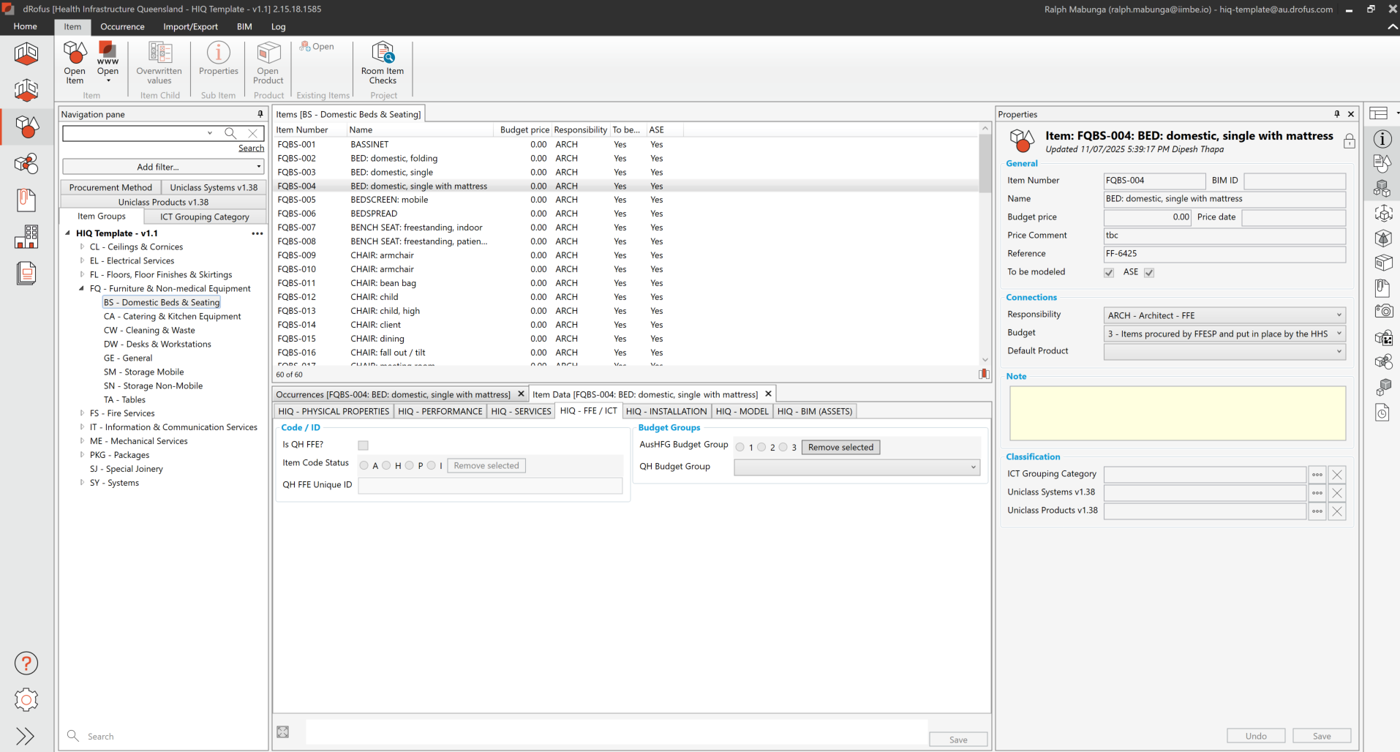
Figure 6: HIQ budget groups

A.3.8 Managing items

A.3.8.1 Package items
dRofus allows the use of packages (items with sub-items) to define typical assemblies of items in a project (e.g. a workstation package that includes monitor, computer, keyboard and mouse). If such packages contain spatially relevant items, these items must still be visible in the BIM/s to the detail level described in this management plan.
The use of packages on the project must be discussed in the dRofus kick-off meeting with the HIQ teams. The dRofus lead is responsible for the setup/management/coordination of packages after approval by the HIQ project director and all relevant stakeholders.
If a package contains items with various responsibilities, the dRofus lead must establish a process to update those items and assign a responsibility for the entire package to one discipline lead in the responsibility matrix. Refer to Appendix C.

A.3.8.2 Creation of new items
Users must use as many items from the provided item list in the dRofus project database. If a new item is required, a new code and item description must be generated in line with the requirements in Section A.3.6.7 New item codes.

A.3.8.3 Transfer items
Items that will be transferred from another location to the project shall be marked as such in the project database. These items shall be managed in the ‘existing items’ module in the dRofus platform. HIQ doesn’t use a separate budget group for transfer items.
The ‘existing Items’ module in dRofus shall be used to record and manage all transfer items, including their condition and status (retain, refurbish, relocate, or replace), to ensure accurate tracking and reporting throughout the project.

A.3.8.4 Item responsibilities
Every item must have a populated ‘item responsibility’ field. The responsibility should be based on the responsibility schedule in Appendix C.
The responsibility to populate and manage certain datasets and properties of items and their occurrences is based on the item data schedule in Appendix B.

A.3.9 Modelled and non-modelled items

A.3.9.1 Predefines settings in health infrastructure dRofus database
The HIQ dRofus project database comes with a pre-defined setting ‘to be modelled’, yes or no, for all items. The dRofus lead must review the pre-defined settings, discuss any changes with all stakeholders and seek approval from the HIQ BIM/digital asset lead prior to implementation. This does not change BIM authoring obligations prescribed in the PIR.

A.3.9.2 General
In general, all items that have a usual location, and meet one or more of the following must be modelled using their actual geometry in the BIM authoring software (as defined in the Queensland Health PIR and BEP templates):
- Have a spatial impact on the design of the room
- Require the provision of building services
- Will be mounted on a ceiling, floor or wall
- Are maintainable items
These items must be modelled to include:
- Realistic dimensions
- Location
- Correct position and size of connectors (indicative only before product is confirmed)
- Mounting points (indicative only before product is confirmed)
- Clearance zones.
However, all non-modelled items still need to appear in the dRofus database, on all FFE schedules and RDS.

A.3.9.3 Budget group one—and sub-groups
General rules from Section A.3.9.2 General apply.

A.3.9.4 Budget group two—and sub-groups
All items are to be modelled with dimensions reflecting the indicative HHS requirements. The HHS will provide a catalogue for budget group two items with indicative makes and models. All budget group 2A or 2A ICT items require test fits.

A.3.9.5 Budget group three—and sub-groups
Loose items must only be modelled if they are part of a specific room layout, a mobile equipment bay or a resuscitation bay.
Loose items assigned to a storage room don’t need to be modelled, with the exception of items permanently stored in the room, such as shelving. Exceptions may apply and will need to be assessed on a case-by-case basis for each project in consultation with the HHS FFE and clinical planning team. Some storage areas (e.g., Store—sterile stock/set-up, store—II machines, dialysis store) shall be modelled to ensure the room is functional.

A.3.9.6 Budget group four—and sub-groups
Only to be modelled if they have a spatial impact on specific room layouts.

A.3.9.7 Placeholder items in BIM
Placeholder geometry can be used to represent an item in a room if the item is:
- A loose item in a storage room
- An Item in a storage bay
- Seals
- Shielding
- Door hardware/ bolts/ locks/ switches
- Paint finishes.

A.3.10 Links

A.3.10.1 Rooms
Rooms will be placed in the BIM/s and linked to the dRofus platform during schematic design. The data must be maintained in both platforms throughout the project. All BIM users must use the dRofus BIM plugin specified in Section B.3.4 Model synchronisation/building information modelling plug-in to link and synchronise data between the dRofus platform and BIM rooms and spaces. See Appendix A for a mapping table to link BIM parameters to the dRofus project database.
Refer to the Queensland Health PIR ‘Attributes’ section and the Queensland Health asset equipment list for mandatory parameters per project stage.
Any deviations from the provided mapping table must be documented in Section B.1.1 Amendments to Part A.

A3.10.2 Items
Items will be placed in the BIM/s and linked to the dRofus project database during schematic design, or as agreed with HIQ. The data must be maintained in both platforms throughout the project. All BIM users must use the BIM plugin specified in section B.1.3 dRofus project database to link and synchronise data between the dRofus platform and elements in the BIM. See Appendix A for a mapping table to link BIM parameters to the dRofus project database.
Refer to the Queensland Health PIR ‘Attributes’ section and the Queensland Health asset equipment list for mandatory parameters per project stage.
Any deviations from the provided mapping table must be documented in Section B.1.1 Amendments to Part A.

A.3.11 Reports
All project database deliverables shall be provided in the specific HIQ formats, within the reports and exports module, at specific project milestones as defined in section A.2.4 Project milestones and deliverables. The HIQ format reports are available for export in the dRofus project database.
- SoA
- RDS
- FFE lists
- Handover and commissioning lists
- Quality assurance lists
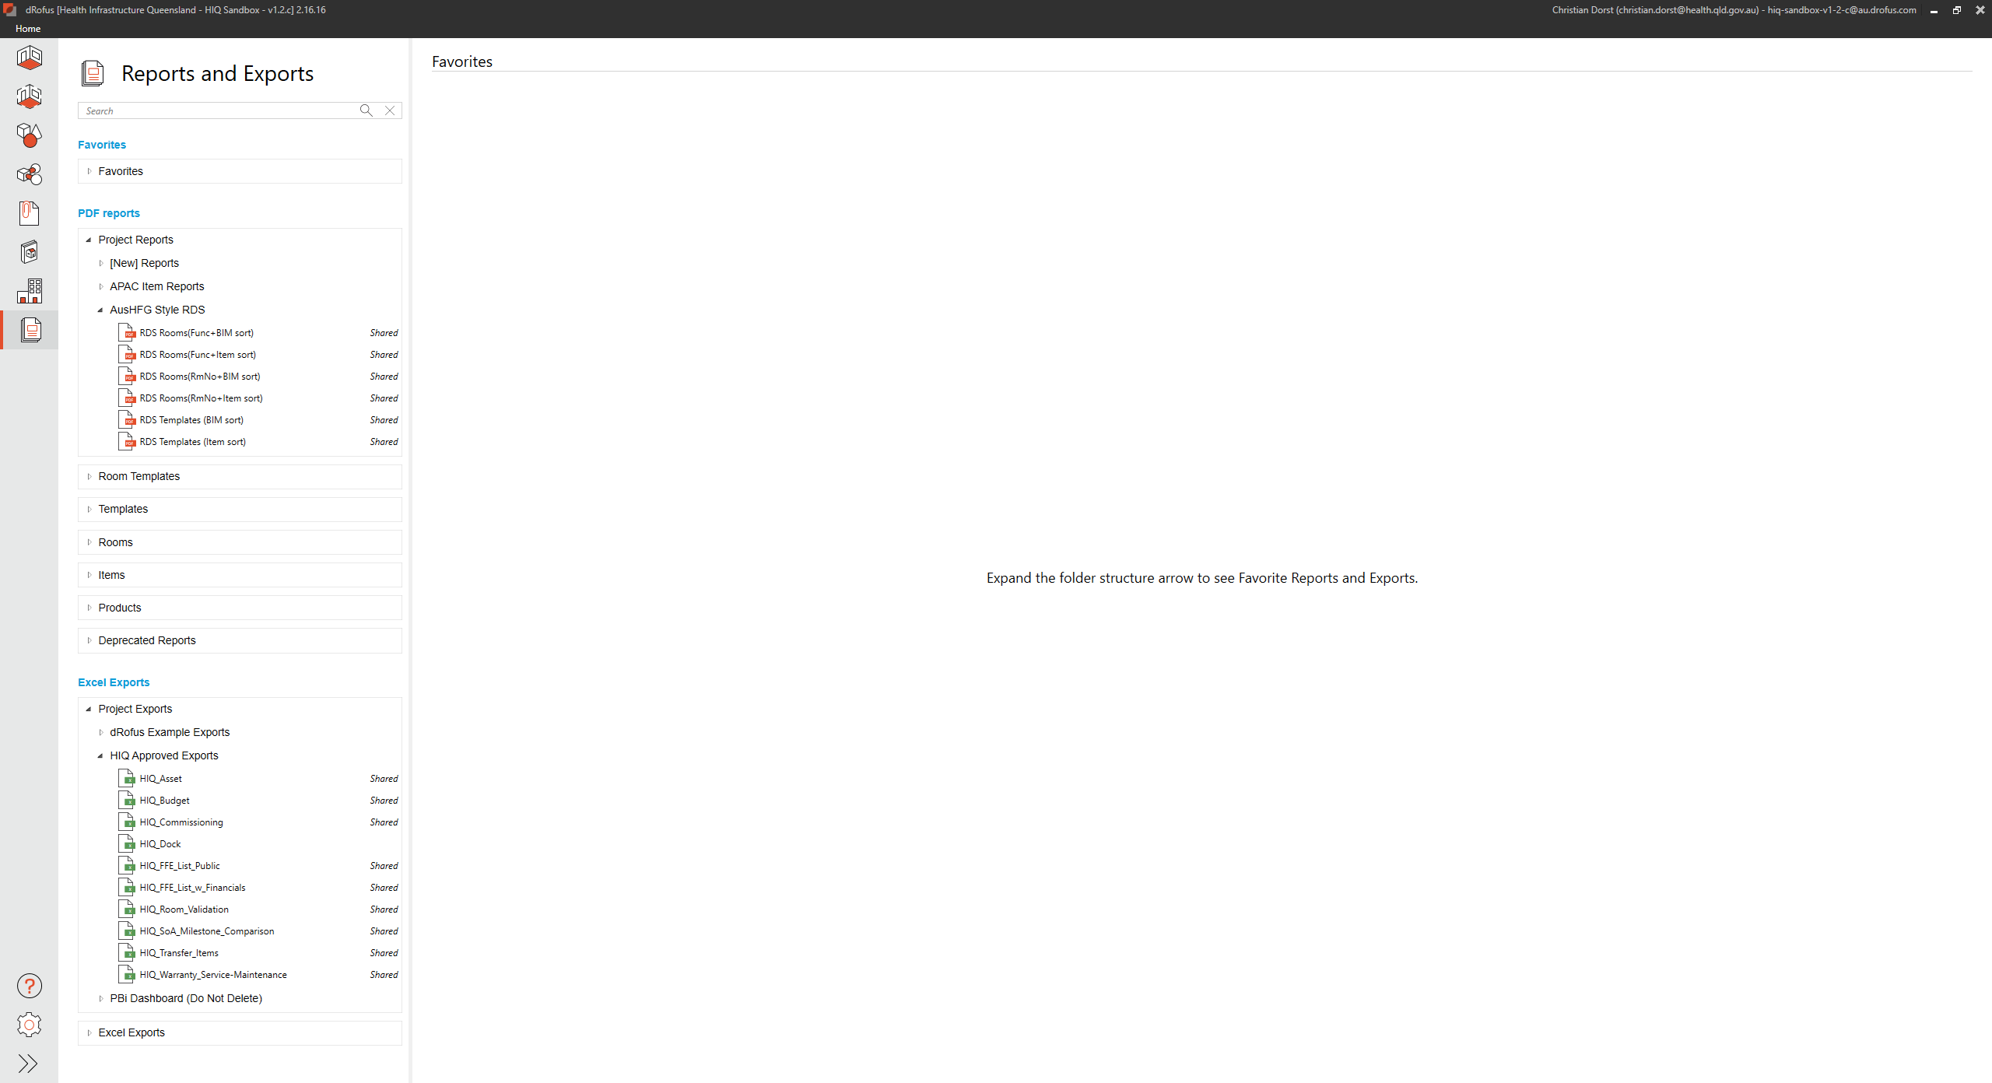
Figure 7: HIQ format reports

A.3.11.1 Schedule of accommodation

A.3.11.1.1 HIQ: Schedule of accommodation summary department
An SoA groups rooms by department and the SoA summary department export report includes:
- Comparison of the briefed area with the standard area and the designed area from BIM/s (if available).
- Identification of AusHFG standard rooms, repeated and unique rooms.
- Intradepartmental circulation, including comparison to gross area from BIM.

A.3.11.1.2 HIQ: Schedule of accommodation breakdown departments
An SoA details departments and their room breakdowns, and the SoA breakdown departments export report includes:
- All departments listed, including all rooms, T+E, UCA and OUT areas.
- Comparison of the briefed area with AusHFG area and the designed area from BIM/s (if available).

A.3.11.2 Room data sheets

A.3.11.2.1 Health Infrastructure Queensland format room data sheet
All RDS must be created for templates and/or rooms at certain milestones in the project using the HIQ RDS export report template. The RDS shall contain references to a room by using the room function number and the field ‘Room number’ from dRofus.

A.3.11.3 Room layout sheets

A.3.11.3.1 Health Infrastructure Queensland format room layout sheets
All RLS must be created for templates and/or rooms at certain milestones in the project using the BIM/s associated with the project database. The RLS must be created in the BIM authoring software and include:
- 1:50 or larger 3D room perspective.
- Floor plan of the room, scale 1:50 or larger including dimensions, grids and distance markers.
- Ceiling plan of the room, scale same as floor plan, including dimensions, grids and distance markers.
- Elevations from four directions, parallel to the main walls of the rooms, including level name and height reference Australian Height Datum (AHD).
- Schedule of room items including item code, item name and quantity.
- Project information.
- Room name, room number, room function number, standard room code, area designed, information of base design, change comments, systems required in room, sqm of a room, height of a room.
- Endorsement block for stakeholder approvals.

A.3.11.4 Furniture, fixtures and equipment lists

A.3.11.4.1 Health Infrastructure Queensland: Furniture, fixtures and equipment list without financials
An export report for all FFE/ICT items in the project without any financial information.

A.3.11.4.2 Health Infrastructure Queensland: Furniture, fixtures and equipment list with financials
An export report for all FFE/ICT items in the project, including budget, actuals and forecasting fields.

A.3.11.4.3 Health Infrastructure Queensland: Room item list
An export report lists all items placed in rooms in the project, and the fields in this report include:
- Room function number
- Room number
- Room name
- Item code
- Project quantity items in rooms
- Template quantity items in rooms
The room Item list is grouped by the room number field.

A.3.11.4.4 Health Infrastructure Queensland: Room validation list
An export report that will be used to check all required FFE/ICT has been commissioned in a room.

A.3.11.4.5 Health Infrastructure Queensland: Transfer items list
An export report of existing items that will be transferred to the project, against gross item numbers and the number of new items procured.

A.3.11.4.6 Health Infrastructure Queensland: Budget report
An export report to track the budget for e.g. Queensland Health procurement teams.

A.3.11.5 Quality assurance lists
The dRofus lead shall conduct a monthly audit of the project database during all phases of their engagement to ensure compliance with this dMP and to maintain readiness for handover to HIQ.
Following each audit, the dRofus lead shall issue the following reports/lists to the relevant appointed party and the discipline leads, detailing required corrective actions and the timeframe for completion. The project database shall also be utilised by the dRofus lead to track and close out deviations, sign off completed rooms, and update room status within the project database.

A.3.11.5.1 Health Infrastructure Queensland: Schedule of accommodation milestone comparison, including AusHFG deviations
An export report containing comparison of area for rooms across all project stages, including AusHFG deviation comments.

A.3.11.5.2 Health Infrastructure Queensland: Occurrence discrepancies
An export report/list of all rooms, showing the total number of items in this room, compared to the item number in the template/standard. Fields in this report include:
- Room function number
- Room number
- Room name
- Item code
- Project quantity items in rooms
- Template quantity items in rooms.

A.3.11.5.3 Health Infrastructure Queensland: Compare room items to template
An export report/list of all items in rooms where discrepancies were found in the list ‘Occurrence discrepancies’. Fields in this report include:
- Room function number
- Room number
- Room name
- Item code
- Item number
- Project quantity
- Template quantity.

A.3.11.5.4 Health Infrastructure Queensland: Budget group control list
An export report/list of all items currently placed in the project showing the budget groups used. Fields in this report include:
- Item code
- Item number
- Budget group
- HIQ budget group
- AusHFG budget group.
The HIQ Budget group control list is grouped by the budget group field.

A.3.11.6 Handover and commissioning

A.3.11.6.1 Health Infrastructure Queensland: Asset data uploader
An export report that contains fields mapped to the HIQ uploader spreadsheet that will assist the asset management unit in importing assets into SAP S/4 Hana.

A.3.11.6.2 Health Infrastructure Queensland: Deliveries and commissioning report
An export report that captures delivery/commissioning information and status to inform project teams.

A.3.11.6.3 Health Infrastructure Queensland: Delivery schedule
An export report/list with items expected to be delivered to an HHS to help track delivery by purchase order number.

A.3.11.6.4 Health Infrastructure Queensland: Warranty and maintenance information
An export report that contains handover maintenance information to the responsible HHS.

A.3.12 dRofus training and support
The dRofus training modules are structured in alignment with phase requirements but may be tailored to specific audiences where necessary. Phase-based training requirements may be adjusted to address the needs of stakeholders responsible for database deliverables, as specified in Section A.2.4 Project milestones and deliverables.
At the commencement of any project stage, a dRofus briefing session shall be held between the lead appointed party’s nominated dRofus lead, the HIQ project director, and the HIQ BIM/digital asset lead are to establish the requirements of the HIQ project database. During this session, the dRofus lead shall identify the HIQ-specific dRofus training modules required for the delivery team and present these to the HIQ BIM/digital asset lead.
The training modules to be used for the project shall be approved by both the HIQ project director and the HIQ BIM/digital asset lead prior to implementation. Attendance at HIQ-organised training sessions is mandatory for the nominated dRofus lead and all nominated dRofus discipline leads.

A.3.12.1 Concept design training modules
The following training modules may be covered and delivered by dRofus, during the HIQ-organised dRofus training session, subject to HIQ project director and the HIQ BIM/digital asset lead approval.
- Introduction to the HIQ dRofus project database
- Setting up the project database using the AusHFG and HIQ ICS
- Using room templates to standardise data
- Adding and organising rooms within the project database
- Generating HIQ-format departmental SoA reports.

A.3.12.2 Schematic design training modules
The following training modules may be covered and delivered by dRofus, during the HIQ-organised dRofus training session, subject to HIQ project director and the HIQ BIM/digital asset lead approval.
- Introduction to the HIQ dRofus project database
- Transferring project database and dRofus lead
- Setting up the project database using the AusHFG and HIQ ICS
- Using room templates to standardise data
- Adding and organising rooms within the project database
- Combining/merging rooms within the project database
- Deleting rooms within the project database
- Splitting rooms within the project database
- Linking rooms in dRofus to Revit rooms or spaces
- Revit attribute configuration and synchronising data using the dRofus Revit plug-in
- Data validation tools to check for discrepancies between the database and Revit
- Generating HIQ-format departmental SoA reports
- Generating schematic design milestone Excel-based report
- Generating milestone copy of the project database at the end of the project stage.

A.3.12.3 Detailed design training modules
The following training modules may be covered and delivered by dRofus, during the HIQ-organised dRofus training session, subject to HIQ project director and the HIQ BIM/digital asset lead approval.
- Introduction to the HIQ dRofus project database
- Introduction to the HIQ room data tabs and the requirements of each appointed party
- Using room templates to standardise data
- Adding and organising rooms within the project database
- Combining/merging rooms within the project database
- Deleting rooms within the project database
- Splitting rooms within the project database
- Linking rooms in dRofus to Revit rooms or spaces.
- Revit attribute configuration and synchronising data using the dRofus Revit plug-in
- Creation of new items that are not part of the AusHFG using the Items module
- Linking items to Revit families
- Data validation tools to check for discrepancies between the database and Revit
- Producing HIQ-format RDS and item schedules
- Generating HIQ-format departmental SoA reports
- Generating detailed design milestone Excel-based report
- Generating milestone copy of the project database at the end of the project stage.

A.3.12.4 Construction documentation training modules
The following training modules may be covered and delivered by dRofus, during the HIQ-organised dRofus training session, subject to HIQ project director and the HIQ BIM/digital asset lead approval.
- Introduction to the HIQ dRofus project database
- Transferring the project database and dRofus lead
- Introduction to the HIQ room data tabs and the requirements of each appointed party
- Using room templates to standardise data
- Adding and organising rooms within the project database
- Combining/merging rooms within the project database
- Deleting rooms within the project database
- Splitting rooms within the project database
- Linking rooms in dRofus to Revit rooms or spaces
- Revit attribute configuration and synchronising data using the dRofus Revit plug-in
- Creation of new items that are not part of the AusHFG using the items module
- Linking items to Revit families
- Data validation tools to check for discrepancies between the database and Revit
- Producing HIQ-format RDS and item schedules
- Generating HIQ-format departmental SoA reports
- Generating construction documentation Excel-based report
- Generating milestone copy of the project database at the end of the project stage.

Part B: dRofus delivery

B.1 Commercial

B.1.1 Amendments to Part A
All amendments to the original HIQ dRofus management plan template must be documented below, reviewed and approved by the HIQ project director. Some changes may also require amendments to the Queensland Health PIR/BEP.
Amendments to the HIQ dRofus management plan template and non-required uses of dRofus are listed in the table below.
Deviation | Reference to Part A | Description
“Deviation 1”
“Deviation 2”
Table 13: Deviations from dRofus management plan requirements

B.1.2. Project details

B.1.2.1 Project Schedule
The project schedule must align with the dates provided by the BIM manager in the BEP/s. Please refer to the relevant BEP.
The project schedule in the DBEP and the CBEP contains the major project milestones for this project.
Deviation | Reference to Part A | Description
DBEP | [enter version here] | [enter date here]
CBEP | [enter version here] | [enter date here]
Table 14: Project schedule

B1.2.2 Project code
Code to indicate the project, consistent across the project
The project-specific elements in the dRofus project database will be identified by using a three-character code (digits or letters).
The agreed code for this project: XXX

B.1.2.3 Project summary description
PIR Section 4.1 (a).
dRofus platform lead to insert a brief description of the project here.
[enter project description here]

B.1.2.4 Project stages
dMP Section A.2.1.6
If stages are not known at the time of the database creation, then splitting can be done once confirmed. If a new database is being created, the new database and project strategy will also have to be documented in this management plan
The project consists of the following stages and includes the described parts below:
Stage | Building | Levels
‘Name stage 1’
‘Name stage 2’
Table 15: Project stages
Each project stage will be managed in a separate database to allow the use of different contractors, procurement strategies and project schedules. This management plan will apply to all project stages in the table above.

B.1.3 dRofus project database
The dRofus project database that will be used for this project is captured in the table below.
dMP A.1.4.
List details of the dRofus database to be used for the project below. Contact the HIQ BIM/digital asset lead to coordinate the database setup.

Database details | Web interface | Project ID
dRofus | [URL to web interface] | [ID of project in database]
Table 16: dRofus project database

B.1.3.1. Project dRofus modules
dMP A.1.3.
List details of when and which modules will be actively used on the project below. Contact the HIQ BIM/digital asset lead to coordinate the database setup.
Modules of the dRofus platform that are actively being used and updated by the platform and discipline leads on this project include:
dRofus modules | Module start phase | Responsible platform/discipline lead
Room templates | [insert phase when the delivery team will start using this module] | [insert responsible platform or discipline lead(s) for this module]
Rooms | [insert phase when the delivery team will start using this module] | [insert responsible platform or discipline lead(s) for this module]
Items | [insert phase when the delivery team will start using this module] | [insert responsible platform or discipline lead(s) for this module]
[add as required] | [insert phase when the delivery team will start using this module] | [insert responsible platform or discipline lead(s) for this module]
Table 17: dRofus modules
B.1.3.2 Server location
Due to the nature of information hosted on the dRofus platform and other related BIM tools, data cannot be hosted on servers outside of Australia.
dRofus server | Server location
[wed-au.drofus.com] | [Australia]
Table 18: dRofus server location

B.2 Management
The following sections detail the collaboration and communication procedures for local and remote users to access and use dRofus for decision-making. The dRofus lead is responsible for ensuring all deliverables listed in this section are successfully produced.

B.2.1 Roles and responsibilities

B.2.1.1 dRofus lead/project admin
dMP Section A.1.5 + A.2.1
List the nominated platform lead for this project. If there was/will be a transfer of ownership, list all previous and/or future leads in the list.
The dRofus database for this project will be administered by the HIQ BIM/digital asset lead. This includes initial database setup, backups, user management and monitoring of server logs. The nominated dRofus lead (dRofus project admin) will be responsible for the quality of the data stored in the dRofus project database and for all documents produced from it. This requires regular data validation and verification throughout the project.
Milestone | Name | Company | Email | Phone
[enter project stage(s)]
Table 19: dRofus lead details

B.2.1.2 Discipline leads for dRofus
dMP Section A.1.5.4.
List the nominated discipline leads for this project.
Discipline | Name | Company | Email | Phone
Architecture
Electrical
Hydraulic
Mechanical
Structural
[add as required]
Table 20: discipline lead details

B.2.1.3 Other contacts
dMP Section A.1.5.4 + A.2.2.
List any other important contacts for this project.
Role | Name | Company/  organisation | Email | Phone
BIM manager
HIQ project director |  | Health Infrastructure Queensland
HIQ assistant project director |  | Health Infrastructure Queensland
HIQ BIM/digital asset lead |  | Health Infrastructure Queensland
HIQ FFE officer |  | Health Infrastructure Queensland
HHS representative
Project manager
Health facility planner
[add as required]
Table 21: Other contacts details

B.2.1.4 User roles and permissions
dMP Section A.2.2.
The below matrix is a default definition of user roles and permissions. The platform lead shall review with the delivery teams and update the table as required. Add modules/permission levels or roles as required.
The users on the project will be assigned the following permissions by the HIQ BIM/digital asset lead during the setup of the project database in dRofus. These key users are specified in Section A.1.5 Key administrative contacts.
Role | Organisation admin | User management | Edit items | Edit rooms | BIM addon edit config | View items | View rooms | Share reports | View reports
dRofus lead | ☐ | ☐ | ☒ | ☒ | ☒ | ☒ | ☒ | ☒ | ☒
BIM manager | ☐ | ☐ | ☒ | ☒ | ☒ | ☒ | ☒ | ☐ | ☒
Discipline leads | ☐ | ☐ | ☒ | ☒ | ☒ | ☒ | ☒ | ☐ | ☒
BIM modeller | ☐ | ☐ | ☒ | ☒ | ☐ | ☒ | ☒ | ☐ | ☒
Architects (non-BIM users) | ☐ | ☐ | ☐ | ☐ | ☐ | ☒ | ☒ | ☐ | ☒
Engineers (non-BIM users) | ☐ | ☐ | ☐ | ☐ | ☐ | ☒ | ☒ | ☐ | ☒
FFE consultants | ☐ | ☐ | ☐ | ☐ | ☐ | ☒ | ☒ | ☐ | ☒
HIQ BIM/digital asset lead | ☒ | ☒ | ☒ | ☒ | ☒ | ☒ | ☒ | ☒ | ☒
HIQ FFE team rep | ☐ | ☐ | ☐ | ☐ | ☐ | ☒ | ☒ | ☐ | ☒
ICT team rep | ☐ | ☐ | ☐ | ☐ | ☐ | ☒ | ☒ | ☐ | ☒
Health facility planners | ☐ | ☐ | ☐ | ☒ | ☐ | ☒ | ☒ | ☐ | ☒
HIQ PDs/PMs | ☐ | ☐ | ☐ | ☐ | ☐ | ☒ | ☒ | ☐ | ☒
HHS project team | ☐ | ☐ | ☐ | ☐ | ☐ | ☒ | ☒ | ☐ | ☒
[add as required] | ☐ | ☐ | ☐ | ☐ | ☐ | ☐ | ☐ | ☐ | ☐
Table 22: User roles and permissions

B.2.1.5 Organisations without direct access to the dRofus platform
Discipline/trade | Organisation | Responsible for updates to the dRofus project database
[add as required]
Table 23: Organisations without dRofus

B.2.1.6 Update workflows
Detail the process for which non-dRofus users are to update the project database. Ensure that any alternative processes meet the requirements of the project database deliverables.
[Describe the desired process to import data provided by non-dRofus users. Please include the responsible team for the upload, validation and verification of this data.]

B.2.2 dRofus leads meeting schedule
dMP Section A.2.3.
List details of the dRofus leads meeting schedule to be actively used on the project below.
The following table specifies the dRofus meetings, timings, and location.
Meeting | Timings | Location
dRofus kick-off | 2 weeks after contract awards | [populate]
dRofus coordination meeting | Monthly | [populate]
User group sessions | [enter as per project delivery schedule] | [populate]
[Enter additional meetings] | [enter as per project delivery schedule] | [populate]
Table 24: dRofus meeting schedule

B.2.3 dRofus training
dMP Section A.3.12.
List details of the dRofus training modules to be used for the project below.
[Detail the required and agreed training modules for each phase here. Please include the responsible team for the upload, validation and verification of this data.]

B.2.4 User group communication processes
dMP Section A.3.5.3
Detail the communication and collaboration processes using dRofus for SoA, RDS, deviation coordination and/or data incorporation from non-dRofus users.
The user group and stakeholder communication processes are documented below.
[enter stakeholder strategy here]

B.3 Technical

B.3.1 Briefed areas management

B.3.1.1 Intra-departmental circulation rate
dMP Section A.3.1.3.1
List out any HPU/s using intra-departmental rates different to the AusHFG Guideline.
The below HPU/s will use an intra-departmental circulation rate different from the AusHFG guideline/s.
HPU/Department | IDC rate to be applied
[HPU or department] | [IDC rate (x.xx)]
Table 25: Intra-departmental circulation rate

B.3.2 Rooms management

B.3.2.1 Room number convention
dMP Section A.3.3 + A.3.4
Provide details for the room numbering convention for rooms and room templates to be used for the project
The room numbers assigned by the delivery team (assigned in field ‘room number’ in dRofus) will follow the below naming convention:
[Describe the agreed room numbering convention on the project, including separators, prefix/suffix, etc.]

B.3.3 Items management

B.3.3.1 New items
dMP Section A.3.6.7 + A.3.8.2
If a project requires the creation of new project-specific items, the platform lead shall coordinate the creation of these codes with the HIQ project director
[If approved by HIQ, describe the process for any new items to be used for the project. Provide details for when, how and by whom new items are created]

B.3.3.2 Package items
dMP Section A.3.8.1
The use of packages on the project must be discussed in the dRofus kick-off meeting with the HIQ teams
[Describe the process for any package items to be used for the project. Provide details for when, how and by whom package items are created]

B.3.3.3 Item status processes
dMP A.3.6.5
All FFE codes will have to be classified by their origin. Platform lead will have to review/manage this setting throughout the project.
[Provide details for how item status will be managed and maintained for each project stage]

B.3.3.4 Transfer item process
dMP Section A.3.8.3
Items that will be transferred from another location to the project shall be marked as such in the project database.

[Provide details on how ‘existing items’ module will be implemented for the project]

B.3.4 Model synchronisation/building information modelling plug-in
dMP Section A.3.10
Detail in this section the project database links to the BIM/s
This section details the processes and use of the BIM plug-in for Revit and/or ArchiCAD.

B.3.4.1 Rooms synchronisation schedule
dMP Section A.3.10.1
Detail in this section the project database links to Rooms in the BIM/s
From schematic design onwards, rooms/spaces and related data must be maintained in the BIM/s and in the dRofus project database. The synchronisation process, responsibilities and frequency are detailed as per below.
Room data sync | Frequency | Date/recurring series | Responsible
*sync task 1* | [how often] | [date or event recurrence] | [Name/Company]
* sync task 2* | [how often] | [date or event recurrence] | [Name/Company]
Table 26: Model synchronisation schedule

B.3.4.2 Items synchronisation schedule
dMP Section A.3.10.2
Detail in this section the project database links to Rooms in the BIM/s
From detailed design onwards, all items and their data must be maintained in the BIM/s and in the dRofus project database. The synchronisation process, responsibilities and frequency as per below.
Room data sync | Frequency | Date/recurring series | Responsible
*sync task 1* | [how often] | [date or event recurrence] | [Name/Company]
* sync task 2* | [how often] | [date or event recurrence] | [Name/Company]
Table 27: Item synchronisation schedule

B.3.4.3 Health Infrastructure Queensland attribute configurations
Appendix A
Delivery team to review ‘Queensland Health BIM parameter mapping table’ in Appendix A and note any proposed changes in this section.
Refer to Appendix A for the mapping table between BIM parameters and dRofus database fields/properties. The dRofus lead must ensure that this mapping is used when configuring the synchronisation settings in the platform/the BIM plug-in. If there are any changes to the Queensland Health BIM parameter mapping table, indicate below.
Deviation | BIM parameter | dRofus field (Queensland Health standard) | dRofusParameter field (proposed)
*Deviation 1*
*Deviation 2*
Table 28: HIQ attribute configurations

B.3.4.3.1 Queensland Health and dRofus shared parameters
HIQ provides two shared parameter files for import of Queensland Health and dRofus parameters into Autodesk Revit. Any shared parameters used within dRofus attribute configurations shall be imported from those two files only.
The dRofus lead must make sure that the Global Unique Identifier (GUID) of shared parameters matches the GUID within the shared parameter .txt files.
It is recommended to load all required shared parameters into a project first before using any dRofus attribute configurations, and to not let the dRofus BIM PlugIn automatically create shared parameters during synchronisation of elements.

B.3.4.3.2 Attribute configuration
The use of the project database requires bi-directional data exchange with the appointed party’ BIM/s appointed party shall enable automated updates of design information and validation of items between the project database and the BIM/s. The dRofus lead shall configure the project’s dRofus attribute settings using the dRofus Revit plug-in or ArchiCAD plug-in.
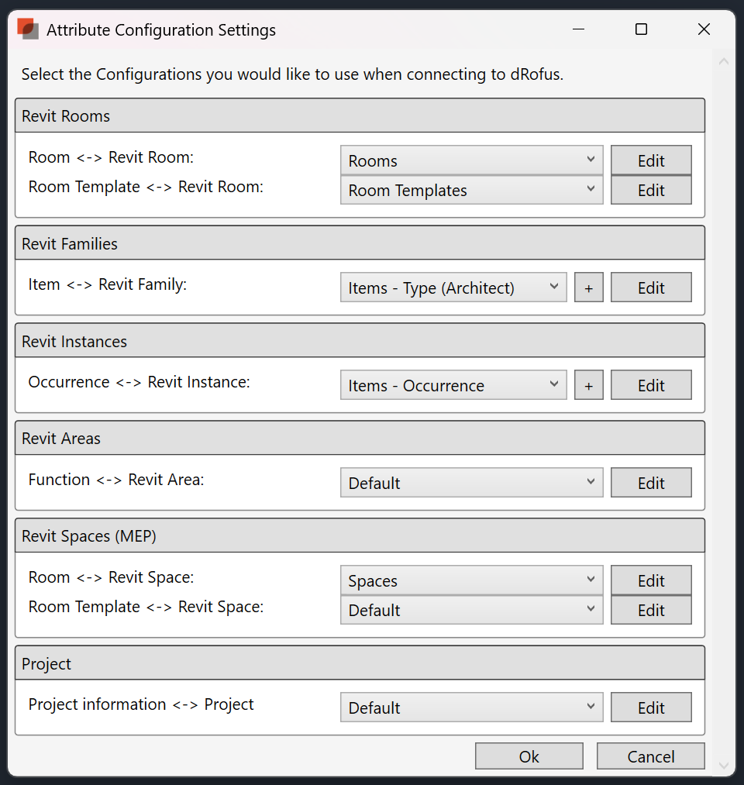
Figure 8: Example dRofus attribute configuration settings
[Replace figure above with project-specific BIM/s parameter configuration. Document the workflow here for appointed party]

B.3.4.3.3 Room attribute configuration
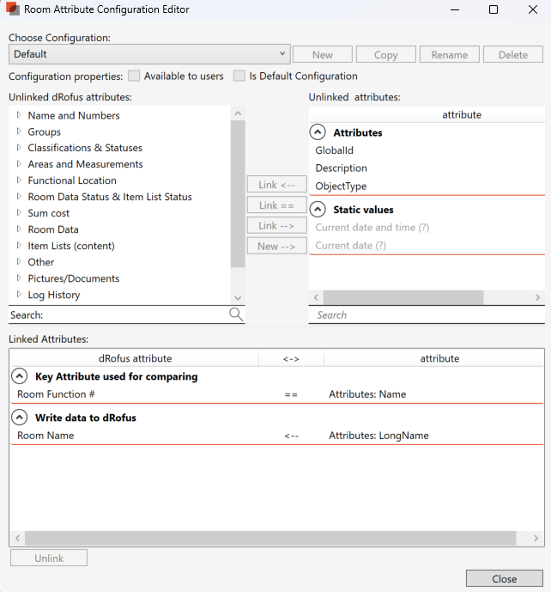
Figure 9: Example room attribute configuration settings
[Replace figure above with project-specific BIM/s parameter configuration. Define the primary and secondary attributes to link rooms and detail the project-specific room parameter configuration workflow here for appointed party]

B.3.4.3.4 Room template configuration
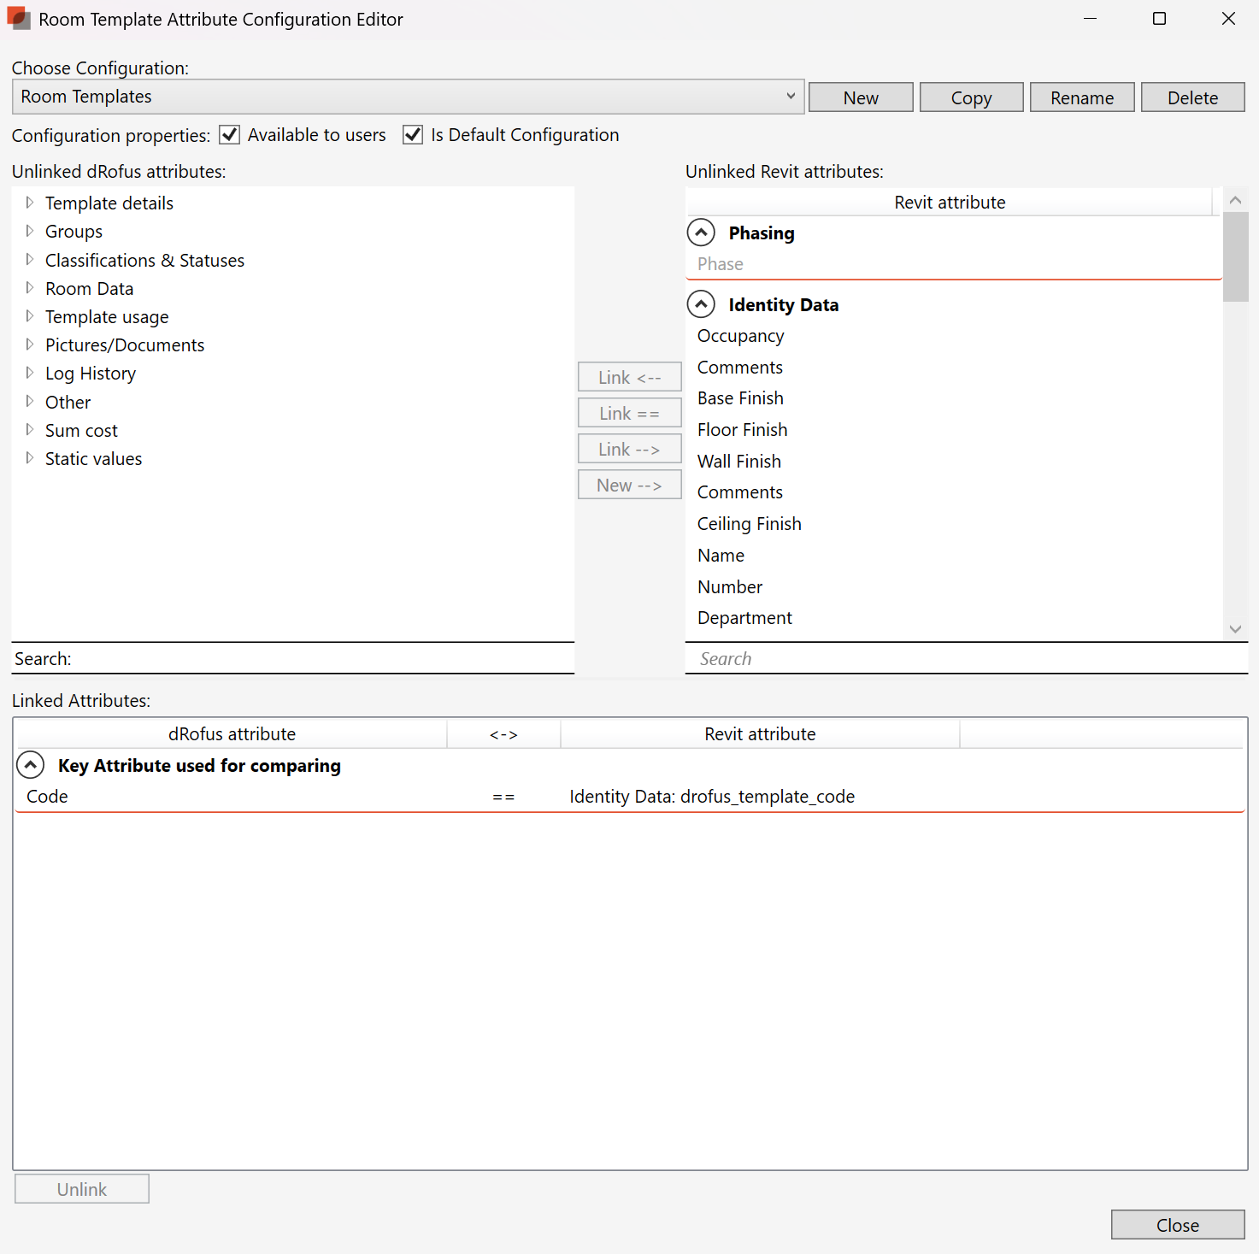
Figure 10: Example room template attribute configuration settings
[Replace figure above with project-specific BIM/s parameter configuration. Define the primary and secondary attributes to link room templates and detail the project-specific room template parameter configuration workflow here for appointed party]

B.3.4.3.5 Mechanical, electrical and plumbing space attribute configuration
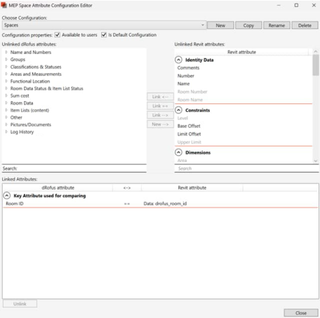
Figure 11: Example MEP space attribute configuration settings
[Replace figure above with project-specific BIM/s parameter configuration. Define the primary and secondary attributes to link Mechanical, Electrical and Plumbing (MEP) Spaces and detail the project-specific MEP Space parameter configuration workflow here for appointed party]

B.3.4.3.6 Item attribute configuration
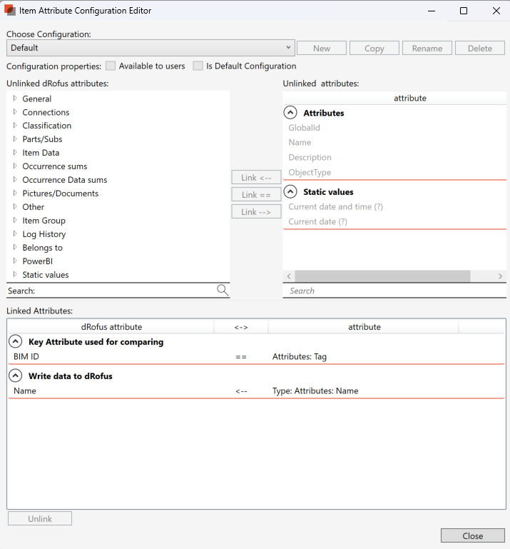
Figure 12: Example item attribute configuration settings
[Replace figure above with project-specific BIM/s parameter configuration. Define the primary and secondary attributes to link Items and detail the project-specific Item parameter configuration workflow here for appointed party]

B.3.4.3.7 Occurrence attribute configuration
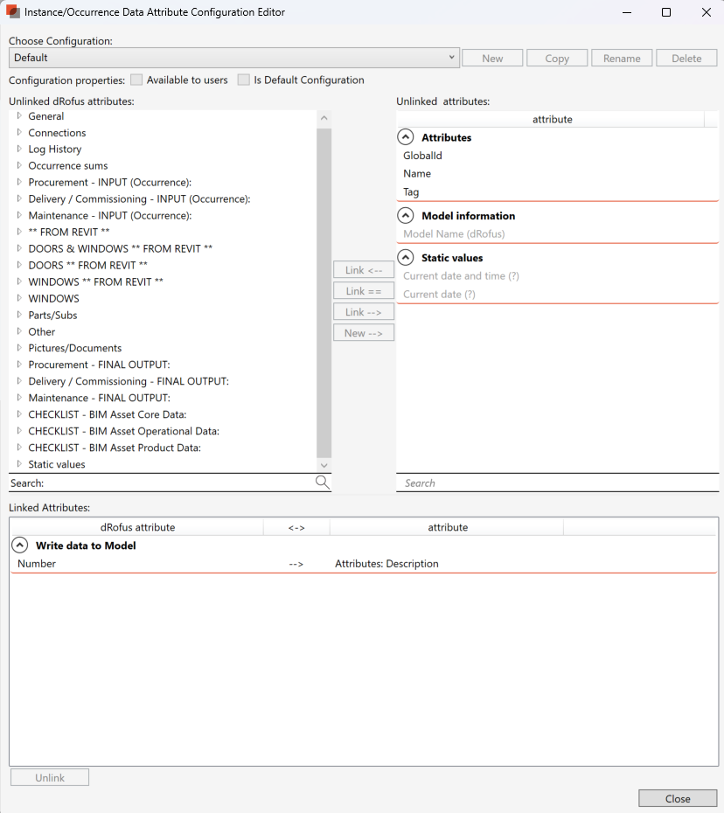
Figure 12: Example occurrence attribute configuration settings
[Replace figure above with project-specific BIM/s parameter configuration. Define the primary and secondary attributes to link Occurrences and detail the project-specific Occurrence parameter configuration workflow here for appointed party]

B.3.5 Project database documentation

B.3.5.1 Schedule of accommodation exports
dMP Section A.3.11.1
Detail the processes to be implemented for the delivery team to produce the SoA exports
[Detail the approach to coordinating the SoA exports using the project database and appointed party BIM/s here]

B.3.5.2 Room data sheet exports
dMP Section A.3.11.2
Detail the processes to be implemented for the delivery team to produce the RDS exports
[Detail the approach to coordinating the RDS exports using the project database and appointed party BIM/s here]

B.3.5.3 Room layout sheet documentation
dMP Section A.3.11.3
Detail the processes to be implemented for the delivery team to produce the RLS documentation
[Detail the approach to coordinating the RLS documentation using the project database and appointed party BIM/s here]

B.3.5.4 Furniture, fixtures and equipment list exports
dMP Section A.3.11.4
Detail the processes to be implemented for the delivery team to produce the FFE list exports
[Detail the approach to coordinating the FFE List exports using the project database and appointed party BIM/s here]

B.3.6 Quality assurance
dMP Section A.2.5
Detail the quality assurance processes implemented for each project stage.
[Detail the intended audit process for each discipline, and how the dRofus lead will coordinate this through each project stage]

B.3.6.1 Quality assurance list exports
dMP Section A.3.11.6
Detail the processes to be implemented for the Delivery team to produce the quality assurance lists.
[Detail the approach to coordinating the quality assurance List exports using the project database and appointed party BIM/s here]

B.3.7 Handover and commissioning

B.3.7.1 Handover and commissioning list exports
dMP Section A.3.11.5
Detail the processes to be implemented for the Delivery team to produce the handover and commissioning export lists.
[Detail the approach to coordinating the handover and commissioning list exports using the project database and appointed party BIM/s here]

Appendix A
Parameter mapping between BIM elements and the dRofus project database
QH BIM Parameter | BIM host | dRofus field | dRofus host | Data creation
Site/buildings
QH_BuildingClass | Project | Building class | Function | Model
QH_BuildingLife | Project | Building expected useful life | Function | Model
QH_BuildingFLOC | Project | Building FLOC | Function | not synced
QH_BuildingName | Project | Building name | Function | Model
QH_Discipline | Project | – | Function | Model
QH_FloorArea | Project | Floor area | Function | Model
QH_No.ofLevels | Project | No. of levels | Function | Model
QH_SitePrecinctFLOC | Project | Precinct code | Function | not synced
QH_SeismicZoneCoefficient | Project | Seismic zone coefficient | Function | Model
QH_WindZone | Project | Wind zone | Function | Model
Rooms/Spaces | BIM host | dRofus field | dRofus host | Data creation
QH_LevelFLOC | Room/space | Level FLOC | Room | dRofus
QH_RoomFLOC | Room/space | Room FLOC | Room | dRofus
QH_FLOC | Room/space | FLOC | Room | dRofus
QH_BriefRoomCode | Room/space | SoA ref number | Room | dRofus
QH_StandardRoomCode | Room/space | AusHFG template code | Room | dRofus
(default) Room Number | Room/space | Room number | Room | Model
QH_RoomName | Room/space | Room name | Room | dRofus
QH_RoomDescription | Room/space | Description | Room | not synced
QH_RoomDepartment | Room/space | Department | Room | dRofus
QH_ProgrammedArea | Room/space | Programmed area | Room | dRofus
QH_RoomFloorArea | Room/space | Designed area | Room | Model
QH_AreaType | Room/space | Room froup | Room | not synced
QH_RoomVolume | Room/space | Volume | Room | Model
QH_LevelName | Room/space | Level | Room | Model
QH_CeilingHeight | Room/space | Ceiling height | Room | Model
QH_PlenumHeight | Room/space | Plenum height | Room | Model
QH_FloorMaterial | Room/space | Floor finish | Room | dRofus
QH_PlantSection | Room/space | Plant section | Room | Either
All model elements | BIM host | dRofus field | dRofus host | Data creation
(default) Type name | Item | Item name | Item | not synced
(default) Type description | Item | Item description | Item | not synced
(default) Phase created | Occurrence | Item phase created | Occurrence | Model
(default) Ifc GUID | Occurrence | Ifc GUID | Occurrence | Model
(default) Classification.Uniclass.Pr.Number | Item | UniclassPrCode | Item | Either
(default) Classification.Uniclass.Pr.Description | Item | UniclassPrtitle | Item | Either
QH_EmissionFactorMaterialCategory | Item | Emission factor material category | Item | Either
QH_EPDRegistrationNumber | Item | EPD registration number | Item | Either
QH_GlazingUvalue | Item | Glazing U value | Item | Model
QH_InsulationRvalue | Item | Insulation R value | Item | Model
QH_FloorLoad | Occurrence | Floor load | Occurrence | Model
QH_LightingEfficiency | Item | Lighting efficiency | Item | Model
QH_UseableWidth | Item | Useable door width | Item | Model
QH_FireRating | Item | Fire rating | Item | Model
QH_SmokeResistant | Item | Smoke resistant | Item | Model
FFE/ICT elements | BIM host | dRofus field | dRofus host | Data creation
QH_BudgetGroup | Item | Budget | Item | dRofus
QH_FFECode | Item | Item number | Item | dRofus
QH_FFEUniqueID | Item | QH FFE unique ID | Item | dRofus
QH_ItemCodeStatus | Item | Item code status | Item | dRofus
QH_IsFFE | Item | Is FFE | Item | dRofus
Assets | BIM host | dRofus field | dRofus host | Data creation
(default) System Name | System | System Name | System | not synced
(default) System Description | System | System Description | System | not synced
(default) Classification.Uniclass.Ss.Number | System | UniclassSsCode | System | Either
(default) Classification.Uniclass.Ss.Description | System | UniclassSsTitle | System | Either
QH_IsSystem | System | Is system asset | System | Autopopulated
QH_AssetName | Item | Asset name | Item | Either
QH_dRofusItemName | Item | Item Name | Item | dRofus
QH_AssetClass | Item | Asset class (code) | Item | Autopopulated
QH_ObjectType | Item | S/4 Object type (code) | Item | Autopopulated
QH_AssetAttributes | Item | Asset characteristics/attributes | Item | Autopopulated
QH_MaintenancePlant | Occurrence | Maintenance plant (code) | Occurrence | Either
QH_ServiceLife | Item | Service life | Item | Autopopulated
QH_IsFinancial | Occurrence | Is financial? | Occurrence | dRofus
QH_AcquisitionDate | Occurrence | Acquisition date | Occurrence | Either
QH_AcquisitionValue | Occurrence | Acquisition value | Occurrence | Either
QH_AcquisitionCurrency | Item | Acquisition currency | Item | Either
QH_IsMaintainable | Item | Is Maintainable? | Item | Autopopulated
QH_IsMME | Item | Is MME? | Item | Autopopulated
QH_IsMedicalEquipment | Item | Is Medical Equipment? | Item | Autopopulated
QH_RoomNoLocated | Occurrence | Occurrence room number | Occurrence | not synced
QH_AssetFLOC | Occurrence | Functional location code | Occurrence | Model
QH_EquipmentSAID | Occurrence | Equipment SAID number | Occurrence | Either
QH_InstallDate | Occurrence | Install date | Occurrence | Either
QH_WarrantyDocuments | Occurrence | Warranty documents –URL | Occurrence | Either
QH_WarrantyStartDate | Occurrence | Warranty start date | Occurrence | Either
QH_WarrantyFinishDate | Occurrence | Warranty finish date | Occurrence | Either
QH_EquipmentManufacturer | Occurrence | Equipment manufacturer | Occurrence | Either
QH_EquipmentModel | Occurrence | Equipment model | Occurrence | Either
QH_FlowRate | Occurrence | Flow rate | Occurrence | Either
QH_PowerInput | Occurrence | Power input | Occurrence | Either
QH_EnergyEfficiencyRatio | Occurrence | Energy efficiency ratio | Occurrence | Either
QH_MandatoryServiceProvider | Occurrence | Mandatory service provider | Occurrence | Either
QH_StartUpDate | Occurrence | Start up date | Occurrence | Either
QH_O+MManual | Occurrence | Operating and maintenance manual | Occurrence | Either
QH_ManufacturerCountry | Occurrence | Manufacturer country | Occurrence | Either
QH_ManufacturerSerialNumber | Occurrence | Manufacturer serial number | Occurrence | Either
QH_GrossWeight | Occurrence | Gross weight | Occurrence | Either
QH_ShippingWeight | Occurrence | Shipping weight | Occurrence | Either
QH_ReplacementCost | Occurrence | Replacement cost | Occurrence | Either

Appendix B
Room template and room datasets and data responsibility in the dRofus project database
Room template properties group | Description | Mandatory? | Data responsibility
Template details | General room template information, e.g. code, name | Y | dRofus lead
Groups (follows room data attachment) | Grouping information for a room template, e.g. template source | Y | dRofus lead
Classification | Uniclass classification | N | dRofus lead

Room properties group | Description | Mandatory? | Data responsibility
Name and numbers | General room information, e.g. room number, room name | Y | dRofus lead
Note | Additional room info | N | dRofus lead
Groups | Grouping information for a room, e.g. template source | Y | dRofus lead
Classification | Uniclass classification | N | dRofus lead
Areas and measurements | Current and historical dimensions of a room | Y | dRofus lead
Power BI | Auto-populated fields for internal HIQ reporting | Y | Auto-populated

Room template/room data group | Description | Mandatory? | Data responsibility
Description | General description/properties of a room template | Y | dRofus lead
AusHFG general room requirements | Room requirements, based on AusHFG standard | Y | dRofus lead
HIQ general room requirements | Room requirements, based on HIQ requirements | Y | dRofus lead
Finishes | Room finishes information | Y | dRofus lead
Acoustic | Acoustic requirements of room | Y | Acoustic discipline lead
AV | AV requirements of room | Y | Electrical discipline lead
Fire | Fire requirements of room | Y | Fire discipline lead
HVAC | HVAC requirements of room | Y | Mechanical discipline lead
Hydraulics | Hydraulic requirements of room | Y | Hydraulics discipline lead
Small power/ICT | Power/ICT requirements of room | Y | Electrical discipline lead
Lighting | Lighting requirements of room | Y | Electrical discipline lead
Security/nurse call | Security/nurse call requirements of room | Y | Electrical discipline lead
Shielding | Shielding requirements of room | Y | Electrical discipline lead
Pneumatic | Pneumatic requirements of room | Y | Hydraulics discipline lead
Review comments | Review comments from stakeholders related to a room template | Y | dRofus lead
AusHFG SC revision info | Revision tracking for AusHFG components | Y | dRofus lead
[TEMPLATES ONLY} - Tracking | Tracking of deviations and briefing comments per project stage | Y | dRofus lead

Item/occurrence datasets and data responsibility in the dRofus project database
Item data group | Description | Mandatory? | Data responsibility
Connections | Services required to operate an item, e.g. low/high voltage, gas connections | Y | dRofus lead
Physical properties | Physical properties of an item, e.g. dimensions, materials, clearance zones | Y | dRofus lead
Description | Indicative product data, e.g. make and model | Y | dRofus lead
Performance | Performance parameters, e.g. fire rating, smoke resistance | Y | dRofus lead
Installation | Notes for the installation of an item | N | dRofus lead
Model | Data related to the item in the BIM model | Y | dRofus lead
Doors | Data related to door items | Y | dRofus lead
Windows | Data related to window items | Y | dRofus lead
BIM asset core data | Asset data required for Maintenance and in SAP S4/Hana, aligned with BIM model | Y | dRofus lead
Delivery / Commissioning - INPUT | Data related to the delivery/ commissioning of an item, e.g. delivery date, delivery location | Y | Group 1 items: dRofus lead  Group 2 and 3 items: HIQ FFE procurement (FFEP)
QH – FFE/ICT coding and budget grouping | Further budget group information and item code information, e.g. AusHFG budget group, item code status | Y | dRofus lead

Item property group | Description | Mandatory? | Data responsibility
General | General item information, e.g. number, name, budget | Y | dRofus lead
Connections | Groups an item is assigned to, e.g. budget group, responsibility | Y | dRofus lead
Note | Additional comments | N | dRofus lead
Classification |  | Y | dRofus lead
PowerBI | Auto-populated fields for internal HIQ reporting | Y | Auto-populated

Occurrence property group | Description | Mandatory? | Data responsibility
General | General occurrence information, e.g. number, quantities, priority | Y | dRofus lead
Product | Link to a product (currently not used on HIQ projects) | N | N/A
Classification |  | Y | dRofus Lead
Connections | Groups an occurrence is assigned to, e.g. budget group, responsibility | Y | dRofus lead
Note | Additional comments | N | N/A
Queensland Health procurement | Data related to the procurement of an occurrence, e.g. Purchase Order (PO) number, order date, etc. | Y | Group 1 items: dRofus lead  Group 2 and 3 items: HIQ FFE procurement (FFEP)
Queensland Health delivery/commissioning | Data related to the delivery/commissioning of an occurrence, e.g. delivery date, delivery location | Y | Group 1 and 2 items: dRofus lead  Group 3 or 4 items: HIQ FFEP
Queensland Health warranty | Warranty data for an asset | Y | Group 1 and 2 items: dRofus lead  Group 3 or 4 items: HIQ FFEP
Queensland Health service + maintenance | Asset data required for maintenance activities | Y | dRofus lead
Queensland Health asset information | Asset data required for asset management and in SAP S4/Hana | Y | dRofus Lead
** FROM REVIT ** | Data related to the occurrence in the BIM model | Y | dRofus lead
DOORS + WINDOWS  ** FROM REVIT ** | Data related to doors/windows occurrences in BIM | Y | dRofus lead
DOORS  ** FROM REVIT ** | Data related to door occurrences in BIM | Y | dRofus lead
WINDOWS  ** FROM REVIT ** | Data related to window occurrences in BIM | Y | dRofus lead
WINDOWS | Data related to window occurrences | Y | dRofus lead
Power BI | Auto-populated fields for internal HIQ reporting | Y | Auto-populated
CHECKLIST – BIM asset core data | Auto-populated fields for QA | Y | Auto-populated
CHECKLIST – BIM asset operational data | Auto-populated fields for QA | Y | Auto-populated
CHECKLIST – BIM asset product data | Auto-populated fields for QA | Y | Auto-populated

Appendix C
Responsibility schedule (RASCI)
R | Responsible  Directly works and completes a task, leads the decision-making process. Minimum one per task.
A | Accountable  Delegates and coordinates work. Is the last one to review a task/deliverable and approves it, one per task.
S | Supporting  Available to help the accountable and/or responsible individual(s) to complete a task.
C | Consulted  Provides input on the impact of a task on the project and/or their wider organisation.
I | Informed  Must be kept in the loop on the progress of a task.

Task/team | Health facility planner | dRofus lead  (lead consultant or MC) | dRofus discipline leads | HIQ project director/PM | HIQ FFE team | eHealth team | HIQ BIM/digital asset lead | Responsible HHS
Project setup
Complete ‘dRofus database setup’ form |  | C | I | R/A |  |  | I
Develop a dRofus management plan (based on HIQ template) | C | R | S | A |  |  | C
Review and approve dRofus management plan | I | I | I | R/A | C | C | C | C
Setup a new project database | I | I | I | C | C | C | R/A | I
Schedule a dRofus Kick-off meeting | S | S | I | R/A | I | I | S | C
Invite users to database | I | R | C | I | I | I | R/A | I
up to concept design
Establish Schedule of Accommodation (SoA) | R/A | S | I | C | I | I | I | I
Assign Intradepartmental Circulation (IDC) T+E areas | R/A | S |  | C |  |  | I
Review item list/data in dRofus before design starts | I | R/A | I | C | C | C | I | I
Review room templates/data in dRofus before design starts | R | R/A | I | C | C | C | I | I
Setup packages in dRofus if required (e.g. ICT) | I | R | I | A | S | S | C
Request additional item codes/changes to items | I | R | I | A | C | C | C | C
Review and approve code requests |  | I |  | A | R | R | I | I
Manage and create items/item data in dRofus | I | R/A | C | I | I | I | I
Manage and create room templates in dRofus | R/A | R | I | C |  |  | I
Manage and create rooms/room data in dRofus | R/A | R | I | C |  |  | I
Document variations form standard rooms | R/A | C |  | C |  |  | I | I
Document variations from briefed areas | R/A | C |  | C |  |  | I | I
Generate reports according to management plan | R | C | C | A | I | I | I | I
Regular QA checks |  | R/A | S | I |  |  | C
Milestoning: Lock stage-specific fields and archive the database (at the end of every milestone) |  | I |  | A |  |  | R
schematic design to construction documentation
Request additional item codes/changes to items |  | R | I | A | C | C | C | C
Manage and create items/item data in dRofus |  | R/A | C | I | I | I | I
Manage and create room templates in dRofus |  | R/A | R | C |  |  | I
Manage and create rooms/room data in dRofus |  | R/A | R | C |  |  | I
Document variations form standard rooms |  | R/A | R | C |  |  | I | I
Document variations from briefed areas/previous stages |  | R/A | R | C |  |  | I | I
Identify transfer items |  | I | I | A | R | C | I | R
Manage ‘existing items’ module in dRofus |  | R/A | I | I | C | C | I | C
Sync rooms to rooms/spaces in BIM model(s) |  | R | A |  |  |  | I
Sync items to BIM model(s) |  | R | A |  |  |  | I
Generate reports according to management plan |  | R/A | C | I | I | I | I | I
Regular QA checks |  | R/A | S | I |  |  | C
Milestoning: Lock stage-specific fields and archive the database (at the end of every milestone) |  | I |  | A |  |  | R
Construction to handover
Request additional item codes/changes to items |  | R | R | A | C | C | C | C
Manage and create budget group 1 and 2 (and subgroups) items/item data in dRofus |  | R/A | I | I | I | I | I
Manage and create budget group 3 (and subgroups) items/item data in dRofus |  | A |  | I | R | I | I | C
Manage and create ICT items/item data in dRofus |  | A |  | I | I | R | I | C
Manage and create room templates in dRofus |  | R/A | I | C |  |  | I
Manage and create rooms/room data in dRofus |  | R/A | I | C |  |  | I
Document variations from standard rooms |  | R/A |  | C |  |  | I | I
Document variations from briefed areas/previous stages |  | R/A |  | C |  |  | I | I
Manage ‘existing items’ module in dRofus |  | R/A | I | I | C | C | I | C
Sync rooms to rooms/spaces in BIM model(s) |  | R/A | R |  |  |  | I
Sync items to BIM model(s) |  | R/A | R |  |  |  | I
Generate reports according to management plan |  | R/A | C | I | I | I | I | I
Regular QA checks |  | R/A | S | I |  |  | C
Milestoning: Lock stage-specific fields and archive the database (at the end of every milestone) |  | I |  | A |  |  | R
Archiving database
Complete ‘dRofus database archiving’ form |  | C | I | R/A |  |  | S
Archive the dRofus database |  | I |  | A | I | I | R | I

Appendix D
Item responsibility
The below table shows the responsible team during the project delivery stages. The appointed dRofus Lead remains responsible for coordination of the different teams and the data quality in the dRofus project database.
Item Responsibility | Responsible till end of concept design | Responsible schematic design to end of construction documentation | Responsible from construction to handover
ARCH | Health Facility Planner | Architect | Architect
CLIENT | Health Facility Planner | Architect | Architect
DOOR | Health Facility Planner | Architect | Architect
ENGG-EL | Health Facility Planner | Electrical engineer | Electrical contractor
ENGG-FI | Health Facility Planner | Fire service engineer | Fire service contractor
ENGG-HY | Health Facility Planner | Hydraulic engineer | Hydraulic contractor
ENGG-ME | Health Facility Planner | Mechanical engineer | Mechanical contractor
ENGG-MG | Health Facility Planner | Medical gas engineer | Medical gas contractor
EPLAN | Health Facility Planner | Architect | Architect
INDES | Health Facility Planner | Architect | Architect
PKGE | Health Facility Planner | Architect | Architect

Appendix E
Collection notice template
Queensland Health is committed to handling your personal information in accordance with the Information Privacy Act 2009 (Qld) and the Queensland Privacy Principles (QPPs).
QPP number five obliges us to advise you of certain matters when collecting your personal information. This collection notice sets out those matters, and explains how we will manage the collection, use, disclosure and storage of your personal information.
The information collected is necessary to invite you as a user to a dRofus project database to manage and view room and item data for project [insert project name].
Purpose examples
- invite and login to a dRofus database
- track changes and comments in a dRofus database
Your personal information has been collected under authority of Australian Law.
If you choose not to provide your name and contact details, we will not be able to add you as a user to a dRofus project database.
- Your personal information has been collected from dRofus Pty Ltd on their Australian server.
The Department of Health ensures that service providers meet our privacy and confidentiality requirements. We do this by entering into a contract or service agreement with them that includes privacy and confidentiality clauses.
- Your personal information was collected by requesting access to a dRofus project database either by yourself or your organisation.
The dRofus project database will also automatically log a user’s sign in/off, changes made in the database and comments added by the user.
All dRofus users on the project can review the change log and/or request an extract via email to hiqdesigninnovationandassurance@health.qld.gov.au
- Your personal information may be disclosed to employees of Queensland Health and other companies/organisations with access to the dRofus project database.
- We are unlikely to disclose your personal information to any overseas recipients. Where we disclose personal information overseas, this will usually occur with agreement, where we are authorised or required by or under law, or otherwise consistently with our obligations under the Information Privacy Act 2009 (Qld).
Our privacy policy explains how you may request access to and/or correction of your personal information. Our policy also explains how you can complain to us if you consider we have breached our obligations to manage your personal information in accordance with the QPPs, and how we deal with privacy complaints Queensland Health Queensland Privacy Principles Policy | Queensland Health
If you have questions regarding how your personal information will be handled contact us at:
Privacy and Right to Information Unit, Department of Health, GPO Box 48, Brisbane, QLD 4001
rti-privacy@health.qld.gov.au

https://www.oic.qld.gov.au/guidelines/for-government/guidelines-privacy-principles/collection/qpp-5-collection-notices

