Financial and Residential Activity Collection (FRAC) Data Collection Guide 2025-2026
2025-2026

Financial and Residential Activity Collection (FRAC) Data Collection Guide
Published by the State of Queensland (Queensland Health), September 2026

This document is licensed under a Creative Commons Attribution 4.0 International licence (CC BY 4.0). To view a copy of this licence, visit creativecommons.org/licenses/by/4.0/
You are free to copy, communicate and adapt the work, as long as you attribute the State of Queensland (Queensland Health).
For more information contact:
Data Services Branch, Queensland Health, GPO Box 48, Brisbane QLD 4001,
email Frasmail@health.qld.gov.au, phone (07) 2100 8810.
An electronic version of this document is available at https://www.health.qld.gov.au/dsb/collections/frac
Disclaimer
The content presented in this publication is distributed by the Queensland Government as an information source only. The State of Queensland makes no statements, representations or warranties about the accuracy, completeness of any information contained in this publication. The State of Queensland disclaims all responsibility and all liability (including without limitation for liability in negligence) for all expenses, losses, damages and costs you might incur as a result of the information.
Table of Contents
Overview 4
Scope 5
Data Collection Approach 5
Recurrent expenditure, product streams and staffing 5
Revenue, Specialised Services, Teaching and Accreditation Status data 5
Data validation and comments 6
Nil activity report 6
Further information 7
New/amended General Ledger codes 7
Account Hierarchy 7
FRAC Contacts 7
Abbreviations 8

Overview
The Financial and Residential Activity Collection (FRAC) is an annual collection of recurrent expenditure, revenue, staffing and other hospital related data reported by the three hierarchical levels of the public health system; being declared public hospitals (acute and psychiatric), Hospital and Health Services (HHSs) and the jurisdiction (the State).
Financial and residential activity reporting is mandatory and is prescribed in the Data Supply Requirements, Appendix 1 Reference Documents of the HHS Service Agreements.
Data reported to the FRAC is used as a source of information for:
- Queensland Health block funded hospitals funding model
- Local Hospital Networks/Public Hospital Establishments National Minimum Data Set (LHN/PHE-NMDS)
- Report on Government Services
- Hospital resources available from the Australian Institute of Health and Welfare’s Hospitals (AIHW) website Hospitals - AIHW
- Independent Health and Aged Care Pricing Authority (IHACPA).
Expenditure reported to the FRAC should align to the annual expenditure data reported as part of the annual National Hospital Cost Data Collection (NHCDC).
The NHCDC is the collection of public hospital cost data from a range of public hospital facilities nationally. The objective of the NHCDC is to provide all governments with a robust dataset, developed using nationally consistent methods of costing hospital activity. The dataset is used for benchmarking, funding and planning hospital services and is the primary dataset used to develop the National Efficient Price and produce weights for the funding of public hospital services on an activity basis.
Queensland Health, in keeping with the Addendum to the National Health Reform Agreement, is required to attest as to the completeness and quality of NHCDC data submitted by providing a Statement of Assurance.
Specifically, this statement includes:
- steps taken to promote completeness and accuracy of activity data
- efforts applied to ensure the classification of activity was in accordance with the current year’s standards, data plans and determinations
- variations in activity volumes and movements between activity-based funding and block funding, and
- as determined by the signing officer, other information deemed useful and relevant.
In preparation for these submissions, it is critical that clinical costing data is complete, final and available to Healthcare Purchasing and Funding Branch (HPFB), Healthcare Purchasing and System Performance Division by the requested date (see memoranda to HHSs and Mater Health Services).

Scope
The scope of the FRAC includes components relative to the three hierarchical levels of the public hospital system:
- public acute and psychiatric hospitals (PHE component)
- HHS (excluding public acute and psychiatric hospitals) (HHS component)
  - HHS reporting is the ‘gap amounts’ i.e., total HHS minus all of the declared public hospitals in the HHS and includes the non-hospital facilities of the HHS.
- jurisdiction (public hospital services managed by the State e.g., Surgery Connect, Community Services Funding Branch)

Data Collection Approach
The FRAC is managed overall by the Data Services Branch (DSB), with the data collection approach being that the HPFB prepare, distribute and validate in-scope expenditure, product stream and human resources (HR) data; and DSB receive and validate revenue, specialised services, teaching and accreditation status data. The DSB compiles and provides the complete Queensland Health’s data submission to the AIHW.

Recurrent expenditure, product streams, and staffing
Refer to this formatting information to assist in the provision of this data to HPFB.

Revenue, Specialised Services, Teaching and Accreditation Status data
These types of data are to be supplied by reporting entities to DSB by completing FRAC form templates.
Type of data | Reporting entity | FRAC form template
Revenue | Hospital (level) | MTHACFR3
Revenue | HHS (level exc Hospitals) | MTHACFR3
Revenue | State (Department of Health) | MTHACFR3
Specialised Services | Hospital (level) | MTHACFR7
Teaching Status | Hospital (level) | MTHACFR10
Accreditation Status | Hospital (level) | MTHACFR11
Completed forms are then to be uploaded through the Aggregate Data Collections (ADC) application. ADC User Guides provide instructions on using this application.
Note: FRAC templates must not be altered in any way. Modified templates will not upload to the ADC, preventing data submission
Please ensure that the form successfully uploads to the ADC. If the upload of the form fails, hover the cursor over the ‘FAILED’ button to view the reason for failure and apply the relevant changes in the Excel form and retry. For example:
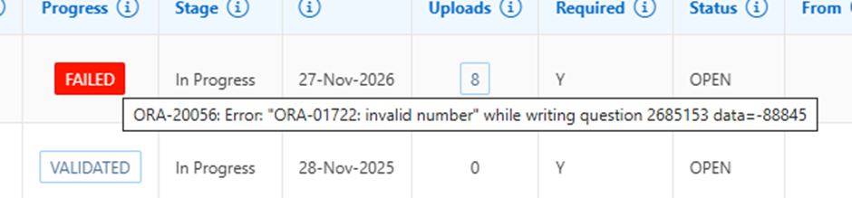

Data validation and comments
Data entered into a FRAC form are validated at source before the form can be submitted for HHS Chief Executive approval. Validation exceptions are raised when the reported activity for the reference year is compared to the previous year and fails predetermined acceptance criteria (e.g., variance percentage is high, same value both periods, null values, negative values reported, decimals reported, etc).
Reporting entities must respond to validation exceptions with relevant and meaningful comments that detail the reason/s for the variations in data reported.
Comments provided are retained within DSB’s databases and are utilised to respond to queries raised from within the Department of Health as well as the Commonwealth Government. Therefore, it is important that the comments provided clearly state the reasons for the variations. Reporting entities will be contacted by DSB seeking comments on data anomalies that appear where adequate comments are not provided.
In addition to validations applied by the ADC application, the DSB also undertake manual data quality checks to ensure the quality of the data and, where necessary, contact HHSs for explanation or amendment to data. This may include data quality, time-series validation checks raised by the AIHW where the department is required to seek further clarification and/or commentary on the data as reported.

Nil activity report
If there is no information to report on a FRAC form, a nil return is required to be submitted in ADC. When uploading a nil statement, please ensure the financial year, facility name and facility ID fields are completed. The Nil Data button on the ‘Data Entry’ screen can also be used to submit a nil statement: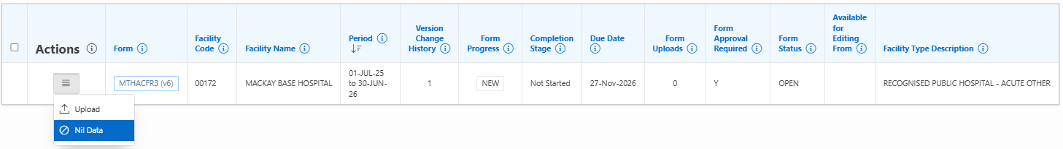

Further information

New/amended General Ledger codes
General ledger account codes for 2025-2026 were sourced from the Finance Branch and based on the S/4HANA general ledger Chart of Accounts.

Account Hierarchy
The ‘FRAC’ account code hierarchy created in S/4HANA is specifically used to support AIHW reporting requirements. As required, the Financial and Asset Accounting team provide advice as to the correct mapping for any expenditure and revenue account codes (as per the Queensland Health Chart of Accounts).
This account hierarchy is incorporated in DSS ‘FRAC’ reports within the ‘Finance T’ folder to assist with expenditure and revenue reporting where required.
The Department of Health job codes have been mapped to AIHW staffing categories in the ‘HR Payroll SAP’ folder to assist with ‘FRAC’ FTE and salaries and wages reporting.

FRAC Contacts
FRAC Contacts
Healthcare Purchasing and Funding Branch | Dominic Flynn  Senior Policy Officer  phone: 07 3708 5900  email: HHSFCU@health.qld.gov.au
Data Services Branch | Regan Molloy  Principal Data Collection Officer – Data Operations Unit  phone: 07 2100 8810  email: regan.molloy@health.qld.gov.au

Abbreviations
Abbreviation | Description
ADC | Aggregate Data Collections
AIHW | Australian Institute of Health and Welfare
DSS | Decision Support System
FRAC | Financial and Residential Activity Collection
FTE | Full-time Equivalent
HHS | Hospital and Health Service
HPFB | Healthcare Purchasing and Funding Branch
HR | Human Resources
IHACPA | Independent Health and Aged Care Pricing Authority
LHN/PHE NMDS | Local Hospital Networks/Public Health Establishments National Minimum Data Set
DSB | Data Services Branch

Top of the Document

Referred to as Local Hospital Network (LHN) nationally.
Includes non-hospital facilities e.g. community health centres, primary health care centres, nursing homes, aged care and other residential care type facilities and Multi Purpose Health Services (MPHSs)

