Procedure for handling potential
breaches of the Australian Code for
the Responsible Conduct of Research

Introduction
Where concerns are raised or identified relating to the conduct of Forensic and Scientific Services (FSS) and Pathology Queensland (PQ) research or researchers, these will be managed in accordance with the Australian Code for the Responsible Conduct of Research (the Code) and the NHMRC Guide to managing potential breaches of the Code for the Responsible Conduct of Research (the Guide).

Background
The Code describes the principles and practices of responsible conduct of research for institutions and researchers.
The Guide provides a framework for investigating and addressing potential breaches of the Code.
All FSS and PQ research must demonstrate the principles of good research practice:
- honesty and integrity
- respect for human research participants, animals and the environment
- good stewardship of public resources used to conduct research
- appropriate acknowledgement of the role of others in research
- responsible communication of research results.

Scope
This procedure applies to all FSS and PQ staff involved in the conduct, supervision or administration of research.
FSS and PQ recognise that breaches range in severity from minor to serious misconduct. The organisational response will be guided by the severity of the breach.
If a preliminary assessment identifies that the severity of the breach is minor, the matter can generally be managed at the local level under the direction of the designated officer. In all other cases, the matter will be managed by the designated officer in accordance with this procedure, including escalating or referring the matter where appropriate.

Definitions
Term | Definition
AEC | Animal ethics committee.  The FSS AEC is constituted in accordance with the Australian code for the care and use of animals for scientific purposes, 2013
Breach | Any failure/s to meet the principles and responsibilities of the Code. A breach/es can occur across a range of severity levels.
Code | The Australian Code for the Responsible Conduct of Research, NHMRC (2018).
Complaint | Dissatisfaction or concern raised about the conduct of research, research integrity or the conduct of an ethics committee.
Fabrication | A deliberately false or improbable account.
Falsification | To state untruthfully, misrepresent.
FSS | Forensic and Scientific Services
Guide | NHMRC Guide to managing potential breaches of the Code for the Responsible Conduct of Research
HREC | Human Research Ethics Committee.  A Committee constituted under the guidance of the National statement on the ethical conduct in human research to conduct the ethical and scientific review of a human research protocol.
Major breach | Serious deviation from the Code or multiple/repeated breaches, including issues that may cause patient/community harm, negatively impact on public confidence and/or departmental reputation
Minor breach | Less serious breaches of the Code that can be satisfactorily remedied at the local level.
Plagiarism | The practice of taking someone else’s work or ideas and passing them off as one’s own. Self-plagiarism occurs where authors publish their own work multiple times
Procedural fairness | A concept which provides a person a fair, reasonable and publicly accountable process in resolving disputes. This process is also called ‘natural justice’.
Research misconduct | A complaint or allegation that involves all the following:  - an alleged serious breach of the Code  - intent, deliberation, recklessness or gross and persistent negligence  - serious consequences, such as false information on the public record, or adverse effects on research participants, animals or the environment.  - Breaches of the Code that warrant formal allegation and investigation would be expected to lead to disciplinary action.  - Appendix 1 provides examples of breaches and research misconduct as outlined in the Guide

Roles and responsibilities
Roles | Responsibilities
Responsible Executive Officer (REO) | Overall and final responsibility for making decisions on responses to serious breaches. Some aspects, including decisions on minor breaches, can be delegated to a senior manager of the relevant business area.
Designated Officer (DO) | A senior manager who receives complaints about research conduct and potential breaches of the Code. The designated officer will oversee the case management and investigation and reports to the REO on serious breaches.
Assessment Officer | Conducts the preliminary investigation to assess the allegations/s and provide advice to the DO including if and how the conduct deviates from the Code and recommendations for further action.
Research Integrity Advisor (RIA) | Supports researchers and promotes responsible research practices that are compliant with the Code. Provides general advice about the complaints process, including how to make a complaint / formally raise a concern. The role of the RIA does not extend to investigation or assessment of the allegation.
FSS Human Ethics Committee (FSS HEC)  FSS Animal Ethics Committee (FSS AEC) | The co-ordinator / Chair is responsible for responding to queries or concerns regarding such matters as:  - decisions of the Committee.  - conduct of a project approved by the Committee.  Major concerns or those that cannot be resolved should be referred to the Designated Officer.
Review Officer (RO) | A senior manager responsible for conducting procedural review when required.
Appendix 2 provides a list of positions and nominated officers currently appointed to these roles.

Process for managing and investigating complaints and alleged breaches of the Code
FSS and PQ adopt the NHMRC recommended approach:
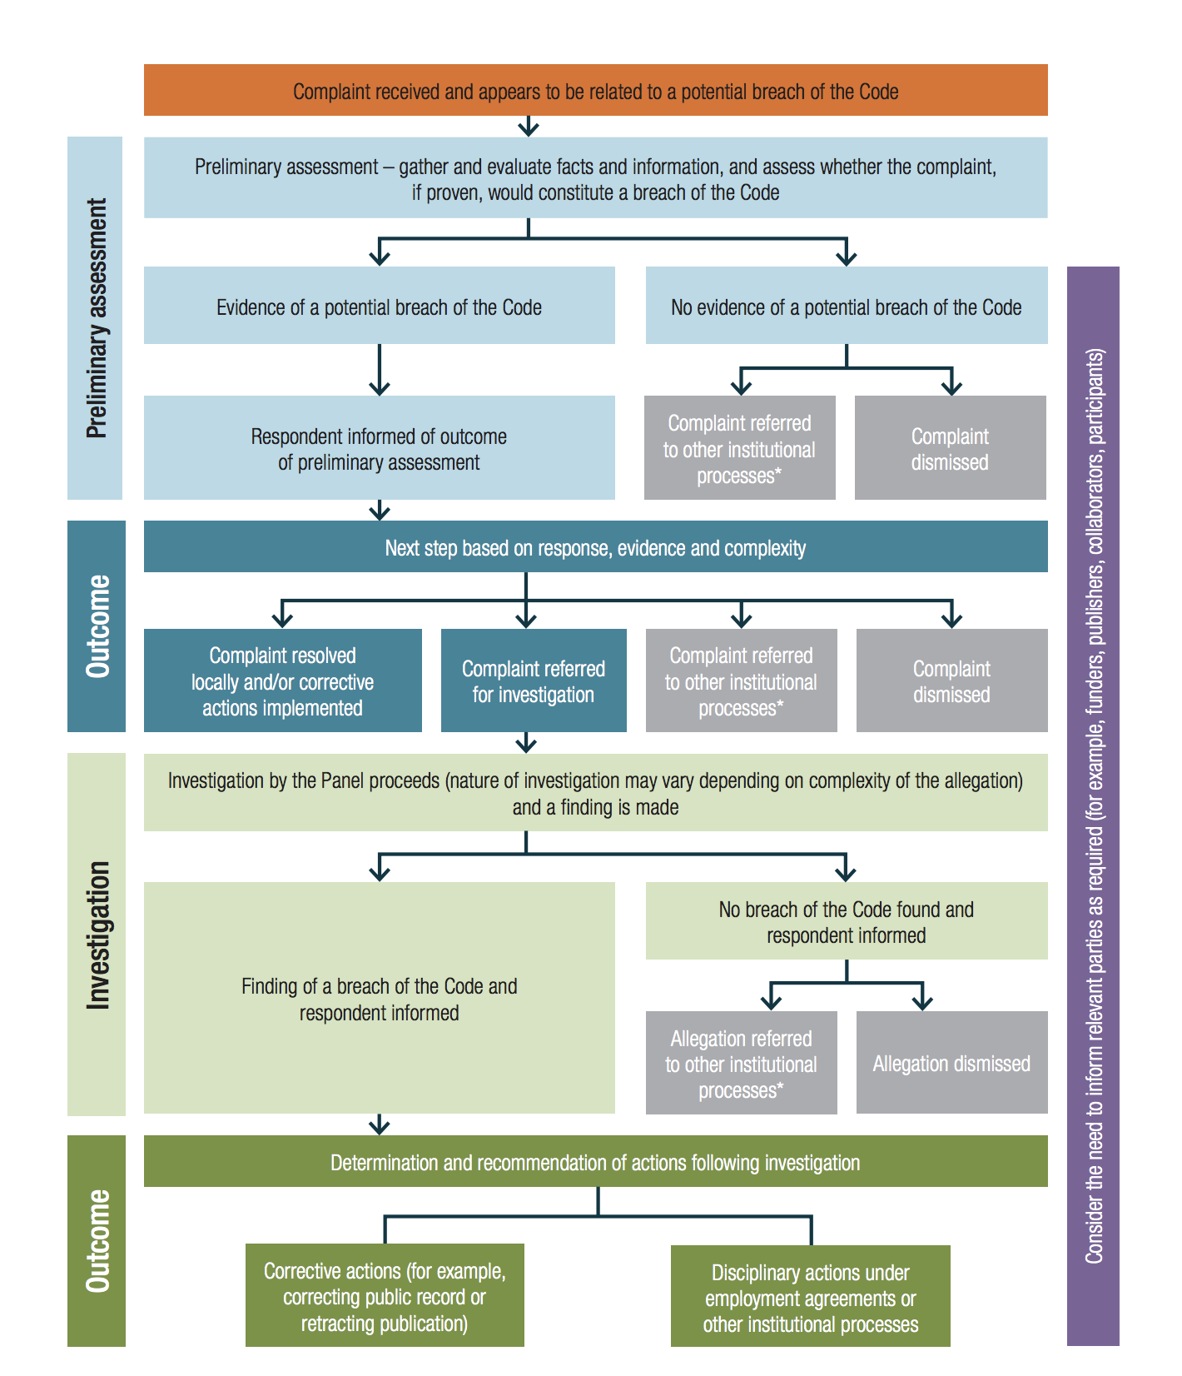
(source: Guide to Managing and Investigating potential breaches of the Australian Code for the Responsible Conduct of Research, 2018)

Lodging a complaint
Anyone who is concerned that a researcher has not acted responsibly should take action to report the issue to the Research Integrity Advisor or Designated Officer in a timely manner.

Preliminary assessment
- The assessment will be informed by the Code and the Guide and be conducted in accordance with this procedure.
- When a complaint or allegation is made, consideration will be given to whether immediate action needs to be taken, e.g. referral of allegations which are not related to research or if there is a risk of harm to humans, animals or the environment.
- Investigations / assessments in the workplace must ensure procedural fairness.
- Designated officers have the authority to secure all documents and evidence relating to the potential breach.

Internal inquiry
- A panel may be constituted to assess the allegation where a significant breach of the Code has been identified.
- The panel should be formed to provide appropriate knowledge and expertise.
- Appointed members must be free from bias or conflicts of interest and be seen to be so.
- At least one member should have experience on similar panels or relevant experience or expertise.
- The panel must provide a written record of its findings, and the reasons for these findings, to the Designated Officer and the person who is accused of breaching the Code.
- Appeals should be directed to the Review Officer in the first instance and if unresolved, to the General Manager PQ.

Independent external inquiry
- Where the consequences of the inquiry are likely to be serious, and the need to maintain public confidence in research is paramount, the Chief Executive or their delegated officer should be alerted and advised to consider establishing an independent external inquiry.
- The terms of reference for the panel will be developed in accordance with the NHMRC sample checklist contained in the Guide.
- Panel members must not be employed by the Department, have any current or recent engagement with the Department or be subject to a reasonable perception of bias.
- The composition of the panel will be determined by the General Manager PQ and will have a minimum of three representatives providing legal expertise, knowledge and expertise in a relevant field of research, but not necessarily directly in the research area of the allegation.
- The panel should be assisted by a legally qualified person acting as ‘counsel assisting’ in the preparation of the case.
- The person facing the allegation is entitled to legal representation.
- The person subject to the inquiry may have an entitlement to appeal to a higher authority.

Procedural fairness
- A person who is the subject of an allegation must be treated fairly and provided with opportunities to respond to allegation/s in writing within reasonable timeframes.
- Any panel formed to conduct an inquiry that may lead to disciplinary action must be free from bias or preconception, and panel members must conduct themselves in a manner which demonstrates this.

Possible sanctions
The process for addressing breaches of the Code must be consistent with relevant workplace agreements, policies and the law.
Possible sanctions may include but are not limited to:
- correction of public records
- disciplinary action under employment agreements and contracts
- training
- compliance plans
- corrective action plans
- letter of reprimand
- supervision
- suspension
- termination of project and/or funds.

Timeframes
Acknowledgement of receipt of the complaint must be issued in writing to the complainant within five working days.
All minor complaints should be resolved within 30 calendar days.
An update will be provided (to the applicant and person who has allegedly breached the Code) by the Assessment Officer or Designated Officer every 30 days while a complaint is unresolved.

References
          - National Health and Medical Research Council 2007 (2018 update), National statement on ethical conduct in human research, NHMRC, Canberra. Available from: https://www.nhmrc.gov.au/about-us/publications/national-statement-ethical-conduct-human-research-2007-updated-2018
          - National Health and Medical Research Council 2018, Australian code for responsible conduct of research, NHMRC, Canberra, Available from https://www.nhmrc.gov.au/about-us/publications/australian-code-responsible-conduct-research-2018
          - National Health and Medical Research Council 2012, Australian code for the care and use of animals for scientific purposes, 8th ed. NHMRC, Canberra. Available from: https://www.nhmrc.gov.au/about-us/publications/australian-code-care-and-use-animals-scientific-purposes/australian-code-care-and-use-animals-scientific-purposes-code
          - National Health and Medical Research Council 2018, Guide to Managing and Investigating Potential Breaches of the Australian Code for the Responsible Conduct of Research, 2018. Available from: https://www.nhmrc.gov.au/sites/default/files/documents/attachments/guide-managing-investigating-potential-breaches.pdf

Associated documentation
- FSS HEC terms of reference QIS 10664
- FSS AEC terms of reference QIS 10642
- Health Support Queensland research guidelines QIS 30900
- National Health and Medical Research Council 2019, Authorship: A guide supporting the Australian Code for the Responsible Conduct of Research.
- National Health and Medical Research Council 2019, Management of Data and Information in Research
- National Health and Medical Research Council 2019, Peer Review: A guide supporting the Australian Code for the Responsible Conduct of Research
- National Health and Medical Research Council 2019, Disclosing conflicts of interest and management of conflicts of interest
- National Health and Medical Research Council 2019, Supervision: A guide supporting the Australian Code for the Responsible Conduct of Research
- National Health and Medical Research Council 2019, Collaborative Research: A guide supporting the Australian Code for the Responsible Conduct of Research

Appendix 1 Examples of breaches of the Code
There are many ways in which researchers may deviate from the standards and provisions of the Code and these breaches occur on a spectrum from very minor to serious. Breaches include but are not limited to:
- disregard for responsibilities in providing peer review
- inadequate supervision or mentorship of researchers or research trainees
- failure to appropriately maintain research records, including inappropriate storage or destruction
- failure to declare and manage conflicts of interest
- conducting research without the required regulatory approval
- failure to acknowledge contributions fairly or awarding authorship where it does not meet the requirements
- not meeting the required research standards (i.e. conducting research without ethics approval or not in accordance with the ethics approval, misuse of research funds)
- fabrication, falsification or misrepresentation of results
- plagiarism
- falsification or misrepresentation to obtain funding
- intentional or reckless behaviour risking the safety of human participants, the well-being of animals or the environment
- deviations from the Code that occur through gross or persistent negligence
- wilful concealment of research misconduct by others.

Appendix 2 Designated positions responsible for handling research complaints and allegations

Role | Delegated position
Responsible Executive Officer (REO) | General Manager, PQ
Designated Officer (DO) | Executive Director, FSS  Executive Director, Research, PQ
Assessment Officer | Principal Advisor or equivalent
Research Integrity Advisor (RIA) | Local area advisors (e.g. Research and Ethics Co-ordinator, FSS; Research Governance Officer, PQ
Review Officer (RO) | Quality Advisor or equivalent
FSS Human Ethics Committee (FSS HEC) | Chair and/or co-ordinator
FSS Animal Ethics Committee (FSS AEC) | Chair

Appendix 3
FSS and PQ will design the associated processes with reference to the NHMRC sample checklists in the Guide https://www.nhmrc.gov.au/sites/default/files/documents/attachments/guide-managing-investigating-potential-breaches.pdf:
- Sample checklist for the preliminary assessment (Appendix 1 of the Guide)
- Sample checklist for the terms of reference for the Panel (Appendix 2 of the Guide)
- Sample checklist for the investigation procedure (Appendix 3 of the Guide)
- Sample checklist for reporting the findings of the investigation (Appendix 4 of the Guide)

