2023-2024 MAC Data Collection Guidelines and Business Rules
Monthly Activity Collection (MAC) 2023-2024

2023-2024 MAC Data Collection Guidelines and Business Rules - Monthly Activity Collection (MAC) 2023-2024
Published by the State of Queensland (Queensland Health), July 2023
This document is licensed under a Creative Commons Attribution 3.0 Australia licence.
To view a copy of this licence, visit creativecommons.org/licenses/by/3.0/au
© State of Queensland (Queensland Health) 2023
You are free to copy, communicate and adapt the work, as long as you attribute the State of Queensland (Queensland Health).

For more information contact:
Statistical Services Branch, Department of Health, Queensland Health, GPO Box 48, Brisbane QLD 4001, email MASmail@health.qld.gov.au.
An electronic version of this document is available at https://www.health.qld.gov.au/hsu/collections/mac
Contents
1 Overview 4
1.1 Non-admitted Patient 4
1.2 Admitted Patient and Beds Availability 4
1.3 MAC Reporting and Data Flow Diagram 5
2 Reporting to MAC 6
2.1 MAC Online and MAC Forms 6
2.2 New/Updated Versions of MAC Forms 6
2.3 Type of Activity to be Reported by Reporting Entity 6
2.4 Monthly Submission and Quarterly Reporting Timeframes for the MAC 7
2.5 Updates to Finalised Quarterly MAC Data 7
2.6 Availability of MAC Data in Decision Support System (DSS) 8
2.7 Chief Executive Officer, HHS approval 8
2.8 NIL activity report 9
2.9 Provision of estimates 9
2.10 Data Validation 9
2.11 Reporting requirements of ‘previously declared’ public health facilities 10
3 MAC Forms 11
4 Non-admitted patient activity data 16
4.1 Transition of non-admitted patient service event reporting to patient-level 16
4.2 Scope 16
4.3 How to count non-admitted services 17
4.3.1 Counting Rules – Diagram 18
5 Admitted Patient activity data 19
5.1 Scope 19
6 Beds Availability data 19
6.1 Scope 19
6.2 Reporting mandate 19
7 Clinic Mapping 20
8 Appendix A – MAC Business Rules 22

- Overview
The Monthly Activity Collection (MAC) is a collection of aggregate-level admitted patient, non-admitted patient (outpatient and emergency service) and bed availability activity data submitted monthly to the Department of Health by the various ‘reporting entities’ of the three different levels of Queensland’s public hospital system. It is managed by the Statistical Services Branch (SSB), Healthcare Purchasing and Funding Branch of Queensland Health.

  - Non-admitted Patient
The MAC non-admitted service event data was the source for all mandated Commonwealth (Australian Institute of Health and Welfare (AIHW) and the Independent Health and Aged Care Pricing Authority (IHACPA)) and State government reporting requirements in previous years, but now with the almost complete transition to patient-level reporting, to meet the ongoing mandated aggregate reporting requirement to the Non-admitted patient care aggregate NBEDS 2023-24 (NAPCA NBEDS), patient-level data collected via the Queensland Health Non-admitted Patient Data Collection (QHNAPDC) is aggregated and the source for the majority of non-admitted reporting. Offender Health Services, Pathology and Diagnostic Services continue to be reported to MAC until their transition to the QHNAPDC is possible.

  - Admitted Patient and Beds Availability
Hospital and Health Services are required to report data to the MAC to ensure that the Queensland Department of Health (DoH) to:
- to fulfil legislative requirements
- to deliver accountabilities to state and commonwealth governments and
- to monitor monthly performance and promote improvements in the safety and quality of Health Services
Under the National Healthcare Agreement, the Queensland Department of Health (DoH) is required to supply the Commonwealth’s Department of Health (CDoH) with hospital activity data on Queensland’s public health system including bed availability.

How MAC data are used
Monthly Activity Collection data are a source for the mandated reporting requirements for the Commonwealth government and the State, as well as for local management purposes.
Some examples include: | Bed availability data are provided to the Commonwealth Government and the State
 | Admitted patient separation data is available from the 4th of each month as admitted patient-level data is not available until 35 days post the end of the reference month.
 | Monthly Activity Collection data are routinely published on the Queensland Health internet and intranet sites as well as in Australian Government publications such as Report on Government Services (ROGS), Australian Hospital Statistics and the My Hospitals website.

  - MAC Reporting and Data Flow Diagram
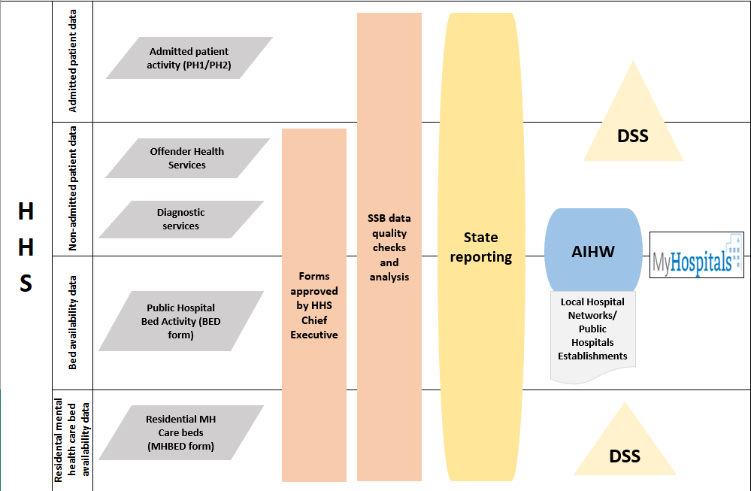

- Reporting to MAC
  - MAC Online and MAC Forms
Data are reported to SSB each month by completing relevant MAC form templates (Microsoft Excel spreadsheets). Once forms are populated, they can then be uploaded to the MAC Online application, which is a web-based application developed by SSB. Once the form has been uploaded to MAC Online, it is validated and then submitted to the SSB database. Refer to the MAC Online User Guides for instructions.

Note: The MAC form templates must not be altered in any way as they will not upload to MAC Online and therefore data cannot be submitted to SSB.
  - New/Updated Versions of MAC Forms
Monthly Activity Collection reporting requirements may change each financial year due to the mandated reporting requirements of the Commonwealth Government, or those of the State/ Departmental business areas. Reporting entities are notified as early as possible prior to the new financial year of the updated requirements through communication to HHSs, forums, this document, supporting annual change information communications and the IHACPA website.

  - Type of Activity to be Reported by Reporting Entity
The type of reporting entity, the unit and type of activity required to be reported on which MAC form is listed in this table.
Please refer to Required Forms by Facility to identify the reporting entities required to report to the MAC and the specific forms required.
  - Monthly Submission and Quarterly Reporting Timeframes for the MAC
All final (approved) versions of MAC reports must be submitted to SSB by the 14th day following the reference month (e.g., for the reference month of September, MAC reports must be submitted by 14th of October).
Where data submissions are not completed or not approved by HHS CEOs by the required due date, reporting entities will receive a reminder email from MASMAIL@health.qld.gov.au.

  - Updates to Finalised Quarterly MAC Data
In previous years, any updates to ‘finalised’ quarterly MAC data required the HHS CEO to provide a request in writing to Healthcare Purchasing and Funding Branch (HPFB). Once approved, SSB would then unlock the specific form and period to be updated by the HHS.
From 2019-20, HPFB has advised that a request from the HHS CEO is no longer required for unlocking of MAC forms for HHS update.
Forms will still be locked down each quarter by SSB, and requests for periods to be unlocked should be sent to MASMail@health.qld.gov.au stating the period and form types.
Refer to the table below for the quarterly reporting schedule:

Quarterly Reporting Schedule
Reporting Quarter | Period | Due Date | Finalisation Date
September | July | 14 August | 14 November
 | August | 14 September
 | September | 14 October
December | October | 14 November | 14 February
 | November | 14 December
 | December | 14 January
March | January | 14 February | 14 May
 | February | 14 March
 | March | 14 April
June | April | 14 May | 14 August  *Final submission due 31 August 2024
 | May | 14 June
 | June | 14 July

  - Availability of MAC Data in Decision Support System (DSS)
Monthly Activity Collection forms submitted with non-admitted activity must have an 'Approved' status for the purposes of providing activity data for Weighted Activity Unit (WAU) reporting in DSS.
An 'approved' status is provided by a HHS CEO (or their nominated delegate) ‘sign-off’ in the MAC Online application. If MAC forms do not have an ‘approved’ status (prior to SSB’s scheduled weekend processing), activity will not be reported in DSS.
This includes data in forms that may have been previously approved but then updated after the monthly deadline. If prior month forms require updating, it is recommended that sites ensure approvals can be processed within the week (and the form/s are returned to a status of ‘approved’) prior to the weekend processing cut off. If forms remain in status of ‘draft’, ‘validated’ or ‘submitted’ at the end of the week no data will appear in DSS for that month until the next weekend processing occurs. To support the management of MAC form status, HHSs are able check the status of the MAC forms in DSS in the 'MAC Forms' folder. This report is updated in line with the SSB’s weekend processing of data, otherwise for real-time status of forms, registered MAC Online users can continue to monitor them in the MAC Online application.
  - Chief Executive Officer, HHS approval
As MAC data are used to substantiate funding and purchasing allocations, Chief Executives (or their delegates) must approve MAC forms. This excludes the BED form which can only be approved by a HHS Chief Executive as per the direction of the Deputy Director-General Healthcare Purchasing and System Performance in the Memorandum of 30 May 2023.
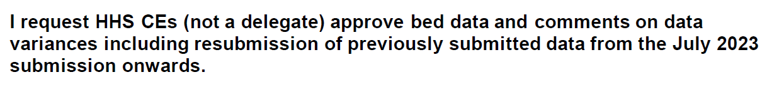
Refer to the MAC Online User Guides for a more detailed flow of MAC forms and processing statuses, and for instructions to set-up the HHS CEO/HHS CEO Delegate user access level to enable the Chief Executive (CEO) to approve the abovementioned MAC reports.
  - NIL activity report
Reporting entities that record no activity during the month are still required to submit the required MAC forms. The cells in which activity is recorded on the form must be left blank. Refer to the MAC Online User Guides for information on the supply of ‘Nil Data’.

  - Provision of estimates
Estimated data should only be provided when significant events such as major computer system failure, industrial action, and natural disasters prevent the availability of data. Any data that is an estimate must be denoted as such in the submitted data (using MAC Online global comments section – see MAC Online User Guides) and updated with actual data by the date the next reference month is due.

  - Data Validation
The MAC Online application validates each line of reported patient activity on the MAC forms. Validation exceptions are raised when the reported activity for the reference month is compared to the previous month and fails predetermined acceptance criteria (e.g.: variance percentage is high, same value both periods, null values etc).
Reporting entities must respond to validation exceptions with relevant and meaningful comments which detail the reason/s for the validation exception.
Comments provided in all MAC forms are retained within SSB databases and are utilised to respond to queries raised by various business areas in the Department of Health, the Minister and senior executive and the Commonwealth Government. Therefore, it is very important that the comments provided clearly state the reasons for the variations.
When possible, the SSB undertake a data quality process to ensure comments provided are relevant and sufficient. In the cases where comments provided do not clearly state the reasons for the variations, reporting entities will be requested to update the comment entered.
Reporting entities will be contacted by SSB seeking additional information on data anomalies that appear following time series trend analysis or any other official enquiry where additional information is required. Refer to the MAC Online User Guides for instructions.
  - Reporting requirements of ‘previously declared’ public health facilities
Previously declared public hospitals are not required to submit the following activity:
- summary level admitted patient activity (PH1 form (MTHACPH1))
- available beds and available bed alternatives (BED form (BA))
The following activity must be reported at the HHS level where indicated in the Required Forms by Facility list:
- Diagnostic services
- Offender Health Services

- MAC Forms
Non-admitted outpatient service event forms
Form Name | Type of activity | Unit of activity | Type of reporting entity
PATHOLOGY  (MTACPATH2) | Pathology service events | Service event | - Mater Hospital Brisbane (facility ID 00001)  - Mater Mothers’ Hospital (facility ID 00003)
The mappings* corresponding to the clinic types on the MTACPATH2 form are:

Diagnostic – Pathology – COVID19
CCC | 269 Diagnostic – Pathology – COVID19
QH Tier 2 Code | 30.09 COVID-19 Response Diagnostics

Diagnostic – Pathology – Other
CCC | 270 Diagnostic – Pathology – Other
QH Tier 2 Code | 30.05 Pathology (Microbiology, Haematology, Biochemistry)
Note: Provider Type is not applicable for these clinic types.
*Refer to Section 7 for more information on Clinic Mapping.
Form Name | Type of activity | Unit of activity | Type of reporting entity
DIAGNOSTIC SERVICES  (AGGDGN) | One-to-one service events for diagnostic clinic types | Service event | - Hospital – public acute  - HHS
The mappings* corresponding to the clinic types on the AGGDGN form are:

Computerised Tomography (CT)
CCC | 261 Diagnostic – Computerised Tomography (CT)
QH Tier 2 Code | 30.03 Computerised Tomography

Mammography Screening
CCC | 262 Diagnostic – Mammography Screening
QH Tier 2 Code | 30.07 Mammography Screening

General Imaging
CCC | 263 Diagnostic – General Imaging
QH Tier 2 Code | 30.01 General Imaging

Magnetic Resonance Imaging (MRI)
CCC | 264 Diagnostic – Magnetic Resonance Imaging (MRI)
QH Tier 2 Code | 30.02 Magnetic Resonance Imaging

Nuclear Medicine
CCC | 265 Diagnostic – Nuclear Medicine
QH Tier 2 Code | 30.04 Nuclear Medicine

Positron Emission Tomography
CCC | 267 Diagnostic – Positron Emission Tomography (PET)
QH Tier 2 Code | 30.06 Positron Emission Tomography

Note: Provider Type is not applicable for these clinic types.
*Refer to Section 7 for more information on Clinic Mapping.
Form Name | Type of activity | Unit of activity | Type of reporting entity
OFFENDER HEALTH SERVICES  (AGGOFH) | One-to-one service events for offender health consultation clinic types by:  - medical officer and other health professional provider types  - medical officer and other health professional provider types which are provided by or received by telehealth | Primary and Community Health (PCH) service events (HHSs only) * | HHS
The mappings** corresponding to the clinic types on the AGGOFH form are:

Offender Health Services new patient (non-ABF) and
Offender Health Services repeat patient (non-ABF)
CCC | 206 Offender Health Services
QH Tier 2 Code | 72.06 Community Health Services – Offender Health Services
Note: Applies to both Medical Officer and Other Health Professional Provider Types.
**Refer to Section 7 for more information on Clinic Mapping.
*The definition of service type classification of Offender Health is:
Health services provided to offenders/prisoners under the supervision of Queensland Corrective Services.
All community health services provided to offenders/prisoners fall into this category. Activity recorded could pertain to a range of service types across the community health service catalogue, but the client/patient is an offender/prisoner.
The counting rules for PCHSEs are as follows:
- ‘client’ is defined as the principal individual to whom therapeutic/clinical content is directed by a healthcare provider(s). Where carers and/or family members are also present during the interaction, only one PCHSE per client may be counted.
- one PCHSE is recorded for each interaction with a client, regardless of the number of healthcare providers present. Note: The reporting of multiple health care provider type activity is not required for PCHSE activity.
- services delivered via telehealth or telephone are included if they meet the definition of a PCHSE. Telehealth PCHSEs are reported by both the provider and receiver.
- one PCHSE is recorded for each client who attends a group session, regardless of the number of healthcare providers present. There is no requirement to separate these session types nor report the number of group sessions. For example, if five clients attended a group session, this would be reported as five PCHSEs.

Admitted patient, residential care and bed availability activity forms
Form Name | Type of activity | Unit of activity | Type of reporting entity
ADMITTED PATIENT ACTIVITY  (MTHACPH1) | Patient admissions, separations, and classification changes. | Separations | - Public acute hospitals  - Public psychiatric hospitals
RESIDENTIAL MENTAL HEALTH CARE  (MTHACPH2) | Consumer admissions**, separations***, and classification changes.  **admissions – whilst consumers are not ‘admitted’ to the facility, the term ‘admissions’ in relation to residential mental health care should be interpreted as ‘commencement of care’.  ***separations - whilst consumers are not ‘separated’ from the facility, the term ‘separations’ in relation to residential mental health care should be interpreted as ‘cessation of care’. | Separations | Residential Mental Health Care facilities
BED  (BED) | The number of available beds and available bed alternatives, including those contracted, and those in residential care facilities used for admitted patients. | - Beds  - Bed Alternatives | - Public acute hospitals  - Public psychiatric hospitals
MENTAL HEALTH BEDS  (MHBED) | The number of available beds* for residential mental health care consumers. | Beds | Residential Mental Health Care Facilities
RESIDENTIAL CARE  (MTHACRC) | Accommodated residents, residents no longer accommodated, non-admitted patient service events, allocation of places by bed funding type, by type of program, and number of residential beds* used for admitted patients. | - Accommodated/ No Longer Accommodated  - Beds | Residential care facilities (including nursing homes, hostels, and independent living units)
MULTI-PURPOSE HEALTH SERVICE  (MTHACMP1) | Accommodated residents, residents no longer accommodated and bed availability*. | - Accommodated/ No Longer Accommodated  - Beds | Multipurpose Health Services
* It should be noted that these beds are utilised to deliver bed-based services to non-admitted patients as these facilities are not ‘declared public hospitals’

- Non-admitted patient activity data
  - Transition of non-admitted patient service event reporting to patient-level
From 01 July 2021, the Director-General mandated that all reporting entities must submit patient-level non-admitted outpatient activity data to QHNAPDC, with the exception of some isolated clinics for which patient-level data could not be supplied. Those reporting entities are permitted to continue to report only the activity of those clinics to the MAC.
- Diagnostic Services form (all facilities) (AGGDGN)
- Offender Health Services form (individualised to each facility with the requested services) (AGGOFH)
  - Scope
Non-admitted patient activity to be reported to the MAC includes:
- outpatient service events (OSEs) provided by diagnostic clinic types
Classification of clinic services will be to the appropriate Corporate Clinic Code (CCC)/Tier 2 clinic class for reporting at the jurisdictional health authority (Queensland Health), Hospital and Health Service (Local Hospital Network (LHN)) and hospital levels.
- Primary and Community Health service events (PCHSEs) provided by Offender Health Primary and Community Health Services clinics that are not able to be classified to a CCC/Tier 2 clinic class and for which funding corresponds with cost centres designated as ‘Non-ABF Service Categories’ in the general ledger ‘Funding Split Hierarchy’. Classification of these clinic services will be to a service type identified in the Service type classifications and counting rules for reporting at the HHS level and may include activity for services that are outsourced. This activity does not fit the criteria prescribed in General list of in-scope public hospital services i.e., considered ABF in-scope services, as these would be able to be reported against the appropriate Tier 2 clinic classification.

Further, this activity must:
- be activity that is funded by the jurisdictional health authority (Queensland Health), Hospital and Health Service, or hospital and inclusive of contracted activity
- be irrespective of location (includes on-campus and off-campus), and
- be included regardless of setting or mode
Excludes:
- services provided from grants issued by the Commonwealth
- services that are the policy and funding responsibility of another state government department or the Commonwealth are not in-scope for this collection, as activity would be reported elsewhere.
- services provided by email
- services provided to patients in the admitted, emergency department or emergency service care settings.
The OSE activity that is to be reported to the MAC is ‘the total number of individual session non-admitted service events provided by an establishment’ and ‘the total number of group session non-admitted service events provided by an establishment’.
The PCHSE activity that is to be reported to the MAC for non-admitted patients is ‘the total number of ‘PCHSEs’ provided to non-admitted patients in the reference period, for each of the Primary and Community Health service types.
  - How to count non-admitted services
Service event data that are reported nationally to the AIHW must be reported in accordance with the NAPCA NBEDS.
The counting rules of this dataset state:
- All non-admitted services that meet the criteria of a non-admitted patient service event should be counted and be counted only once regardless of the number of health care providers present.
- Patients can be counted as having multiple non-admitted patient service events in one day, provided that every visit meets each of the criteria in the definition of a non-admitted patient service event.
It should be noted that this has always been the level of reporting to MAC to meet the requirements of this dataset.
    - Counting Rules – Diagram

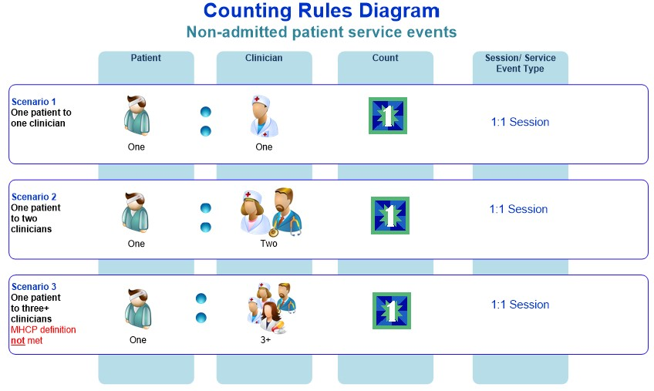

- Admitted Patient activity data
  - Scope
All public and public psychiatric hospitals must have their monthly admitted patient activity summary data reported on the PH1 form (excluding nursing homes, hostels, independent living units and Multi Purpose Health Services who are required to complete a RC or MP1 form respectively). Residential mental health care services must report this monthly activity on the PH2 form.

- Beds Availability data
Department of Health must have accurate data on the number of beds available in Queensland’s public hospitals (including contracted beds), residential care facilities (both RMHC facilities and other non-mental health facilities e.g.: aged and young disabled care facilities) and multi purpose health services. Bed availability is a key performance indicator for Department of Health as it represents a measure of service provision which is easily interpreted by the public.
  - Scope
All public acute and psychiatric hospitals must report their monthly bed availability.
  - Reporting mandate
There are Commonwealth and State requirements for reporting on the number of beds available in Queensland’s public hospitals. State reporting requirements for public hospitals also include those beds that are used for admitted patient care that may be located in other facilities such as residential care facilities (i.e., both RMHC facilities and other non-mental health facilities).
Department of Health (Commonwealth)
Under the National Healthcare Agreement, Queensland is required to supply the Commonwealth’s Department of Health with hospital activity data on Queensland’s public health system.
Australian Institute of Health and Welfare (AIHW)
As a signatory to the National Health Information Agreement, Queensland is required to provide hospital activity data to the AIHW according to agreed NMDSs. To comply with these reporting obligations, data reported to the MAC for public hospital bed availability is used to meet the Local Hospital Networks/Public hospital establishments NMDS 2023–24 (LHN/PHE NMDS).
- Clinic Mapping
Service event classifications
 | What are they? | It maps to:
Corporate Clinic Codes (CCCs) | Corporate Clinic Codes are the most granular level of classification of non-admitted patient service event activity. They have been created over the years by Queensland Health to record outpatient service event activity according to the clinical services provided. | Corporate Clinic Codes  map to  MAC clinic types
MAC Clinic Types | Monthly Activity Collection Clinic Types have been created over the years by Queensland Health to enable the reporting from CCC to earlier national reporting requirements before the introduction of IHACPA Tier 2 clinic classifications. There is not a one-to-one mapping between CCC and MAC clinic types – rather one or more CCCs can map to a MAC Clinic Type. | Monthly Activity Collection Clinic Types  map to  IHACPA Tier 2 clinic classifications
Tier 2 clinic classifications | The Tier 2 Non-Admitted Services Definitions Manual (Tier 2 Manual) defines the clinic classifications (classes) required for reporting non-admitted services.  In addition, IHACPA has published the following two documents and recommends that these along with the Tier 2 Manual and the data set specifications are used collectively.  The IHACPA Tier 2 Non-Admitted Services Compendium (Tier 2 Compendium) – this document provides details on the counting and classification rules associated with the Tier 2 non-admitted services classification as well as business rules and scenarios to assist users to consistently classify activity, and  Tier 2 Non-admitted services national index (Tier 2 Index) - this index assists users of the Tier 2 classification allocate local clinics to a Tier 2 class in a consistent manner.  Note: IHACPA publications must be referenced in conjunction with the Department of Health’s HPFB resources and this data collection guide, as in some cases local reporting rules and requirements take precedence over these national guidelines. Please contact the HPFB, Healthcare Purchasing and System Performance Division for further assistance.
    - Example of a Clinic Mapping:
Tier 2 Clinic Class

30.03
Computerised Tomography
MAC Clinic Type

Computerised Tomography (CT)
Corporate Clinic Code

261
Diagnostic –
Computerised Tomography

The mappings between the Corporate Clinic Codes, MAC Clinic Types, and IHACPA’s Tier 2 Clinic Classes for Diagnostic and Offender Health are provided below.

CCC | Corporate Clinic Code Description | Provider Type | QHNAPDC |  | MAC
 |  |  | QH Tier 2  Code | Tier 2 Clinic (Qld) Description* | MAC Form | MAC Clinic Name
206 | Offender Health Services | Medical Officer | 72.06 | Community Health Services - Offender Health Services | AGGOFH | Offender Health Services new patient (non-ABF)  Offender Health Services repeat patient (non-ABF)
206 | Offender Health Services | Other Health Professional | 72.06 | Community Health Services - Offender Health Services | AGGOFH | Offender Health Services new patient (non-ABF)  Offender Health Services repeat patient (non-ABF)
261 | Diagnostic - Computerised Tomography (CT) | N/A | 30.03 | Computerised Tomography | AGGDGN | Computerised Tomography (CT)
262 | Diagnostic - Mammography Screening | N/A | 30.07 | Mammography Screening | AGGDGN | Mammography screening
263 | Diagnostic - General Imaging | N/A | 30.01 | General Imaging | AGGDGN | General Imaging
264 | Diagnostic - Magnetic Resonance Imaging (MRI) | N/A | 30.02 | Magnetic Resonance Imaging | AGGDGN | Magnetic resonance imaging (MRI)
265 | Diagnostic - Nuclear Medicine | N/A | 30.04 | Nuclear Medicine | AGGDGN | Nuclear Medicine
267 | Diagnostic - Positron Emission Tomography (PET) | N/A | 30.06 | Positron Emission Tomography | AGGDGN | Positron Emission Tomography
269 | Diagnostic - Pathology - COVID19 | N/A | 30.09 | COVID-19 Response Diagnostics | PATH2 (Mater only) | Diagnostic - Pathology - COVID19
270 | Diagnostic - Pathology - Other | N/A | 30.05 | Pathology (Microbiology, Haematology, Biochemistry) | PATH2 (Mater only) | Diagnostic - Pathology - Other
*The Tier 2 mappings are based on the Tier 2 definitions as prescribed in the relevant data sets for statistical reporting purposes including AIHW reporting. The alternate mappings shown in the comments are managed by Healthcare Purchasing and Funding Branch (HPFB) and are used for IHACPA reporting, activity based funding (ABF) purposes and Decision Support System (DSS) reporting. These mappings differ due to the application of the relevant data set; HPFB mappings have been derived from consultation with HHSs performing the services and historical mappings, to ensure continuity of reporting and funding.

- Appendix A – MAC Business Rules
Business Rule # 1
Rule No. | 1 | Rule Type | Exclusion - Patient admitted at time of service event
Rule Name | Patient admitted at time of a reported service event
Business Rule | If the date/time of a service event is between the start and end date/time (inclusive) for the same patient’s admitted episode of care, the service event cannot be reported to MAC.
Data item | N/A | Applicable Values in Data Domain |  | N/A
Overarching Process
Service events that meet this business rule must not be reported to the MAC.

Business Rule # 2
Rule No. | 2 | Rule Type | Exclusion - Emergency Department/Service Patient
Rule Name | Patients who are attending Emergency Department/ Service at the time of the reported service event
Business Rule | If the date/time of a service event is between the start and end date/time (inclusive) for the same patient’s emergency department/service attendance, the service event cannot be reported to MAC.
Data item | N/A | Applicable Values in Data Domain |  | N/A
Overarching Process
Service events that meet this business rule must not be reported to the MAC.

Business Rule # 3
Rule No. | 3 | Rule Type | Exclusion - Service Events delivered by email
Rule Name | Exclude service events with a service delivery mode of email.
Business Rule | A service event provided by email is excluded from reporting to MAC.
Data item | Service delivery mode | Applicable Values in Data Domain |  | 4 Electronic mail
Overarching Process
Service events that meet this business rule must not be reported to the MAC.

Business Rule # 4
Rule No. | 4 | Rule Type | Exclusion - Multidisciplinary Case Conferences (MDCC)
Rule Name | Exclude service events which meet the MDCC definition.
Business Rule | A service event provided where the patient is not present and meets the definition of an MDCC is excluded from reporting to MAC.
Data item | N/A | Applicable Values in Data Domain |  | N/A
Overarching Process
Service events that meet this business rule must not be reported to the MAC. MDCCs are only reportable to the QHNAPDC. QHNAPDC MDCC service events will be aggregated for national reporting.

The term ‘reporting entity’ used in this manual refers to one of the three hierarchical levels for reporting monthly activity data i.e., either the hospital, the HHS or the State. The term ‘reporting entities’ used in this manual refer collectively to the three hierarchical levels for monthly activity reporting being the hospital, the HHS and the State.
Preliminary PH1 and PH2 (where relevant) reports are due on the 4th day of each month following the reference month. For most hospitals using HBCIS, these forms are generated and sent automatically using the ‘Report Monitor’ functionality. A final version is required on the 14th which should contain any amendments to the preliminary version.
As per the Memorandum to HHS CEs dated 13th March 2013 from Executive Director, Healthcare Purchasing, Funding and Performance Management Branch.
Includes declared public hospitals as well as private hospitals that provide public health services under contractual arrangements with Department of Health.
Information retrieved from Primary and Community Health Service Catalogue for MAC Reporting. Retrieved 01/06/2022.
Outpatient service events must meet the definition of a service event being “an interaction between one or more healthcare provider(s) with one non-admitted patient, which must contain therapeutic/clinical content and result in a dated entry in the patient's medical record” Australian Government, Australian Institute of Health and Welfare. National Health Data Dictionary. <Non-admitted patient service event (aihw.gov.au)> Retrieved 01/06/2022.
A PCHSE is defined as an interaction between a client and one or more healthcare provider(s) containing therapeutic/clinical content, resulting in a dated entry in the patient’s medical record, file or other client service record and occurring in a community setting, or under the auspices of a community health service.
Australian Government, Australian Institute of Health and Welfare. National Health Data Dictionary. <http://meteor.aihw.gov.au/content/index.phtml/itemId/679562> Retrieved 01/06/2022.
Australian Government, Australian Institute of Health and Welfare. National Health Data Dictionary. <http://meteor.aihw.gov.au/content/index.phtml/itemId/679572> Retrieved 01/06/2022.

