Click the icon below for the Microsoft Excel version of the Revenue (FR3) form

Revenue (MTHACFR3) Form
Information and form link current for 2024-2025 FRAC

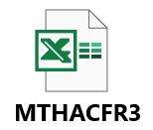
**This information sheet should be read in conjunction with the latest Financial and Residential Activity Collection (FRAC) Data Collection Guide.

Reporting Data
Revenue received by the Hospital and Health Service (HHS) and the public hospital are to be reported on this form. These data are HHS and facility level data.
- Similar Fund Hierarchies (applied for expenditure reporting) have been applied for the reporting of Revenue in the DSS ‘FRAC’ reports.
- Revenue is to be reported and must be reported in whole dollar amounts.
- No decimals permitted.
- No negative values/integers permitted. Report only positive values/integers.
- Revenue reported to the FRAC is as per the General Ledger.
- Revenue for the PHE component and the HHS component must equal the total revenue for the entire HHS for the financial year in the General Ledger.
- The default view for the ‘Revenue – FR3’ Work Board aligns to national specifications for recurrent revenue reporting to the AIHW.

DSS FRAC Work Boards
DSS FRAC Work Boards created sourcing the S4 general ledger are in the Finance T Module of DSS. i.e., Revenue – FR3.
The ‘Revenue – FR3’ Work Board consists of two views:
1. MAC FR3 Form view (Left)
2. Measures by Account FRAC view (Right)
MAC FR3 Form view | This view displays the Revenue categories required for reporting to the FRAC that are aligned for national reporting to the AIHW.  Please use the MAC FR3 Form view when exporting from DSS to the FR3 form.
Measures by Account FRAC view | This view displays the Revenue categories required for reporting to the FRAC but provides further breakdown as to the revenue sub-categories that are mapped under each main Revenue reporting category.  It is provided in the Work Board as a reference point (only).
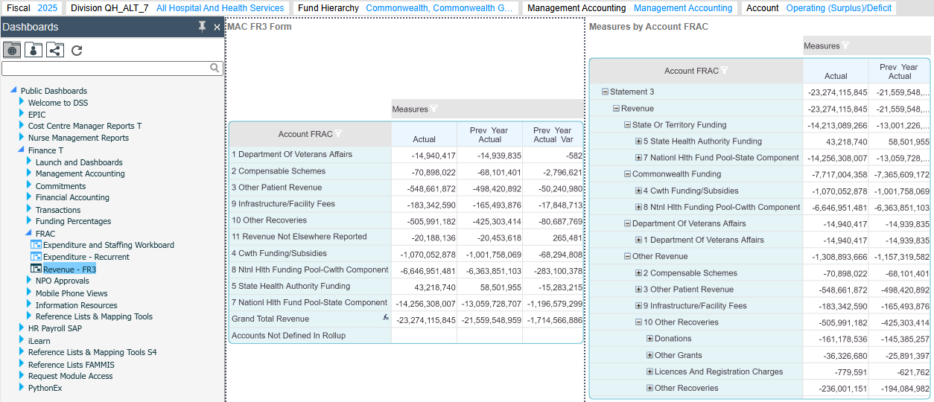
Note: The ‘Revenue – FR3’ Work Board does not contain the Revenue category ‘6 - Other state or territory funding’ as mapping of the revenue COA by Finance Branch did not determine any accounts under this category. It will appear on the FR3 forms within MAC Online for completeness and if mapping should change in future.
Note: Advice from Financial Accounting & System Operations, Finance Branch is that the revenue codes '450242, 43, 44, 46 & 48' are reported as expenditure as a nett offset to their equivalent expenditure codes (as advised in the Qld Health Chart of Accounts), as per Financial Accounting reporting standards. For FRAC, these revenue accounts are also being reported the same way to align with these standards.
© State of Queensland (Queensland Health) 2025

creativecommons.org/licenses/by/3.0/au

