Conditions Applying to an Approved Yellow Fever Vaccination Centre
In the conditions appearing below:
- ‘Appointment’ means appointment as a Yellow Fever Vaccination Centre.
- ‘Practice’ means a medical practice appointed by the relevant state/territory health authority as a Yellow Fever Vaccination Centre.
- ‘Applicant’ means the Medical Practitioner or Nurse Practitioner applying to have the Medical Practice approved as a Yellow Fever Vaccination Centre and who takes responsibility for the Practice continuing to meet World Health Organization (WHO) and Australian requirements for yellow fever vaccination.
- ‘Accredited practitioner’ means a medical practitioner or nurse practitioner who has achieved accreditation through successful completion of the Yellow Fever Vaccination Learning Module.
- The Applicant acknowledges that the Queensland Government is not liable for any costs incurred by the Practice as a result of provision of yellow fever vaccination.
- All practitioners at the Practice who administer or supervise administration of the yellow fever vaccine are accredited.
- The Practice will issue an International Certificate of Vaccination or Prophylaxis against yellow fever in line with WHO and Australian requirements.
- The vaccine administered has been approved by WHO.
- A person who has received the yellow fever vaccine must be provided with a certificate in the form specified in Annex 6 of the IHR.
- The certificate is signed by the clinician, who shall be a medical practitioner or other authorised health worker (nurse practitioner), supervising the administration of the vaccine.*
- The certificate bears the official stamp of the administering centre using the model shown below, and includes the unique Queensland identification number issued by Queensland Health and specifies the Yellow Fever Vaccination Centre was accredited in Queensland.
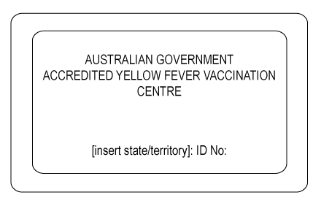

- The certificate is an individual certificate and not a collective one. Separate certificates must be issued for each child.
- The certificate is signed by the person vaccinated. A parent or guardian shall sign the certificate when the child is unable to write. If the person vaccinated is illiterate, their signature shall be their mark and the indication by another that this is the mark of the person vaccinated.
- The certificate is printed and completed in English or French. The certificate may also be completed in another language on the same document in addition to either English or French.
- The certificate must be dated correctly in the sequence of day, month and year, with the month written in letters.
- The certificate is valid for the duration of the life of the person vaccinated. The validity dates are to be recorded as the date 10 days after the vaccination date until ‘lifetime.’
- An equivalent document issued by the Armed Forces to an active member of those Forces shall be accepted in place of an international certificate if:
(a) the document embodies medical information substantially the same as that required by the international certificate; and
(b) the document contains a statement in English or French and where appropriate in another language in addition to English or French recording the nature and date of the vaccination.
- Any exemption to vaccination will consist of a dated and signed medical exemption letter on letterhead stationery from an approved Yellow Fever Vaccination Centre. The letter should clearly state that yellow fever vaccine is contraindicated on medical grounds and display the centre’s official stamp provided by the Queensland Health. Medical exemption letters should be written for the current trip only. The Medical Contraindications to Vaccination section of the International Certificate of Vaccination or Prophylaxis also needs to be completed, stamped and signed.
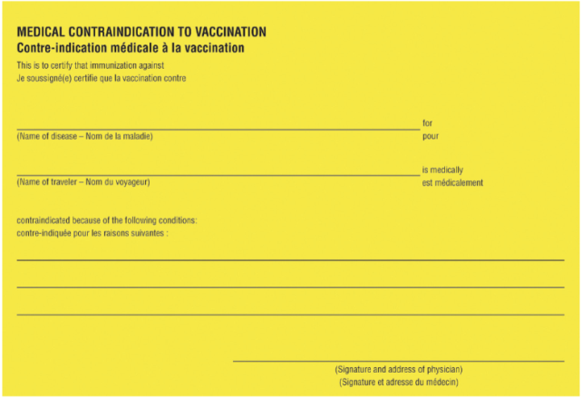

* With respect to point 3, either the medical practitioner (or other authorised health worker), or the nurse administering the vaccine under the delegation of the prescribing practitioner, may complete and sign the International Certificate of Vaccination or Prophylaxis.
- Patients referred to the practice for yellow fever vaccination will only be provided with relevant travel advice. Other non-urgent medical problems or their complications identified during the consultation will be managed only with the consent of the referring doctor or will be returned to the referring doctor for treatment.
- Changes relating to the particulars of the Practice, including any change of name or address, shall be immediately notified in writing to Queensland Health. At the discretion of Queensland Health, the appointment may be transferred to a new address without any requirement to reapply.
- If the person nominated as point of contact for yellow fever vaccination administrative requirements leaves the practice, Queensland Health must be informed of another person to take their place within 7 days.
- If the Applicant leaves the Practice, another medical practitioner or nurse practitioner must agree to take responsibility for the Practice continuing to meet clinical standards for yellow fever vaccination by completing the relevant form and forwarding to Queensland Health within 7 days.
- The Practice will notify Queensland Health if it intends to cease provision of yellow fever vaccinations or if circumstances change which will alter its capability to adhere to the requirements in this document within 7 days.
- The Practice will notify Queensland Health of all medical practitioners and nurse practitioners accredited to administer the yellow fever vaccine, and if they leave the practice, within 7 days.
- The Practice will participate in periodic surveys distributed by Queensland Health related to yellow fever vaccine provision.
- Details of the Practice, such as the name of the Practice, address and telephone number, will be included in lists of Yellow Fever Vaccination Centres on the Queensland Health website.
- The Practice will, from time to time, allow a person or persons authorised in writing by Queensland Health, to enter premises used by the Practice for the purposes of conducting yellow fever vaccinations in order to ensure compliance with all specified conditions. The Practice will provide all records relating to yellow fever vaccinations to that person or persons upon request, with an adequate timeframe given by Queensland Health to allow for the accessing of records.
- A breach of any of the above conditions by the Practice may, at the discretion of Queensland Health, may result in
- a probationary period, subject to the conditions set by Queensland Health, or
- withdrawal of the appointment.
- The appointment may be immediately withdrawn in the case of a breach of patient safety, evidence-based practice or medical ethics.
- On being notified in writing by Queensland Health that the appointment to provide yellow fever vaccinations has been withdrawn, the Practice shall cease to conduct vaccinations on the date stipulated in the notification.
- If the Medical Practice, of which I am an approved representative, is appointed as a Yellow Fever Vaccination Centre, I hereby agree to the above conditions.

……………………………………..
Name of Applicant
………………………………………
Signature
Date:……………………………

Please submit completed form to your Public Health Unit:
Queensland Health Public Health Units
(https://www.health.qld.gov.au/system-governance/contact-us/contact/public-health-units)

