2026-2027 Aggregate Data Collections (ADC)
Guidelines and Business Rules
Previously known as the Monthly Activity Collection (MAC)

2026-2027 Aggregate Data Collections Guidelines and Business Rules
Published by the State of Queensland (Queensland Heath), July 2026

This document is licensed under a Creative Commons Attribution 4.0 International licence (CC BY 4.0). To view a copy of this licence, visit creativecommons.org/licenses/by/4.0/
You are free to copy, communicate and adapt the work, as long as you attribute the State of Queensland (Queensland Health).

For more information contact:
Data Services Branch, Queensland Health, GPO Box 48, Brisbane QLD 4001,
email aggmail@health.qld.gov.au
An electronic version of this document is available at
https://www.health.qld.gov.au/hsu/collections/AggregateDataCollection
https://www.health.qld.gov.au/dsb/collections/dchome

Disclaimer
The content presented in this publication is distributed by the Queensland Government as an information source only. The State of Queensland makes no statements, representations or warranties about the accuracy, completeness of any information contained in this publication. The State of Queensland disclaims all responsibility and all liability (including without limitation for liability in negligence) for all expenses, losses, damages and costs you might incur as a result of the information.
Contents
1 Overview 1
1.1 Non-admitted patient 1
1.2 Admitted patient and bed availability 1
2 Reporting to the ADC 3
2.1 QHIDS and ADC Forms 3
2.2 New/updated versions of ADC forms 3
2.3 Type of activity to be reported by reporting entity 3
2.4 Monthly submission and quarterly reporting timeframes 3
2.5 Updates to finalised quarterly ADC data 4
2.6 Availability of aggregate data in Decision Support System (DSS) 4
2.7 Chief Executive Officer, HHS approval 5
2.8 Nil activity report 5
2.9 Provision of estimates 5
2.10 Data Validation 5
2.11 Reporting requirements of ‘previously declared’ public health facilities 6
3 Aggregate Data Collections Forms 7
4 Non-admitted patient activity aggregate data collection 11
4.1 Transition of non-admitted patient service event reporting from aggregate to patient-level 11
4.2 Scope 11
4.3 How to count non-admitted services 12
4.4 Counting Rules – Diagram 12
5 Admitted Patient activity aggregate data collection 13
5.1 Scope 13
6 Bed Availability aggregate data collection 13
6.1 Scope 13
6.2 Reporting mandate 13
7 Clinic Mapping 13
7.1.1 Example of a Clinic Mapping: 14
8 Appendix A – ADC Business Rules 16

- Overview
Aggregate Data Collections (ADC) are collections of aggregate-level admitted patient, non-admitted patient (outpatient), bed availability and public hospital establishment data submitted to the department by the various ‘reporting entities’ of the three different levels of Queensland’s public hospital system.
The ADC are managed by the Data Operations Unit (DOU), Data Services Branch (DSB), Healthcare Purchasing and Systems Performance Division of Queensland Health.
From 1st July 2026, the ADC has replaced the Monthly Activity Collection (MAC) and the MAC Online application.
  - Non-admitted patient
Aggregate non-admitted patient service event data was the source for all mandated Commonwealth and State government reporting requirements until recent years.
With the almost complete transition from aggregate-level reporting to patient-level reporting, patient-level data collected via the Queensland Health Non-admitted Patient Data Collection (QHNAPDC) is aggregated to report to the Non-admitted patient care aggregate NBEDS 2026-27 ,. Offender Health Services, Pathology (Mater only) and some Diagnostic Services continue to be reported to the ADC until their transition to reporting at the patient-level is possible.
  - Admitted patient and bed availability
Hospital and Health Services are required to report this data to the ADC to fulfil their mandated reporting requirements, to provide Queensland Health with timely data to monitor monthly performance and meet State and Commonwealth government reporting requirements under the National Healthcare Agreement.
Some examples of the use of this data include:
- Bed availability data is used within Queensland Health as well as reported to the Commonwealth Government
- Admitted patient separation data is available from the 4th of each month providing early access as admitted patient-level data is not available until 35 days following the end of the reference month.
- ADC data are routinely published on the Queensland Health internet and intranet sites as well as in Australian Government publications such as Report on Government Services (ROGS), Australian Hospital Statistics and the My Hospitals website.

ADC Reporting and Data Flow Diagram

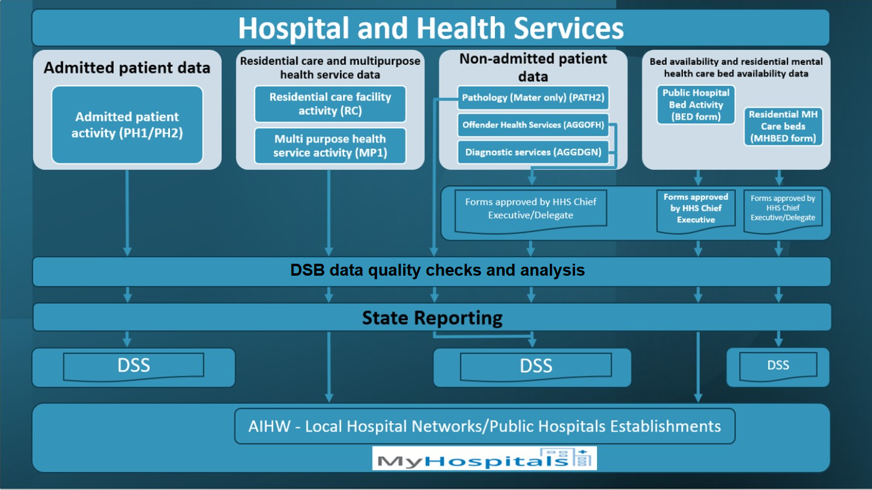
- Reporting to the ADC
  - QHIDS and ADC Forms
Data are reported to DOU each month by completing relevant ADC form templates (Microsoft Excel spreadsheets). Once forms are populated, they are then uploaded to the QHIDS application, a web-based application developed by DSB. Once the form has been uploaded to QHIDS, it is validated and then submitted to the DSB database. Refer to the QHIDS Aggregate Data Collections User Guides for instructions.
Note: Aggregate Data Collections form templates must not be altered in any way as they will not upload to the QHIDS Aggregate Data Collections application and therefore data cannot be submitted to DSB.
  - New/updated versions of ADC forms
ADC reporting requirements may change each financial year with new or updated mandated reporting requirements of the Commonwealth or State Governments, or Queensland Health’s business areas.
Reporting entities are notified of the updated requirements as early as possible prior to the new financial year through communication to HHSs, information sessions, data collection documentation, supporting annual change communications and the IHACPA website.
  - Type of activity to be reported by reporting entity
ADC form, the type and unit of activity required to be reported on each form by the type of reporting entity, is listed in this table.
Please refer to Required Forms by Facility to identify the specific forms required by each reporting entities required to report to each Aggregate Data Collections.
  - Monthly submission and quarterly reporting timeframes
All final (approved) versions of ADC reports must be submitted to DOU by the 14th day following the reference month (e.g., for the reference month of September, forms must be submitted by 14th of October).
Where data submissions are not completed or not approved by HHS CEOs by the required due date, reporting entities will receive a reminder email from aggmail@health.qld.gov.au.
  - Updates to finalised quarterly ADC data
ADC forms are locked down each quarter by DOU, and requests for periods to be unlocked should be sent to aggmail@health.qld.gov.au stating the reason, period and form type/s.
Refer to the table below for the quarterly reporting schedule:

Quarterly Reporting Schedule
Reporting Quarter | Period | Due Date | Finalisation Date
September | July | 14 August | 14 November
September | August | 14 September | 14 November
September | September | 14 October | 14 November
December | October | 14 November | 14 February
December | November | 14 December | 14 February
December | December | 14 January | 14 February
March | January | 14 February | 14 May
March | February | 14 March | 14 May
March | March | 14 April | 14 May
June | April | 14 May | 14 August  with final submission due Friday 6 August 2027
June | May | 14 June | 14 August  with final submission due Friday 6 August 2027
June | June | 14 July | 14 August  with final submission due Friday 6 August 2027
  - Availability of aggregate data in Decision Support System (DSS)
ADC forms submitted with non-admitted activity must have an 'Approved' status for the purposes of providing activity data for Weighted Activity Unit (WAU) reporting in DSS.
An 'approved' status is obtained by a HHS CEO (or their nominated delegate (not applicable to BED form approval)) ‘sign-off’ in the QHIDS ADC application. If ADC forms do not have an ‘approved’ status (prior to DOU’s scheduled weekend processing), activity will not be reported in DSS.
This includes data in forms that may have been previously approved but then updated after the monthly deadline. If prior month forms require updating, it is recommended that sites ensure approvals can be processed within the week (and the form/s are returned to a status of ‘approved’) prior to the weekend processing cut off. If forms remain in status of ‘draft’, ‘validated’ or ‘submitted’ at the end of the week no data will appear in DSS for that month until the next weekend processing occurs. To support the management of ADC form status, HHSs are able check the status of ADC forms in DSS in the 'ADC Forms' folder pending changes by DSS. This report is updated in line with the DSB’s weekend processing of data, otherwise for real-time status of forms, registered QHIDS users can continue to monitor them in the QHIDS application.
  - Chief Executive Officer, HHS approval
As ADC data are used to substantiate funding and purchasing allocations, Chief Executives (or their delegates) must approve Aggregate Data Collections forms. The approval by a Chief Executive’s delegate does not apply to the BED availability form which can only be approved by a HHS Chief Executive as per the direction of the Deputy Director-General Healthcare Purchasing and System Performance in the Memorandum of 30 May 2023.
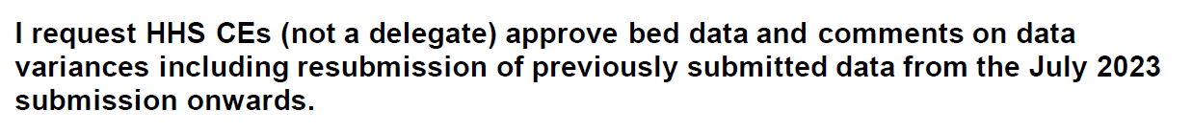
Refer to the QHIDS Aggregate Data Collections User Guides for a detailed flow of Aggregate Data Collections forms and processing statuses, and for instructions for the Primary User role to set-up the HHS CEO/HHS CEO Delegate user access level to enable the Chief Executive to approve the abovementioned ADC reports.
  - Nil activity report
Reporting entities that record no activity during the month are still required to submit the required ADC forms. The cells in which activity is recorded on the form must be left blank. Refer to the QHIDS Aggregate Data Collections User Guides for information on the supply of ‘Nil Data’.
  - Provision of estimates
Estimated data should only be provided when significant events such as major computer system failure, industrial action, and natural disasters prevent the availability of data. Any data that is an estimate must be denoted as such in the submitted data (using ADC global comments section – see QHIDS Aggregate Data Collections User Guides) and updated with actual data by the date the next reference month is due.
  - Data Validation
The QHIDS ADC application validates each cell of reported patient activity on ADC forms. Validation exceptions are raised when the reported activity for the reference month is compared to the previous month and fails predetermined acceptance criteria (e.g.: variance percentage is high, same value both periods, null values etc).
Reporting entities must respond to validation exceptions with relevant and meaningful comments which detail the reason/s for the validation exception.
Comments provided in all ADC forms are retained within DSB databases and are utilised to respond to queries raised by various business areas in the department, the Minister and senior executive and the Commonwealth Government. Therefore, it is very important that the comments provided, clearly state the reasons for the variations.
When possible, the DOU undertake a data quality process to ensure comments provided are relevant and sufficient. In the cases where comments provided do not clearly state the reasons for the variations, reporting entities will be requested to update the comment entered, which will require CE reapproval.
Reporting entities will be contacted by DOU seeking additional information on data anomalies that appear following time series trend analysis or any other official enquiry where additional information is required. Refer to the QHIDS Aggregate Data Collections User Guides for instructions.
  - Reporting requirements of ‘previously declared’ public health facilities
Previously declared public hospitals are not required to submit the following activity:
- summary level admitted patient activity (PH1 form (MTHACPH1))
- available beds and available bed alternatives (BED form)
The following activity must be reported at the HHS level:
- diagnostic services
- Offender Health Services

Refer to the Required Forms by Facility list.

- Aggregate Data Collections Forms
Non-admitted outpatient service event collection forms
Form Name | Type of activity | Unit of activity | Type of reporting entity
PATHOLOGY  (MTACPATH2) | Pathology service events | Service event | - Mater Hospital Brisbane (facility ID 00001)  - Mater Mothers’ Hospital (facility ID 00003)
The mappings* corresponding to the clinic types on the MTACPATH2 form are:

Diagnostic – Pathology – COVID19
CCC | 269 Diagnostic – Pathology – COVID19
QH Tier 2 Code | 30.09 COVID-19 Response Diagnostics

Diagnostic – Pathology – Other
CCC | 270 Diagnostic – Pathology – Other
QH Tier 2 Code | 30.05 Pathology (Microbiology, Haematology, Biochemistry)
Note: Provider Type is not applicable for these clinic types.
*Refer to Section 7 for more information on Clinic Mapping.

Form Name | Type of activity | Unit of activity | Type of reporting entity
DIAGNOSTIC SERVICES  (AGGDGN) | One-to-one service events for diagnostic clinic types | Service event | - Hospital – public acute  - HHS
The mappings* corresponding to the clinic types on the AGGDGN form are:

Computerised Tomography (CT)

CCC | 261 Diagnostic – Computerised Tomography (CT)
QH Tier 2 Code | 30.03 Computerised Tomography

Mammography Screening
CCC | 262 Diagnostic – Mammography Screening
QH Tier 2 Code | 30.07 Mammography Screening

General Imaging
CCC | 263 Diagnostic – General Imaging
QH Tier 2 Code | 30.01 General Imaging

Magnetic Resonance Imaging (MRI)
CCC | 264 Diagnostic – Magnetic Resonance Imaging (MRI)
QH Tier 2 Code | 30.02 Magnetic Resonance Imaging

Nuclear Medicine
CCC | 265 Diagnostic – Nuclear Medicine
QH Tier 2 Code | 30.04 Nuclear Medicine

Positron Emission Tomography
CCC | 267 Diagnostic – Positron Emission Tomography (PET)
QH Tier 2 Code | 30.06 Positron Emission Tomography
Note: Provider Type is not applicable for these clinic types.
*Refer to Section 7 for more information on Clinic Mapping.

Form Name | Type of activity | Unit of activity | Type of reporting entity
OFFENDER HEALTH SERVICES  (AGGOFH) | One-to-one service events for offender health consultation clinic types by:  - medical officer and other health professional provider types  - medical officer and other health professional provider types which are provided by or received by telehealth | Primary and Community Health (PCH) service events (HHSs only) * | - HHS
The mappings** corresponding to the clinic types on the AGGOFH form are:

Offender Health Services new patient (non-ABF) and
Offender Health Services repeat patient (non-ABF)
CCC | 206 Offender Health Services
QH Tier 2 Code | 72.06 Community Health Services – Offender Health Services
Note: Applies to both Medical Officer and Other Health Professional Provider Types.
**Refer to Section 7 for more information on Clinic Mapping.

*The definition of service type classification of Offender Health is:
Health services provided to offenders/prisoners under the supervision of Queensland Corrective Services.
All community health services provided to offenders/prisoners fall into this category. Activity recorded could pertain to a range of service types across the community health service catalogue, but the client/patient is an offender/prisoner.
The counting rules for PCHSEs are as follows:
- ‘client’ is defined as the principal individual to whom therapeutic/clinical content is directed by a healthcare provider(s). Where carers and/or family members are also present during the interaction, only one PCHSE per client may be counted.
- one PCHSE is recorded for each interaction with a client, regardless of the number of healthcare providers present. Note: The reporting of multiple health care provider type activity is not required for PCHSE activity.
- services delivered via telehealth or telephone are included if they meet the definition of a PCHSE. Telehealth PCHSEs are reported by both the provider and receiver.
- one PCHSE is recorded for each client who attends a group session, regardless of the number of healthcare providers present. There is no requirement to separate these session types nor report the number of group sessions. For example, if five clients attended a group session, this would be reported as five PCHSEs.

Admitted patient, residential care and bed availability activity collection forms
Form Name | Type of activity | Unit of activity | Type of reporting entity
ADMITTED PATIENT ACTIVITY  (MTHACPH1) | Patient admissions, separations, and classification changes. | Separations | - Public acute hospitals  - Public psychiatric hospitals
RESIDENTIAL MENTAL HEALTH CARE  (MTHACPH2) | Consumer admissions**, separations***, and classification changes.  **admissions – whilst consumers are not ‘admitted’ to the facility, the term ‘admissions’ in relation to residential mental health care should be interpreted as ‘commencement of care’.  ***separations - whilst consumers are not ‘separated’ from the facility, the term ‘separations’ in relation to residential mental health care should be interpreted as ‘cessation of care’. | Separations | Residential Mental Health Care facilities
BED  (BED) | The number of available beds and available bed alternatives, including those contracted, and those in residential care facilities used for admitted patients. | - Beds  - Bed Alternatives | - Public acute hospitals  - Public psychiatric hospitals
MENTAL HEALTH BEDS  (MHBED) | The number of available beds* for residential mental health care consumers. | Beds | Residential Mental Health Care Facilities
RESIDENTIAL CARE  (MTHACRC) | Accommodated residents, residents no longer accommodated, non-admitted patient service events, allocation of places by bed funding type, by type of program, and number of residential beds* used for admitted patients. | - Accommodated/ No Longer Accommodated  - Beds | Residential care facilities (including nursing homes, hostels, and independent living units)
MULTI-PURPOSE HEALTH SERVICE  (MTHACMP1) | Accommodated residents, residents no longer accommodated and bed availability*. | - Accommodated/ No Longer Accommodated  - Beds | Multipurpose Health Services
* It should be noted that these beds are utilised to deliver bed-based services to non-admitted patients as these facilities are not ‘declared public hospitals’

- Non-admitted patient activity aggregate data collection
  - Transition of non-admitted patient service event reporting from aggregate to patient-level
From 01 July 2021, the Director-General mandated that all reporting entities must submit patient-level non-admitted outpatient activity data to QHNAPDC. For that reporting year, there were some isolated exceptions to this direction where patient-level data could not be supplied, including the activity of the following clinics. The activity of these clinics is still reported, either all or in part, at the aggregate-level to Aggregate Data Collections.
- Diagnostic Services form (all facilities) (AGGDGN)
- Pathology (Mater only) (MTACPATH2)
- Offender Health Services form (individualised to each facility with the requested services) (AGGOFH)
  - Scope
Non-admitted patient activity to be reported to the ADC includes:
- outpatient service events (OSEs) provided by diagnostic clinic types
Classification of clinic services will be to the appropriate Corporate Clinic Code (CCC)/Tier 2 clinic class for reporting at the jurisdictional health authority (Queensland Health), Hospital and Health Service (Local Hospital Network (LHN)) and hospital levels.
- Primary and Community Health service events (PCHSEs) provided by Offender Health Primary and Community Health Services clinics that are not able to be classified to a CCC/Tier 2 clinic class and for which funding corresponds with cost centres designated as ‘Non-ABF Service Categories’ in the general ledger ‘Funding Split Hierarchy’. Classification of these clinic services will be to a service type identified in the Service type classifications and counting rules for reporting at the HHS level and may include activity for services that are outsourced. This activity does not fit the criteria prescribed in General list of in-scope public hospital services i.e., considered ABF in-scope services, as these would be able to be reported against the appropriate Tier 2 clinic classification.
Further, this activity must:
- be activity that is funded by the jurisdictional health authority (Queensland Health), Hospital and Health Service, or hospital and inclusive of contracted activity
- be irrespective of location (includes on-campus and off-campus), and
- be included regardless of setting or mode
Excludes:
- services provided from grants issued by the Commonwealth
- services that are the policy and funding responsibility of another state government department or the Commonwealth are not in-scope for this collection, as activity would be reported elsewhere.
- services provided by email
- services provided to patients in the admitted, emergency department or emergency service care settings.
The OSE activity that is to be reported to Aggregate Data Collections is ‘the total number of individual session non-admitted service events provided by an establishment’ and ‘the total number of group session non-admitted service events provided by an establishment’.
The PCHSE activity that is to be reported to Aggregate Data Collections for non-admitted patients is ‘the total number of ‘PCHSEs’ provided to non-admitted patients in the reference period, for each of the Primary and Community Health service types.
  - How to count non-admitted services
Service event data that are reported nationally to the AIHW must be reported in accordance with the NAPCA NBEDS.
The counting rules of this dataset state:
- All non-admitted services that meet the criteria of a non-admitted patient service event should be counted and be counted only once regardless of the number of health care providers present.
- Patients can be counted as having multiple non-admitted patient service events in one day, provided that every visit meets each of the criteria in the definition of a non-admitted patient service event.
It should be noted that this has always been the level of reporting to Aggregate Data Collections (previouly Monthly Activity Collection (MAC) to meet the requirements of this dataset.
  - Counting Rules – Diagram
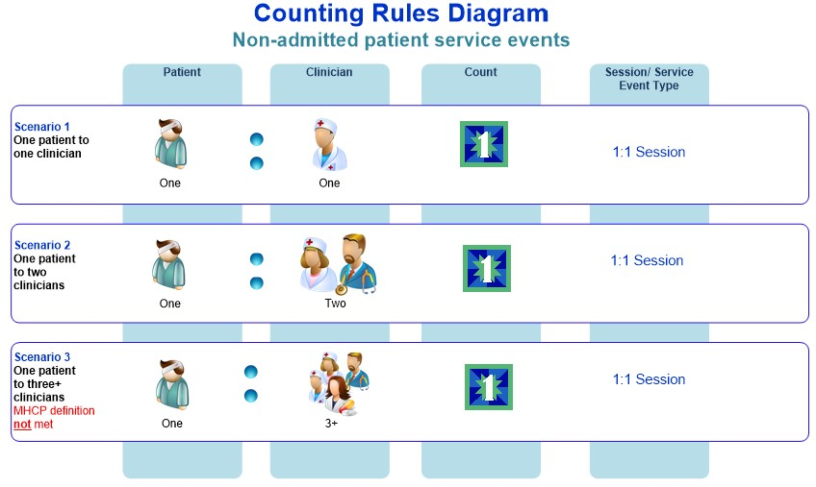
- Admitted Patient activity aggregate data collection
  - Scope
All public and public psychiatric hospitals must have their monthly admitted patient activity summary data reported on the PH1 form (excluding nursing homes, hostels, independent living units and Multi Purpose Health Services who are required to complete a RC or MP1 form respectively). Residential mental health care services must report this monthly activity on the PH2 form.
- Bed Availability aggregate data collection
Queensland Health must have accurate data on the number of beds available in Queensland’s public hospitals (including contracted beds), residential care facilities (both RMHC facilities and other non-mental health facilities e.g.: aged and young disabled care facilities) and multi purpose health services. Bed availability is a key performance indicator for the department as it represents a measure of service provision which is easily interpreted by the public.
  - Scope
All public acute and psychiatric hospitals must report their monthly bed availability.
  - Reporting mandate
There are Commonwealth and State requirements for reporting on the number of beds available in Queensland’s public hospitals. State reporting requirements for public hospitals also include those beds that are used for admitted patient care that may be located in other facilities such as residential care facilities (i.e., both RMHC facilities and other non-mental health facilities).
Department of Health (Commonwealth)
Under the National Healthcare Agreement, Queensland is required to supply the Commonwealth’s Department of Health with hospital activity data on Queensland’s public health system.
Australian Institute of Health and Welfare (AIHW)
As a signatory to the National Health Information Agreement, Queensland is required to provide hospital activity data to the AIHW according to agreed NMDSs. To comply with these reporting obligations, data reported to Aggregate Data Collections for public hospital bed availability is used to meet the Local Hospital Networks/Public hospital establishments NMDS 2026–27 (LHN/PHE NMDS).
- Clinic Mapping
Service event classifications
 | What are they? | It maps to:
Corporate Clinic Codes (CCCs) | Corporate Clinic Codes are the most granular level of classification of non-admitted patient service event activity. They have been created over the years by Queensland Health to record outpatient service event activity according to the clinical services provided. | Corporate Clinic Codes  map to  Aggregate Data Collections clinic types
Aggregate Data Collections Clinic Types | Aggregate Data Collections Clinic Types have been created over the years by Queensland Health to enable the reporting from CCC to earlier national reporting requirements before the introduction of IHACPA Tier 2 clinic classifications. There is not a one-to-one mapping between CCC and Aggregate Data Collections clinic types – rather one or more CCCs can map to an Aggregate Data Collections Clinic Type. | Aggregate Data Collections Clinic Types  map to  IHACPA Tier 2 clinic classifications
Tier 2 clinic classifications | The Tier 2 Non-Admitted Services Definitions Manual (Tier 2 Manual) defines the clinic classifications (classes) required for reporting non-admitted services.  In addition, IHACPA has published the following two documents and recommends that these along with the Tier 2 Manual and the data set specifications are used collectively.  The IHACPA Tier 2 Non-Admitted Services Compendium (Tier 2 Compendium) – this document provides details on the counting and classification rules associated with the Tier 2 non-admitted services classification as well as business rules and scenarios to assist users to consistently classify activity, and  Tier 2 Non-admitted services national index (Tier 2 Index) - this index assists users of the Tier 2 classification allocate local clinics to a Tier 2 class in a consistent manner. Note: IHACPA publications must be referenced in conjunction with the department’s HPFB resources and this data collection guide, as in some cases local reporting rules and requirements take precedence over these national guidelines. Please contact the HPFB, Healthcare Purchasing and System Performance Division for further assistance.
    - Example of a Clinic Mapping:
ADC Clinic Type
Computerised Tomography (CT)
Tier 2 Clinic Class
30.03
Computerised Tomography
Corporate Clinic Code
261
Diagnostic –
Computerised Tomography

The mappings between the Corporate Clinic Codes, Aggregate Data Collections Clinic Types, and IHACPA’s Tier 2 Clinic Classes for Diagnostic and Offender Health are provided below.
CCC | Corporate Clinic Code Description | Provider Type | QHNAPDC |  | Aggregate Data Collections
CCC | Corporate Clinic Code Description | Provider Type | QH Tier 2  Code | Tier 2 Clinic (Qld) Description* | Aggregate Data Collections Form | Aggregate Data Collections Clinic Name
206 | Offender Health Services | Medical Officer | 72.06 | Community Health Services - Offender Health Services | AGGOFH | Offender Health Services new patient (non-ABF)  Offender Health Services repeat patient (non-ABF)
206 | Offender Health Services | Other Health Professional | 72.06 | Community Health Services - Offender Health Services | AGGOFH | Offender Health Services new patient (non-ABF)  Offender Health Services repeat patient (non-ABF)
261 | Diagnostic - Computerised Tomography (CT) | N/A | 30.03 | Computerised Tomography | AGGDGN | Computerised Tomography (CT)
262 | Diagnostic - Mammography Screening | N/A | 30.07 | Mammography Screening | AGGDGN | Mammography screening
263 | Diagnostic - General Imaging | N/A | 30.01 | General Imaging | AGGDGN | General Imaging
264 | Diagnostic - Magnetic Resonance Imaging (MRI) | N/A | 30.02 | Magnetic Resonance Imaging | AGGDGN | Magnetic resonance imaging (MRI)
265 | Diagnostic - Nuclear Medicine | N/A | 30.04 | Nuclear Medicine | AGGDGN | Nuclear Medicine
267 | Diagnostic - Positron Emission Tomography (PET) | N/A | 30.06 | Positron Emission Tomography | AGGDGN | Positron Emission Tomography
269 | Diagnostic - Pathology - COVID19 | N/A | 30.09 | COVID-19 Response Diagnostics | PATH2 (Mater only) | Diagnostic - Pathology - COVID19
270 | Diagnostic - Pathology - Other | N/A | 30.05 | Pathology (Microbiology, Haematology, Biochemistry) | PATH2 (Mater only) | Diagnostic - Pathology - Other
*The Tier 2 mappings are based on the Tier 2 definitions as prescribed in the relevant data sets for statistical reporting purposes including AIHW reporting. The alternate mappings shown in the comments are managed by Healthcare Purchasing and Funding Branch (HPFB) and are used for IHACPA reporting, activity based funding (ABF) purposes and Decision Support System (DSS) reporting. These mappings differ due to the application of the relevant data set; HPFB mappings have been derived from consultation with HHSs performing the services and historical mappings, to ensure continuity of reporting and funding.

- Appendix A – ADC Business Rules
Rule No. | Rule Type | Business Rule | Data Item | Applicable Values in Data Domain
1 | Exclusion - Patient admitted at time of service event | If the date/time of a service event is between the start and end date/time (inclusive) for the same patient’s admitted episode of care, the service event cannot be reported to Aggregate Data Collections. | N/A | N/A
2 | Exclusion - Emergency Department/Service Patient | If the date/time of a service event is between the start and end date/time (inclusive) for the same patient’s emergency department/service attendance, the service event cannot be reported to Aggregate Data Collections. | N/A | N/A
3 | Exclusion - Service Events delivered by email | A service event provided by email is excluded from reporting to Aggregate Data Collections. | Service delivery mode | 4 Electronic mail
4 | Exclusion - Multidisciplinary Case Conferences (MDCC) | A service event provided where the patient is not present and meets the definition of an MDCC is excluded from reporting to Aggregate Data Collections. MDCCs are only reportable to the QHNAPDC. QHNAPDC MDCC service events will be aggregated for national reporting. | N/A | N/A

The term ‘reporting entity’ used in this manual refers to one of the three hierarchical levels for reporting monthly activity data i.e., either hospital, the HHS or the State. The term ‘reporting entities’ used in this manual refer collectively to the three hierarchical levels for monthly activity reporting being the hospital, the HHS and the State.
Preliminary PH1 and PH2 (where relevant) reports are due on the 4th day of each month following the reference month. For most hospitals using HBCIS, these forms are generated and sent automatically using the ‘Report Monitor’ functionality. A final version is required on the 14th which should contain any amendments to the preliminary version.
As per the Memorandum to HHS CEs dated 13th March 2013 from Executive Director, Healthcare Purchasing, Funding and Performance Management Branch.
Includes declared public hospitals as well as private hospitals that provide public health services under contractual arrangements with the department.
Information retrieved from Primary and Community Health Service Catalogue for MAC Reporting. Retrieved 01/06/2022.
Outpatient service events must meet the definition of a service event being “an interaction between one or more healthcare provider(s) with one non-admitted patient, which must contain therapeutic/clinical content and result in a dated entry in the patient's medical record”. Australian Government, Australian Institute of Health and Welfare. National Health Data Dictionary. <Non-admitted patient service event (aihw.gov.au)> Retrieved 01/06/2022.
A PCHSE is defined as an interaction between a client and one or more healthcare provider(s) containing therapeutic/clinical content, resulting in a dated entry in the patient’s medical record, file or other client service record and occurring in a community setting, or under the auspices of a community health service.
Australian Government, Australian Institute of Health and Welfare. National Health Data Dictionary. <http://meteor.aihw.gov.au/content/index.phtml/itemId/679562> Retrieved 01/06/2022.
Australian Government, Australian Institute of Health and Welfare. National Health Data Dictionary. <http://meteor.aihw.gov.au/content/index.phtml/itemId/679572> Retrieved 01/06/2022.

