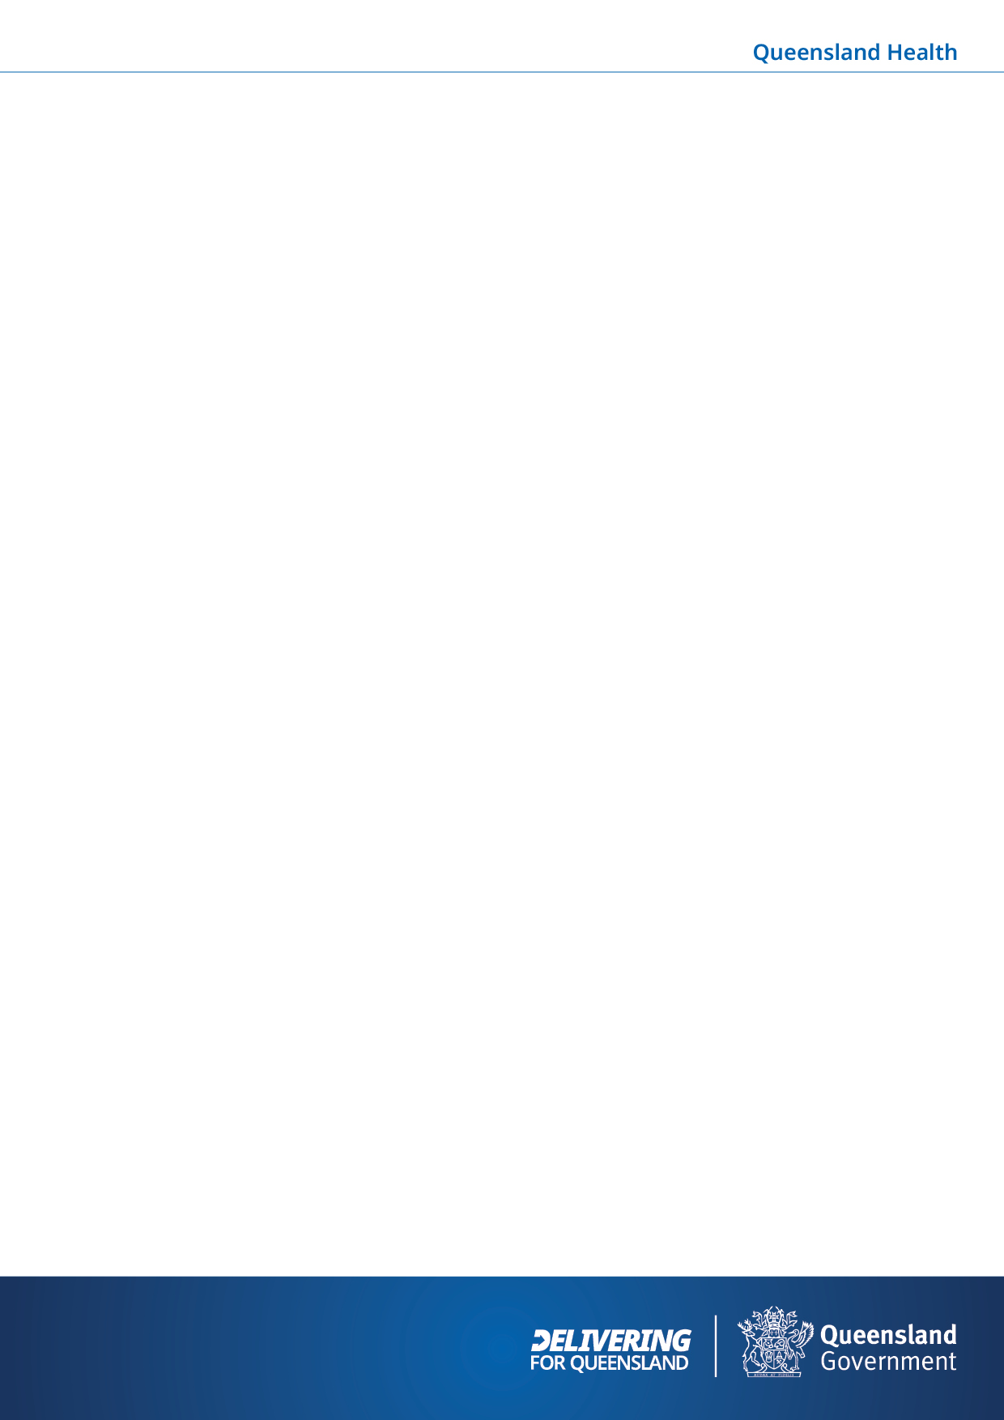
An application under the Public Health Act 2005 generally is not required where researchers are able to obtain participant consent to use the personal or identifying information for a clearly specified research study, if the Data Custodian is satisfied that the consent form provides enough information to the participants for informed consent.
Request to access data via consent
Data Services Branch DSB ID:
This request form was produced by the Data Services Branch for consent-based research requests for data and linkage from the Data Services Branch. For more information about consent requests and the Data Services Branch, see https://www.health.qld.gov.au/dsb/consent.
Please note:
- The Data Services Branch can only release data for consenting participants aged 18 years or over,
- Where multiple datasets are to be linked by the Data Services Branch, copies of Data Custodian approval for each relevant dataset must be provided to the Data Services Branch by the researcher before data can be released. Approval may involve a signature on this form, an email or other written approval from the appropriate Data Custodian,
- Other Data Custodians may choose to sign this form. Repeat the signature block if more than one signature is required,
- Other Queensland Data Custodians may choose not to approve release of their data based on consent and recommend a different approval process,
- Appropriate ethics approval/s must be attached, and data is released for analysis for the duration of ethics approval only.
What data items are available from DSB?
Data Collection* | Link to Commonly Requested Data Items** | Collection Manual
Queensland Hospital Admitted Patient Data Collection (QHAPDC) | List of QHAPDC data items | QHAPDC Manual
Queensland Health non-Admitted Patient Data Collection (QHNAPDC) | List of QHNAPDC data items | QHNAPDC Manual
Emergency Data Collection (EDC) | List of EDC data items | N/A
Perinatal Data Collection (PDC) | List of PDC data items | PDC Manual
Deaths | List of Deaths data items | N/A
Master Linkage File | Check the available linked data in the Master Linkage File | N/A
* See the Commonly Requested Data Items for a list of DSB and non-DSB data collections.
**This is a subset of available data items based on the most commonly requested data. For a complete listing of all data items, please refer to the collection manual.

The purpose of this form is to ensure that the Data Custodian and the Data Services Branch Client Services Team have the correct details of your request. Please complete this form and email back to DLQ@health.qld.gov.au.
Client information
Title and Name
Name of Institution
Position Title
Address
Telephone |  | Email
Please list the names of all researchers or persons who will view/access the data (add rows as required). All persons listed on this application form must complete a Conditions of Disclosure form prior to the release of the requested data.
Title and Name | Position Title | Name of Institution

Is data linkage required? ☐ Yes ☐ No
Documentation
Consent forms | ☐ Attached
Information sheet | ☐ Attached
HREC approval | HREC approval: ☐ Attached
HREC approval | HREC approval number:
HREC approval | HREC valid to: Click or tap to enter a date. OR Ongoing – indicate the date when the next annual report is due: Click or tap to enter a date.

Data request
Study title
Format of consent | ☐ Signed hardcopy ☐ Electronic consent  Note: A sample of signed consent forms, selected by DSB, must be provided prior to the provision of data.
Data collections | Which data collections do you need information from?
Scope of request | Which records are being requested from these data collections? (e.g. For the consented cohort, all admissions at public and private hospitals in Queensland and all related death records between 1 July 2012 and 31 December 2017)
Patient identifiers | Do you need to provide any data (such as a list of patients) to the Data Services Branch for this request? If so, which data items/identifiers from that cohort will be provided to DSB to enable linkage with the requested data collections?
Date range of request | What are the earliest and latest dates of data being requested? (e.g. 1 July 2012 – 31 December 2017).  For linkage requests, please note the time frames available in the Master Linkage File. Please confine your request to the available MLF date ranges.
Data security | Where will the data be stored and how will security be maintained?
Data flow | If DSB is to exchange data with other data custodians for linkage purposes, describe the flow of data. (e.g. Who is giving the information to you (including the name of the relevant person/s giving the information and to whom the information is given))
Data items linked to the cohort that are requested from [COLLECTION] | Data items include:
The Data Custodian for each data collection must approve the request before data can be released.

Data custodian authorisation
(Repeat as necessary)
I have considered this application and have seen all the relevant documents that are required for this project. The Department is:
☐ Able to confirm that the data services indicated will be provided within the present resources
☐ Unable to provide data services indicated on the following grounds:
The custodian has supplied these data for an approved research request but makes no warranty as to the fitness of the data, nor of the proposed methods, for the purpose for which the data has been provided and do not necessarily represent those of Queensland Health.
Repository Name
Data Custodian Name
Position
Unit
Hospital / Facility
Signature |  | Date

