[enter project title]
Construction BIM Execution Plan

[enter project title] - Construction BIM Execution Plan
Published by the State of Queensland (Queensland Health), October 2022
This document is licensed under a Creative Commons Attribution 3.0 Australia licence.
To view a copy of this licence, visit creativecommons.org/licenses/by/3.0/au
© State of Queensland (Queensland Health) 2022
You are free to copy, communicate and adapt the work, as long as you attribute the State of Queensland (Queensland Health).

For more information contact:
Health Capital Division, Department of Health, Queensland Health, GPO Box 48, Brisbane QLD 4001, email HCDCorro@health.qld.gov.au, phone (07) 3328 9310.
An electronic version of this document is available at https://www.health.qld.gov.au/system-governance/policies-standards/doh-policy

Queensland Health disclaimer
To the best of Queensland Health’s knowledge, the content of this document was correct at the time of publishing. Readers are responsible for implementing the requirements of this document appropriately to the circumstances and for interpreting any requirements, including those referenced in documents external to this document. Queensland Health accepts no responsibility and disclaims all liability for all expenses, losses (including direct and indirect loss), damages and costs incurred as a result of decisions or actions taken as a result of any data, information, statement or advice, expressed or implied, contained within, including where incorporated by reference. The inclusion in this document of information and material provided by third parties does not necessarily constitute an endorsement by Queensland Health of any third party or its products and services.

Project summary
HHS | [refer to PIR Section 4.1]
Facility Name | [refer to PIR Section 4.1]
Project Address/location | [refer to PIR Section 4.1]

Document control
Prepared by | [refer to PIR Section 4.1– BIM Manager]
Title | [refer to PIR Section 4.1– BIM Manager]
Company | [refer to PIR Section 4.1– BIM Manager]
Contact Details | [refer to PIR Section 4.1– BIM Manager]

Version history
Version no. | Date | Changed by | Nature of amendment
0.1 |  |  | Initial draft
0.2 |  |  | minor revision
1.0 |  |  | major revision

Contents
Terms 5
Acronyms 8
1 Purpose of this document 10
1.1 Document structure 11
2 Introduction 12
3 Overview 13
3.1 BIM Execution plan overview 13
3.2 Project summary/description 13
3.3 Reference documents 13
4 Commercial 15
4.1 Procurement strategy 15
4.2 Project schedule 15
4.3 Amendments to PIRs 15
4.4 Non-required uses of BIM (delivery team uses) 16
4.5 Delivery team 17
5 Management 18
5.1 Project location and setout 18
5.2 BIM coordination meetings 18
5.3 User group and stakeholder communication processes 19
5.4 Existing conditions modelling 19
5.5 Design modelling 19
5.6 Construction delivery 19
5.7 Commissioning and handover 29
6 Technical 31
6.1 Software selection 31
6.2 Project common data environment 32
6.3 IFC 33
6.4 Data standards 35
6.5 AIRs 37
6.6 2 Documentation 46
6.7 Schedules 46
6.8 Room data sheets 46
6.9 Operation and maintenance manuals 47
6.10 Federated model and coordination 47
6.11 Quality assurance and control 48
7 Appendices 49
7.1 Appendix A – BIM manager 49
7.2 Appendix B – QS requirements or model content plan 50

Terms
Term | Definition
Appointed Party | A provider of information for the project, including services and typically has a lead party such as an Architect or Managing Contractor
Asset Information Model (AIM) | Information model relating to the operational stage. As per ISO19650
Asset Information Requirements (AIR) | Information requirements in relation to the operation of the asset. As per ISO19650
BIM Execution Plan (BEP) | A detailed plan, created from the Queensland Health BEP Template, that documents the use of BIM on a project. It outlines who is responsible for what in the BIM process, when in the process they are responsible for it, and how they will execute Queensland Health requirements as specified in the Project Information Requirements (PIR) and Capital Infrastructure Requirements (CIR)
BEP Template | The standard Queensland Health Building Information Modelling (BIM) Execution Plan Template to be used by Delivery Teams. Refers to Design BEP (DBEP) and Construction BEP (CBEP)
Building Information Modelling (BIM) | The use of a shared digital representation of a built asset to facilitate design, construction and operation processes to form a reliable basis for decisions
Building Information Models (BIM/s) | Means all models that any contributing party (or its sub-contractors) is required to produce and deliver in accordance with the BEP, PIR and CIR
BIM Manager | A Delivery Team provided resource to manage the BIM and asset information creation processes on the project
Delivery Team | A collection of Appointed Parties contributing to capital works project – the composition of which may change according to the project requirements and schedule, but typically comprises design consultants, Contractor and sub-Contractors, as per ISO 19650. For the purposes of this document, the Delivery Team excludes Queensland Health and its internal Project Managers as its representatives
Exchange Information Requirements (EIR) | Queensland Health requirements to enable the exchange of information from the (Project Information Model) PIM to the AIM. In this instance, the EIR is combined with the PIR to reduce the number of documents to be reviewed by the Delivery Team
Federated Model | An assembly of discipline/trade BIM/s combined for uses such as coordination, collaboration, and exchange with the Appointing Party
Key Decision | A business decision that Queensland Health values which can be made using information created by the Delivery Team
Level of Development (LOD) | The degree to which the element’s geometry and attached information have been progressed and the degree to which Delivery Team members may rely on the information when using the model. Queensland Health doesn’t specify the LOD requirements per stage, however, if the Delivery Team wishes to use LOD, the 2021 US BIM forum specification shall be used as a guiding principle
Level of Information | The specific asset data associated with the individual objects within the BIM
Level of Information Need | The level of information need provides methods for describing information to be exchanged according to the EIR and namely the PIR
Laser Scanning | The process of capturing digital information about the shape of an object with equipment that uses a laser to measure the distance between itself and the object, the resulting output is a point cloud
Massing Model | An early volumetric model useful for understanding bulk and scale, areas of floor plates and departmental layouts and adjacencies
Model Content Plan (MCP) | A Quantity Surveyor (QS) developed document that defines the modelling requirements (units of measure, codification) for the Delivery Team to enable the QS to perform cost estimating from BIM
Model Element | An individual component within a BIM (e.g. wall, floor, nurse call device, room, diffuser, column etc)
Model Element Author | A person responsible for creating an element (object) in the BIM environment
openBIM | A universal approach to the collaborative design, realisation and operation of buildings based on open standards and workflows
Photogrammetry | The process of extracting 3D information from photos or video to convert into digital models or point clouds
Project Brief | Queensland Health requirements for a specific project
Project Information Model (PIM) | The information model relating to the delivery stage. The PIM consists of documentation, non-geometric information and geometric information of the project typically using BIM, CAD and GIS. As per ISO19650
Project Information Requirements (PIR) | Queensland Health information requirements and exchange processes to enable the creation and management of the PIM to support the ongoing AIM
Project Manager | A Queensland Health assigned resource to ensure the Delivery Team complies with the PIR and BEP enabling the creation of the PIM and AIM. The Project Manager's responsibility is to manage the scope, time, cost, quality, resources, communications, and risk aspects of the project

Acronyms
Abbreviated Terms | Definition
3D | Three-dimensional digital model
AusHFG | Australasian Health Facility Guidelines
AIM | Asset Information Model
AIR | Asset Information Requirements
BIM | Building Information Modelling
BIM/s | Building Information Models
BEP | BIM Execution Plan (refers to DBEP and CBEP)
CAD | Computer Aided Design/Drafting
CBEP | Construction BIM Execution Plan
CIR | Capital Infrastructure Requirements
CMMS | Computer Maintenance Management System
DBEP | Design BIM Execution Plan
FF&E | Furniture Fixture and Equipment
HCD | Health Capital Division
HHS | Hospital and Health Service
IFC | Industry Foundation Classes (IFC)
LOD | Level of Development
LOI | Level of Information
PIM | Project Information Model
PIR | Project Information Requirements
RDS | Room Data Sheets
SiD | Safety in Design
SoA | Schedule of Accommodation

- Purpose of this document
Using the Queensland Health Project Information Requirements (PIR), this Construction Building Information Modelling (BIM) Execution Plan (CBEP) template is to be populated in Microsoft Word by the tendering Delivery Team for the named project.
Track changes must be used to highlight any changes between the original document and all subsequent revisions. Once agreed by the Delivery Team and Queensland Health, accept changes and record a summary in the version history table on page 3.
The CBEP must outline the Contractor’s proposed approach to using the design BIM/s and nominate the information management practices for construction. Before the start of construction, the CBEP shall be reviewed, revised and agreed with the Queensland Health Project Management, confirming the approach for construction.
The design BIM/s shall be used by the Contractor to inform the tender price and shall be developed throughout construction, in alignment with the PIR, to ultimately produce as-built BIM/s containing asset data for the project that will be handed over to the Hospital and Health Service (HHS).
The Contractor is to use any of the following information sources to assist in the creation of this document:
- Queensland Health Capital Infrastructure Requirements (CIR)
- Queensland Health PIR for BIM
- Design BIM Execution Plan (DBEP) for the project
- Design BIM/s, drawings, reports and schedules
- Queensland Health Asset Equipment Lists
- Queensland Health BIM Data Uploader Template
- Any existing conditions HHS BIM/s
- Existing 2D drawings, reports and schedules
- Survey information including laser scans
- HHS Asset Information Requirements (AIR) (e.g. naming, coding, classifications)
- Functional Design Brief and any space planning information
- AusHFG codes and guidelines

The CBEP must be developed taking into consideration the Queensland Health PIR, CIR and current revision of the DBEP. The CBEP will be used as part of the assessment criteria for determining a preferred Delivery Team for construction stages.
The CBEP and Federated Model will be used by the HHS as the reference for how the as-built BIM was created.
  - Document structure
The document is divided up into Commercial, Managerial and Technical sections in alignment with ISO 19650. The Managerial section is further split into the logical project delivery stages. In this way, Appointed Parties can work through the project delivery stages, understanding the specific BIM requirements for each discipline/trade for the given stage.
This document articulates how information shall be structured, managed and delivered by each Appointed Party contracted by Queensland Health, in alignment with the PIR.
As changes during project delivery are inevitable, such as new Delivery Team members joining the project, the BEP shall be revised by the BIM Manager when any new Appointed Party joins the project and/or before each new project stage commences.

[All text in [square brackets] indicates a placeholder for Delivery Team or Appointed Party input. Any placeholder text or rows in tables shall be replaced or deleted prior to issue. Instructional text is provided to assist in the development of this document. Enable visibility in File > Options > Display > check Hidden Text (green text should be visible below). It should be turned off prior to publishing the document and this paragraph deleted.]

Instructional text is shown in this way. DO NOT DELETE instructional text as it contains the section references to the Project Information Requirements which will aid you in completing this document.

Hide instructional text prior to issue to Queensland Health. To hide it, go to File > Options > Display > Hidden Text and uncheck the box. The final BEP may be issued to the wider Delivery Team as a PDF

All text in [square brackets] should be replaced with the Appointed Party or Delivery Team approaches.

- Introduction
Table 1: BIM requirements related to project scale
  - Queensland Health BIM Objectives
No: | Queensland Health BIM objective | Required uses of BIM by Appointed Parties | Tiers
1 | BIM is procured and incorporated into project delivery (PIR 2.1) | From the earliest outset, a BEP is to be created, based on the PIR and CIR. The BEP is to be administered and updated by a Delivery Team BIM Manager | ALL
2 | Improving collaboration, coordination and capacity (PIR 2.2) | Discipline/trade BIM/s are to be combined into a Federated Model and used as a primary decision-making tool for coordination, collaboration | ALL
3 | Platform agnostic – use of openBIM formats (PIR 2.3) | Both native formats and IFC are contractual deliverables at handover. | ALL
4 | Structured and gradual development of BIM to provide an as-built dataset (PIR 2.4) | Continual development of the planning and design BIM/s to support the construction/as-built BIM/s, and any associated AIRs | ALL
5 | Improved data structuring and Information coordination (PIR 2.5) | SoA, drawings, schedules, AusHFG & HHS asset coding to be coordinated and linked to BIM | ALL
6 | Benefits realisation is measured and tracked (PIR 2.6) | BIM benefits realisation are discussed and reported at milestone deliverables by the Delivery Team using the Queensland Health BIM metrics for projects.xlxs | ALL
7 | Clearer design & construction comprehension (PIR 2.7) | The Delivery Team shall leverage BIM visualisation tools (3D collaboration tools that may be supplemented with VR/AR) to help inform stakeholders of design/constructability solutions | ALL
8 | Workplace Health and Safety in BIM (PIR 2.8) | Identified Safety in Design (SiD) risks must be navigable within the Federated Model to improve understanding and minimise or eliminate these risks | Tier 1 & 2 only
9 | Quantity Surveying from BIM (PIR 2.9) | The Quantity Surveyor (QS) is to use design BIM/s to inform the cost planning activities including whole-of-life costs | Tier 1 & 2 only
10 | BIM to be used for operational planning and staging (PIR 2.10) | The Delivery Team is to leverage BIM for operational planning, decanting and staging, and construction planning | Tier 1 only
- Overview
  - BIM Execution plan overview
PIR Section 2 (d and e) and 4.1. Appointed Parties to nominate the BIM Manager and collaboratively develop the BEP.
Refer to the Queensland Health PIR for details of:
- Responsibilities of the Delivery Team and BIM Manager
- Purpose of the DBEP and CBEP
- Production, development and implementation of the DBEP and CBEP
- Updating the DBEP and CBEP prior to the commencement of a new project stage or when a material change affects the contents of this document as per Section 4.1 of the PIR
  - Project summary/description
Refer to the DBEP. Also PIR Section 4.1 (a). Design BIM Manager to insert a brief description of the project here.
[Enter project description here]
  - Reference documents
Construction BIM Manager – the first table indicates the version of the TEMPLATE documents, and second table the current version of the documents used on this project, to allow for future comparison.
The current revision of the Queensland Health capital delivery documents is recorded below.
Table 2: Reference documents
Document | Version | Date
CIR | [Enter Version] | [XX / XX / XXXX]
Queensland Health PIR | [Enter Version] | [XX / XX / XXXX]
DBEP template
CBEP template
Queensland Health Asset Equipment List
Queensland Health BIM Data Uploader Template

Table 3: Project documents
Document | Version | Date
DBEP | [Enter Version] | [XX / XX / XXXX]
CBEP
Model Content Plan

- Commercial
  - Procurement strategy
The BIM Manager is to document the procurement strategy. If unknown, write ‘to be confirmed’. If the procurement strategy involves the designer as part of the contractor engagement, the DBEP and CBEP can be combined into one document, the Design and Construction BEP.
[Enter procurement method here]
  - Project schedule
PIR Section 4.1 (b). Table 4.
The estimated dates for major project milestones, as they relate to Queensland Health project stages for BIM are shown in Table 4.
Table 4: Project schedule
Project phase or milestone | Estimated start date | Estimated completion date
Functional Design Brief | Refer to the DBEP | Refer to the DBEP
Master Plan | Refer to the DBEP | Refer to the DBEP
Schematic Design | Refer to the DBEP | Refer to the DBEP
Detailed Design | Refer to the DBEP | Refer to the DBEP
Tender Documentation | Refer to the DBEP | Refer to the DBEP
Construction Documentation | Refer to the DBEP | Refer to the DBEP
Construction | [XX / XX / XXXX] | [XX / XX / XXXX]
Commissioning/Handover | [XX / XX / XXXX] | [XX / XX / XXXX]
Project Evaluation | [XX / XX / XXXX] | [XX / XX / XXXX]
  - Amendments to PIRs
PIR Section 2 (f) and 4.1 (e). Appointed Parties to document any issues, technical or capability/capacity challenges.
The following amendments to the Queensland Health PIR are applicable to this project.
Table 5: PIR concerns
PIR Clause No. | Clause Title | Amendment
[enter clause] | [enter title] | [enter change]
  - Non-required uses of BIM (delivery team uses)
PIR Section 4.1 (e). Any non-Queensland Health required BIM uses or processes that the Delivery Team feel are necessary to complete the design and construction of the project (beyond those stated in the PIR) must be detailed below. This is to clearly differentiate these uses and deliverables independently to the requirements of Queensland Health. Appointed Parties must document any BIM use not available to Queensland Health i.e. Delivery Team uses only.
The following table identifies Delivery Team uses of BIM unavailable to Queensland Health.
Table 6: Delivery team uses of BIM (not required by Queensland Health)
Stage | Use | By whom | Comments
Construction | [e.g. Structural Fabrication Models] | [Steel fabricators] | [Steel fabrication BIM/s will be produced and used for coordination but not delivered as part of the Federated Model. The Structural Engineers BIM/s will be updated to as-built and included in the Federated Model.]
Commissioning/Handover | [enter use] | [enter party] | [enter context]

  - Delivery team
The contact details for key stakeholders who will be involved in planning and managing BIM on this project are detailed in Table 7.

The contact details for key stakeholders involved in planning and managing BIM on this project are detailed in Table 7.
Table 7: Key Project team members
Role | Discipline | Name | Company | Email/phone
QS | Cost Planning | [refer to DBEP as applicable] | [refer to DBEP as applicable] | [refer to DBEP as applicable]
BIM Manager  (see Appendix A) | BIM
Civil Engineer | Civil
Architectural BIM Lead | Architecture | [refer to DBEP as applicable] | [refer to DBEP as applicable] | [refer to DBEP as applicable]
Structural BIM Lead | Structure | [refer to DBEP as applicable] | [refer to DBEP as applicable] | [refer to DBEP as applicable]
Mechanical Trade BIM Lead | Mechanical
Hydraulic Trade BIM Lead | Hydraulic
Electrical Trade BIM Lead | Electrical
Vertical Transportation BIM Lead | Vertical Transportation
Speciality Trade BIM Lead

- Management
The following sections detail the collaboration and communication procedures for local and remote users to access and use BIM for decision making. The Delivery Team’s BIM Manager is responsible for ensuring all deliverables listed in this section are successfully produced.
  - Project location and setout
Refer to the DBEP for established values

In Table 8 below, the BIM Manager shall nominate a single file that has all the World and Local Setout coordinates and location settings, so the individual trade BIM/s can reference these for the project. This file, identified as the Master Co-ordinate file, will serve as the source of the project coordinates and for sharing such information. Any changes shall be documented and communicated to the team when exchanging this file.
In Table 8, the Master Coordinate file coordinates and survey data is detailed. All Delivery Team model authors are to use these real-world coordinates to establish their model positions.
Master co-ordinates file name = [enter]
Table 8: Model Geographic Location
Attribute | Details
Geodetic Datum used | [enter which Mapping Grid of Australia]
Height Reference | [enter Australian Height Datum (AHD)]
Grid Datum | [enter Australian Geodetic Datum (AGD)]
 | [enter Local Grid reference]
Project Location | [enter the project location, identifiable by cardinal points]
Model rotation | [enter the project North rotation]
  - BIM coordination meetings
PIR Section 4.3
The following table specifies the BIM meetings, timings, and location.
Table 9: Meetings
Meeting | Timings | Location
Construction BIM Execution Planning | 2 weeks after contract award | [populate]
Safety in Construction Workshop | [enter as per project delivery schedule] | [populate]
3D Coordination / Clash Resolution | [minimum fortnightly] | [populate]
3D Design Review Meetings | [minimum fortnightly] | [populate]
AIRs planning (with HHS) | Before physical construction begins | [populate]
  - User group and stakeholder communication processes
Refer to the DBEP for Design Stakeholder strategy. Also PIR Section 4.1 (h) and 2.7.
The user group and stakeholder communication processes (including the use of the BIM for staging, decanting and operational planning) are documented below.
[enter stakeholder strategy here]

BIM Requirements by Project Stages
  - Existing conditions modelling
Refer to the DBEP.
  - Design modelling

For Project Planning through to Tender Evaluation and Award refer to the project DBEP.

  - Construction delivery

PIR Section 3.9
    - Overview
Models completed during Construction Delivery are considered to be suitable for fabrication and assembly. From construction onwards, the BIM/s must contain the requirements of all previous project stages as nominated in the DBEP and incorporate the following:
- The extent of subcontractors, fabricators and suppliers developing BIM/s shall be agreed between Queensland Health and the Delivery Team to suit the HHS requirements of as-builts. All required modelling shall be a continuation and development of the design intent models, as such all requirements documented in the DBEP and PIR shall apply:
- Throughout construction, modifications may be made to the project because of procurement, cost, material and/or equipment selection or constructability issues. Where these changes are within the scope of the project these changes must be coordinated with the design BIM/s and documented in the workshop/fabrication models (if created)
- At the end of construction there must be limited spatial coordination issues and all applicable workshop detailing information should be coordinated and incorporated
- Procurement, fabrication and construction will commence within this project stage
- Design and construction subcontractors may prepare workshop models in 3D software packages approved for use by Queensland Health, however they must provide models in their native format and IFC exports for co-ordination
- Where developing model elements further (from Design stages) to include finish and/or manufacturer data, the existing generalised model elements should be modified by enhancing the component, NOT deleting it and replacing it, which would erase the underlying data
- Integration and synchronisation of the BIM/s with the space planning tool or database (if used) must be continued from the design stages, in order to support the provision of coordinated as-built, asset, and Furniture, Fixture and equipment (FF&E) information during handover
- All instances of model elements in a service run must be allocated to a defined system
- Model elements shall contain AusHFG coding for rooms and all clinical FF&E, be aligned to the HHS AIRs and have the corresponding Group 1, 2, or 3 attributes embedded
- QH_ Asset parameters relevant to Construction shall be populated in the BIM/s as per Section 4.13 of the PIR by each Model Element Author as required
- QH_Asset Grouping must be populated for each model element that is identified as an asset in the Queensland Health Asset Equipment Lists. These model elements will then exist as an instance in the relevant Asset Group BIM schedule. See PIR Section 4.14
- An IFC format Federated Model, compiling all discipline/trade-centric BIM/s at the Construction stage is to be used for coordination and made available and readily accessible to Queensland Health
- [Enter additional Delivery Team items here]
    - Architectural BIM
All other elements not mentioned below that the Delivery Team identifies as being required to complete deliverables for this project stage must be agreed and a documented approach is specified in this CBEP below.
For construction onwards, the BIM must contain the architecture requirements of the DBEP and:
- Review and revise the BIM/s and space planning tool for any Queensland Health approved Request for Information or Technical Query from the workshop detailers
- Incorporate any Queensland Health approved revisions to the BIM and model elements due to coordination issues with the fabrication models and/or installation process
- Incorporate any Queensland Health approved revisions to the BIM, model elements and space planning tool due to procurement approaches
- [Enter additional Appointed Party items here]
    - External façade BIM
All other elements not mentioned below that the Delivery Team identifies as being required to complete deliverables for this project stage must be agreed and a documented approach is specified in this CBEP below.
In coordination with the Architect and Structural Consultant, the subcontractor shall develop BIM/s incorporating all of the following:
- Fabrication elements
- Fixing elements connecting façade to structure
- Any additional elements that are considered required for coordination
- [Enter additional Appointed Party items here]
If the subcontractor appointed does not have the capability to further develop the BIM/s then the Contractor must arrange for the Architect, at the Contractor’s cost, to incorporate the details above.
    - Structural BIM
All other elements not mentioned below that the Delivery Team identifies as being required to complete deliverables for this project stage must be agreed and a documented approach is specified in this CBEP below.
For construction onwards, the BIM/s must contain the structural requirements of the Design BIM Execution Plan and:
- Prepare and send the model data to the structural steel workshop detailer as the basis of the workshop model. This model data is to be sent as drawings and 3D model(s)
- Review and revise the structural BIM/s for any Queensland Health approved Request for Information or Tender Query from the workshop detailers. Incorporate any Queensland Health approved revisions to the structural BIM/s and model elements due to coordination issues with the fabrication models and/or installation process
- Incorporate any Queensland Health approved revisions to the structural BIM/s and model elements due to procurement approaches
- Incorporate any approved changes to the designed systems from the workshop model
- [Enter additional Appointed Party items here]
    - Precast concrete
All other elements not mentioned below that the Delivery Team identifies as being required to complete deliverables for this project stage must be agreed and a documented approach is specified in this CBEP below.
The subcontractor shall develop a 3D model incorporating all of the following:
- Structural precast elements shall be modelled as individual discrete constructed elements, depicted to the exact height, length, width and ratings (fire) and containing all required sleeves and penetration to properly reflect precast element types. All precast elements shall be modelled with the necessary intelligence to produce accurate precast schedules
- All precast concrete stairs and landings and necessary openings and framing members for stair systems shall be depicted to the exact height, length, width and ratings (fire)
- All necessary precast shafts, pits, sumps and openings, including necessary intelligence to produce accurate plans and building/wall sections depicting these design and constructed elements
- All miscellaneous steel including angles for panel openings, panel bearing, and channels for mechanical shall be modelled
- [Enter additional Appointed Party items here]

If the subcontractor appointed does not have the capability to further develop the BIM/s then the Contractor must arrange for the Structural consultant, at the Contractor’s cost, to incorporate the details above.
    - Structural steel subcontractor
All other elements not mentioned below that the Delivery Team identifies as being required to complete deliverables for this project stage must be agreed and a documented approach is specified in this CBEP below.
The subcontractor shall develop a 3D model depicting the structural steel scope of work incorporating all of the following:
- Actual elevations and location of member connections
- Large elements of typical connections applied to all structural steel connections such as base plates, gusset plates, cleat plates, anchor rods
- Joist bridging and lateral braces
- Fire protection coating
- Any miscellaneous steel pertaining to the joist
- Joist seat width
- Erection details for installation
- Chord and web member section profiles are defined
- Joist layout in coordination with metal deck fasteners confirmed
- Non-standard joist seat depths and\or sloping joist seat
- Any miscellaneous steel members with the correct size and orientation
- Any steel structure reinforcement such as web stiffeners, sleeve penetrations
- All assembly elements
- The model will represent an “as fabricated” fully detailed level of information
- The model/s shall include necessary intelligence to reflect accurate quantities by trade type (steel)
- [Enter additional Appointed Party items here]

All trade models shall be updated and maintained to reflect changes in the work as a result of coordination or design/construction changes and shall be delivered at the end of the project as an “as-built” record model of the Structural systems in its entirety.
    - Mechanical (HVAC) subcontractor
All other elements not mentioned below that the Delivery Team identifies as being required to complete deliverables for this project stage must be agreed and a documented approach is specified in this CBEP below.
The subcontractor shall develop a 3D model incorporating all of the following systems:
- Supply, return, exhaust, relief and outside air ductwork, including any insulation modelled to outside face dimension or duct insulation (whichever is greater). Insulation shall be separately indicated as a semi-transparent thickness around the pipework
- All ductwork and pipework modelled in fabricated lengths incorporating flanges, joints, other connectors, etc.
- All equipment installed in the mechanical scope of work (including fans, air handling units, built-up air handling units, pumps, tanks, valves, controls, heat exchangers, smoke and fire dampers)
- Incorporate vendor model elements for equipment when selected. If used these model elements must have the ability to carry the required asset information
- All valves (including valve stems and handles), gauges and control valves
- Pipes sized at and over 15mm diameter, including any insulation
- Diffusers, registers, louvres, grilles, high and low point drains, starters etc
- All equipment installed in the respective scopes of work
- Hangers and seismic bracing for normal, emergency and isolated power systems or applicable specialty system and structural supports including strong-back angles and uni-strut supports where required
- Acoustic and fire-rated collars and dampers
- Concrete equipment pads, inertia pads
- Clearance zones for access, service space requirements, gauge reading, valve clearances and other operational clearances must be modelled as part of the mechanical equipment for coordination/constructability reviews
- Access doors and panels including access zones in front, above and below shall be modelled and comply with accessibility requirements for above listed items for code and maintenance purposes
- The model/s shall include necessary intelligence to reflect accurate quantities by type of the building services
- [Enter additional Appointed Party items here]
All trade models shall be updated and maintained to reflect changes in the work as a result of coordination or design changes and shall be delivered at the end of the project as an “as-built” record model of the mechanical system in its entirety.
    - Medical gas subcontractor
All other elements not mentioned below that the Delivery Team identifies as being required to complete deliverables for this project stage must be agreed and a documented approach is specified in this CBEP below.
The subcontractor shall develop a 3D model incorporating all off the following medical gas systems including but not limited to:
- All medical gas systems, equipment and devices, modelled to overall height, width and depth
- All pipework modelled in fabricated lengths incorporating flanges, joints, other connectors, etc.
- Plant room equipment such as generators, manifolds and compressors
- Pipe information including size, type, and insulation needs. Insulation shall be separately indicated as a semi-transparent thickness around the pipework
- All valves (including valve stems and handles), gauges and control valves, solenoids/emergency shut-off valves and information such as operation method etc.
- Bracket and support details
- Acoustic and fire-rated collars and dampers
- Nist connection plate details
- Outlet information
- Control and indicator panels
- All equipment installed in their respective scope of work
- Clearance zones for access, service space requirements, gauge reading, valve clearances and other operational clearances must be modelled as part of the medical gas equipment for coordination/constructability reviews
- Access doors and panels including access zones in front, above and below shall be modelled and comply with accessibility requirements for above listed items for code and maintenance purposes
- The model/s shall include necessary intelligence to reflect accurate quantities by type of the building services
- [Enter additional Appointed Party items here]
All trade models shall be updated and maintained to reflect changes in the work as a result of coordination or design changes and shall be delivered at the end of the project as an “as-built” record model of the medical gas system in its entirety.
    - Electrical subcontractor
All other elements not mentioned below that the Delivery Team identifies as being required to complete deliverables for this project stage must be agreed and a documented approach is specified in this CBEP below.
The subcontractor shall develop a 3D model incorporating all of the following systems:
- All electrical systems, equipment and devices, modelled to overall height, width and depth
- All cable containment and fittings (cable tray/ladder/ducting)
- All conduits 15mm or larger
- Acoustic and fire-rated collars and dampers
- All equipment installed in the respective scopes of work, panels, transformers, switch / paralleling gear, automatic transfer switch, generators, starters, variable frequency drive
- Hangers and seismic bracing for normal, emergency and isolated power systems or applicable specialty systems and structural supports including strong-back angles and uni-strut supports where required
- Light fixtures, exit signs, recessed electrical devices, speakers, AV equipment and devices, modelled and coordinated with ceilings and walls and incorporating access clearances or zones required for maintenance
- Concrete equipment pads, inertia pads
- All electrical components must be assigned to an electrical switchboard
- Creation of panel schedules is mandatory, within the model authoring tool, for all electrical components
- Clearance zones for access, service space requirements, gauge reading, valve clearances and other operational clearances must be modelled as part of the electrical equipment for coordination/constructability reviews
- Access doors and panels including access zones in front, above and below shall be modelled and comply with accessibility requirements for above listed items for code and maintenance purposes
- The model/s shall include necessary intelligence to reflect accurate quantities by type of the building services
- [Enter additional Appointed Party items here]
All trade models shall be updated and maintained to reflect changes in the work as a result of coordination or design changes and shall be delivered at the end of the project as an “as-built” record model of the electrical system in its entirety.
    - ICT and security
All other elements not mentioned below that the Delivery Team identifies as being required to complete deliverables for this project stage must be agreed and a documented approach is specified in this CBEP below.
The subcontractor shall develop a 3D model incorporating all of the following systems:
- All cable containment and fittings (cable tray / ladder / ducting).
- All conduits 15mm or larger
- Acoustic and fire-rated collars and dampers
- Speakers, AV equipment and devices
- Clearance zones for access, service space requirements, gauge reading, valve clearances and other operational clearances must be modelled as part of the ICT and security equipment for collision checking; and
- The model/s shall include necessary intelligence to reflect accurate quantities by type of the building services; and
- All other elements not mentioned above that the capital consultants identify as being required to complete deliverables for the part must be set out and a documentation approach specified in this CBEP
- [Enter additional Appointed Party items here]

All trade models shall be updated and maintained to reflect changes in the work as a result of coordination or design changes and shall be delivered at the end of the project as an “as-built” record model of the ICT and security system in its entirety.
    - Fire protection subcontractor
All other elements not mentioned below that the Delivery Team identifies as being required to complete deliverables for this project stage must be agreed and a documented approach is specified in this CBEP below.
The subcontractor shall develop a 3D model incorporating all of the following systems:
- Risers, main and branch piping including sprinkler lines at and over 15mm diameter
- Pumps, controllers, automatic transfer switch and equipment installed in the fire protection system scope of work
- All sprinkler heads, detectors, alarms and public address systems
- All valve assemblies, gauges and control valves, drain valves and fire department connections, including valve clearances
- Insulation on piping if required. Insulation shall be separately indicated as a semi-transparent thickness around the pipework
- Fire alarm components and devices
- Acoustic and fire-rated collars and dampers
- Hangers and seismic bracing, and structural supports including strong-back angles and uni-strut supports where required
- Concrete equipment pads, inertia pads
- Clearance zones for access, service space requirements, gauge reading, valve clearances and other operational clearances must be modelled as part of the Fire Protection equipment for coordination/constructability reviews
- Access doors and panels including access zones in front, above and below shall be modelled and comply with accessibility requirements for above listed items for code and maintenance purposes
- The model/s shall include necessary intelligence to reflect accurate quantities by type of the building services
- [Enter additional Appointed Party items here]
All trade models shall be updated and maintained to reflect changes in the work as a result of coordination or design changes and shall be delivered at the end of the project as an “as-built” record model of the fire protection system in its entirety.
    - Hydraulics subcontractor
All other elements not mentioned below that the Delivery Team identifies as being required to complete deliverables for this project stage must be agreed and a documented approach is specified in this CBEP below.
The subcontractor shall develop a 3D model incorporating all of the following systems:
- All piping systems (sized at and over 15mm diameter), including insulation. Insulation shall be separately indicated as a semi-transparent thickness around the pipework
- All equipment installed in the plumbing scope of work, (including domestic water, chilled water, steam, storm/roof leaders, pumps, tanks, water heaters, in-wall carriers, in-wall plumbing equipment
- Fixtures: sinks, toilet fixtures, water tanks, floor sinks
Note: plumbing fixtures and fittings should preferably be copy monitored through the architectural link. The Hydraulic BIM/s should at least contain a connection point family aligned to the fixture within the architectural model
- All valves, gauges and control valves
- Clean-outs
- Acoustic and fire-rated collars and dampers
- Hangers and seismic bracing, and structural supports including strong-back angles and uni-strut supports where required
- Clearance zones for access, service space requirements, gauge reading, valve clearances and other operational clearances must be modelled as part of the Hydraulic equipment for coordination/constructability reviews
- The model/s shall include necessary intelligence to reflect accurate quantities by type of the building service
- [Enter additional Appointed Party items here]
All trade models shall be updated and maintained to reflect changes in the work as a result of coordination or design changes and shall be delivered at the end of the project as an “as-built” record model of the plumbing and hydraulics system in its entirety.
    - As-built space planning or database
All other elements not mentioned below that the Delivery Team identifies as being required to complete deliverables for this project stage must be agreed and a documented approach is specified in this CBEP below.
The space planning database (if used) must be used to the fullest extent practicable to:
- create and manage design and building data, and BIM intelligence
- produce non-drawing-based deliverables required in this project stage
In construction this includes:
- Preparation of asset lists and asset documentation required for delivery at the end of construction
- Maintenance of FF&E and mechanical equipment schedules, selections and related installation and commissioning data
- Maintenance of spatial and room naming data synchronised between the BIM and trade models and space planning tool or database
- Building fabric schedules e.g. signage schedules, AV schedules
- [Enter additional Appointed Party items here]

    - Construction - BIM deliverables
The disciplines/trades in Section 5.6 must produce BIM/s or 3D models that reflect the design/construction intent and be capable of integration with the workshop level trade/fabrication models. The BIM/s will accurately represent the design and construction solution by the end of construction, incorporating all of the following elements:
- All BIM/s, fabrication/trade models are to be delivered/exchanged to Queensland Health in the agreed open standard format (IFC2x3 minimum). IFC exports should be run through an IFC “model optimiser” prior to delivery to Queensland Health
- All IFC models to contain all QH asset parameters using QH Custom Property Sets
- Federated Model in IFC format
- All model elements submitted are to be compatible and editable within the native BIM authoring tools. No model elements shall be stripped of data and all drawings and schedules should remain and be reference the model elements and, where applicable, the space planning tool and/or database
- All separately required deliverables related to the HHS asset management and maintenance system input requirements (as defined in the PIR/DBEP) are to be met regardless of the BIM requirements for the project
- Electronic drawing, space planning information database and models are to be provided to Queensland Health on a hard drive as applicable unless otherwise agreed (e.g. by web file transfer or similar)
- Asset data extracted from BIM into the Queensland Health BIM Data Uploader Template.xlsx and consolidated for all disciplines by the BIM Manager
- Project stage-specific BIM benefits realisation metrics shall be documented in Queensland Health BIM metrics for projects.xlsx template

    - BIM audit

An Audit of all BIM files (including the space planning database if used) for the project will be undertaken by Queensland Health BIM advisor/s during Construction. The advisor/s will assess the Federated Model in IFC format to ensure alignment with the DBEP/CBEP and PIR. The Queensland Health BIM Data Uploader Template.xlsx shall be checked for compliant asset data and the Queensland Health BIM metrics for projects.xlsx completed. A report with actions will be produced and the Delivery Team will have a nominated time horizon to remedy any deficiencies.
  - Commissioning and handover

    - Overview
PIR Section 3.10. Contractor to detail below the methodologies/collaborative software platforms to be used to create and collate asset management and as-built information
As-built models
Define the type of as-built model required. For example:
- As documented plus approved changes during construction, verified by;
- As surveyed (on-site by scanning, etc.)
- Visually, evidenced through photo overlay or photogrammetry
Define or refer to the data required for FM purposes, e.g Section 6.5.
State the purpose for which the BIM/s are to be used and define the dimensional accuracy required.
Asset Information for Facilities Management
The strategy for the collection of HHS asset data at commissioning and handover stage will be shaped by decisions made earlier in the project, e.g.:
Scenario 1 – additional project-specific HHS critical asset information has been specified in the PIR/DBEP/CBEP: In this instance, confirm with the HHS and Queensland Health that this still meets their requirements. If not, determine what their revised requirements are and agree an appropriate response
Scenario 2 – no additional project-specific HHS asset data is required, just the minimum requirements set out in the PIR/DBEP/CBEP: In this instance, establish if the defined information is populated as required.
Whichever scenario applies it should be confirmed/agreed and documented in the CBEP.
Describe the format for integrating additional project-specific HHS critical asset information,
e.g. new tab on the Queensland Health BIM Data Uploader Template
Describe the method of recording and exchanging information, e.g. spreadsheets,
Describe who will be responsible and outline procedures for capturing and recording information and verifying its correctness, including sign-off protocols.
For As-Built, the BIM/s must contain the requirements of all previous project stages, updated to capture the relevant commissioning asset data and reflect the completed works to an as-built status.
[enter details here]
    - Model verification
PIR 3.10. In this section document the as-built model verification process. This may consist of a measured approach using laser scanning, or a visually verified approach using photogrammetry, 360 photos, or photos.

[enter details here]

    - As-built - BIM deliverables

The Contractor must prepare and supply asset management and as-built information as detailed in the construction contract preliminaries, Queensland Health PIR, DBEP & CBEP, and CIR, and any documents referenced therein such as the Queensland Health BIM metrics for projects.xlsx template, Queensland Health Asset Equipment Lists.xlsx, or Queensland Health BIM Data Uploader Template.xlsx, including:
- Discipline-centric BIM/s in both native and IFC formats, incorporating all elements nominated in the PIR, DBEP and CBEP
- Federated Model in IFC format
- All IFC models to contain all QH asset parameters using QH Custom Property Sets
- Asset data extracted from BIM into the Queensland Health BIM Data Uploader Template.xlsx template and consolidated for all disciplines by the BIM Manager
- Project stage-specific BIM benefits realisation metrics shall be documented in Queensland Health BIM metrics for projects.xlsx template
- All other handover contract deliverables including O&Ms in a searchable digital format, referenced as agreed with the HHS.

    - BIM audit
An Audit of all BIM files (including the space planning database if used) for the project will be undertaken by Queensland Health BIM advisor/s prior to as-built handover. The advisor/s will assess the Federated Model to ensure alignment with the DBEP/CBEP and PIR. The Queensland Health BIM Data Uploader Template.xlsx shall be checked for compliant asset data and the Queensland Health BIM metrics for projects.xlsx validated. A report with actions will be produced and the Delivery Team will have a nominated time horizon to remedy any deficiencies.

- Technical
The following Section reflects the expected uses for BIM on the project, aligned to the PIR. Changing uses of BIM during the project changes the scope of service previously agreed and documented and has contractual implications. To reduce the risk of disputes, manage changes in conformance with the terms and conditions in agreements and contracts and keep a cumulative record of agreed changes in a constant location, e.g. the BEP. Each version of the BEP should highlight changes agreed since the issue of the previous version.
  - Software selection
PIR Section 2.3, 4.6, 4.8 - 4.10. Add other Delivery Team members and software as necessary.
The chosen (buildingSMART IFC certified) BIM authoring tools are recorded in Table 10. Once endorsed by the Delivery Team, use of different versions is not permitted without approval from the nominated Queensland Health representative.
Table 10: Software selection
Disciplines | Software (version/build) | Use
Cost Planning | [enter] | Costing
Civil | [enter] | Design authoring
Architecture | [enter] | Design authoring
Façade | [enter] | Design authoring
Structure | [enter] | Detailing and Fabrication
Precast Concrete | [enter] | [enter]
Steel Fabricator | [enter] | [enter]
Mechanical Trade | [enter] | [enter]
Electrical Trade | [enter] | [enter]
ICT & Security Trade | [enter] | [enter]
Fire Protection Trade | [enter] | [enter]
Hydraulic Trade | [enter] | [enter]
[enter specialist trades] | [enter] | [enter]
Scheduling/Programming | [enter] | [enter]
Cost Estimating | [enter] | [enter]
Specifications | [enter] | [enter]
Delivery Team Collaboration | [enter] | Model collaboration
Delivery Team Collaboration | [enter] | Document management system
Delivery Team Coordination | [enter] | Clash Detection/avoidance
Delivery Team Coordination | [enter] | Issue Tracking
  - Project common data environment
PIR section 2, 4.11 nominates the project CDE for design and how access will be managed for Queensland Health representatives.
[enter CDE details here or refer to relevant document]
    - Information status, revision and classification
Document the proposed approach to managing the information containers held within the CDE, such as status (Concept, SD, DD, CD, IFC) revision (1,2,3, and A, B, C etc) and information container classification. Check the Aconex guide if relevant
[enter details here]
    - Information containers
PIR Section 4.4. Appointed Parties to document the information containers graphically showing the relationships e.g. cost plan, discipline BIM/s versus trade models and the Federated Model, interaction with the CDE etc. Check the Aconex guide if relevant
The below diagram identifies the high-level information delivery plan and the associated information containers.
[enter diagram here]
    - Collaboration resources
Detail how to request access, uses of each system/platform, etc. below.
The details of the project’s collaboration resources are documented below.
[enter details here]
    - Exchange frequency
Use this section to define a table showing Model Element Authors, model formats (native, IFC, etc.), frequency of exchange, (e.g. weekly, milestone, etc.)
[enter details here]
Table 11: Model Exchange Frequency
Disciplines/Trades | Weekly collaboration (native formats) | Project Stage Milestones (native and IFC formats)
Civil | [enter – e.g. upload to cloud model collaboration tool, Issue tracking, etc] | [enter – e.g. upload to cloud model collaboration tool, Issue tracking, Aconex, etc]
Architecture | [enter] | [enter]
Façade | [enter] | [enter]
Structure | [enter] | [enter]
Precast Concrete | [enter] | [enter]
Steel Fabricator | [enter] | [enter]
Mechanical Trade | [enter] | [enter]
Electrical Trade | [enter] | [enter]
ICT & Security Trade | [enter] | [enter]
Fire Protection Trade | [enter] | [enter]
Hydraulic Trade | [enter] | [enter]
[enter specialist trades] | [enter] | [enter]
  - IFC
At each project stage, discipline/trade BIM/s shall be provided to Queensland Health in both native and IFC formats. Native formats provide a method for future works and asset management and maintenance activities, however, IFC is the mandated openBIM format. All BIM/s shall be exported as buildingSMART IFC 2X3 format, however, there is a preference for IFC 4 if all BIM authoring tools on the project are both import and export compatible.
In addition to other project and BIM deliverables, a Federated Model in IFC format is required at each project stage from DD onwards. All IFC models shall be exported from the BIM authoring tool with the custom Queensland Health parameters (refer to Section 6.5.4) mapped to the Queensland Health IFC User Defined Property Sets. This gathers all of the Queensland Health parameters conveniently on their relevant tab.
Table 12: Custom IFC user defined property sets
QH Property Set | IFC Element
QH_Building | IfcBuilding
QH_Space | IfcSpace
QH_Asset | IfcElement
QH_System | IfcSystem

The mapping should also remove the QH_ prefix to all parameter names. The Property Sets retain their QH_ prefix. In future, a more integrated approach may be taken to better align Queensland Health parameters with native properties of the IFC schema.
    - Export settings (revit to IFC)
The steps below should aid in higher compliance. Other authoring tools should follow the same principles with regards to mapping Queensland Health BIM Shared Parameters to custom IFC Property Sets as defined in Section 6.5.2.
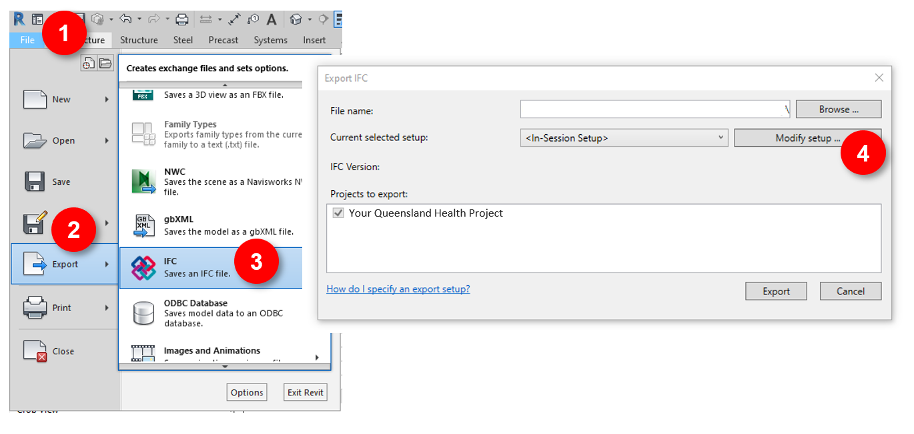
Figure 1: Exporting IFC from Revit (1)
In the relevant 3D export view in Revit (refer to Figure 1: Exporting IFC from Revit (1)Figure 1):
- Select File
- Select Export
- Select IFC
- Select Modify setup

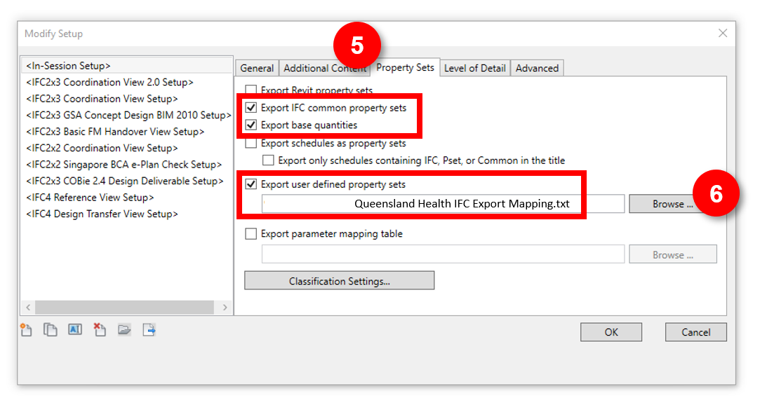
Figure 2: Exporting IFC from Revit (2)
In the Modify Setup dialogue box (refer to Figure 2):
- Select the Property Sets tab, ensure relevant tick boxes are checked
- Browse to and select the Queensland Health IFC Export Mapping file
- Click OK and export as usual
Other settings may be adjusted as required but the result shall be all QH parameters being successfully mapped to the relevant QH custom Property Set tab in IFC (refer to Figure 3)
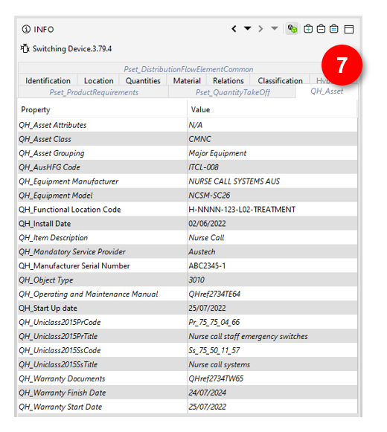
Figure 3: Example IFC showing QH_Asset Property Set tab
  - Data standards
Refer to the DBEP. Also PIR Section 2.4, 3.3, 4.1(c), 4.12 and 4.13. Appointed Parties to document the HHS asset data standards to be used e.g. floor/level naming, building, room name and numbering and asset coding.
The following asset data standards and HHS specific naming /coding requirements shall be used.
    - HHS building, floor/level and zoning naming
Refer to the DBEP. Also PIR Section 4.1(m). Appointed Parties shall use HHS coding. Engage with the relevant QH representative to obtain the necessary details, such as Functional Location Code values, level naming, etc., at the beginning of the project.
[enter here]
    - AusHFG room coding
Along with the nominated room naming and numbering schema, the AusHFG coding of rooms in BIM shall be used. This includes Room Code, Room Name, Room Description, Department, etc. Refer to Section 6.5.4 for required parameters and the Australasian Health Facilities Guidelines for further details.
    - BIM object coding
Refer to the DBEP. Also PIR Section 2.8, 2.9.2.1, 4.1 and 4.10. Appointed Parties to use QS and AusHFG coding.
Each Furniture, Fixture and Equipment (FF&E) model element must contain the AusHFG coding. The AusHFG model resource provides a free library of health facilities components for those organisations that are new to BIM. For more information see the Australasian Health Facilities Guidelines website.
All FF&E shall also contain the Group value (Group 1, 2 or 3) relating to the supplier/installer.
    - Uniclass classification
Queensland Health has recently implemented the Uniclass 2015 classification system. This is part of a phased implementation, with assets appearing on the Queensland Health Asset Equipment Lists initially requiring codes from the Systems (Ss) and Products (Pr) tables.
Where a Uniclass code has been supplied in the Queensland Health Asset Equipment Lists, it may be necessary to add another level of depth depending on the specific product or system being installed.
For example, an Air Handling Unit has a provided product code of Pr_60_65_03, however when specifying an AHU a more specific code may now be relevant, e.g. Pr_60_65_03_XX. This may also impact the provided System code. It is expected that all Uniclass codes are updated as necessary to match the most appropriate level as shown in Table 13.
Table 13: Uniclass 2015 code format
Uniclass 2015 Level | Code Format
Table | Aa
Group | Aa_00
Sub-group | Aa_00_00
Section | Aa_00_00_00
Object | Aa_00_00_00_00

Further information about the implementation of Uniclass is presented in the Queensland Health Uniclass 2015 Guidelines.
  - AIRs
The minimum AIR required by Health Capital Division are documented below in Section 6.5.4, however, various Computerised Maintenance Management Systems (CMMS) may be used by each HHS, and their asset needs may vary.
The AIR is the minimum compulsory asset information deliverable. Consultation with the HHS Facilities Manager following construction award shall agree to the extent of additional AIR. Consideration of how critical information will be transposed between the PIM and the AIM shall be sought early in construction.
Collaboration with the HHS Facilities Manager will provide much of the needed Queensland Health defined project specifics, such as level naming, approved manufacturers, mandatory service providers, etc.
    - Functional Location Codes
The spatial location of all assets is important for Queensland Health to be able to successfully manage them. Functional Location Codes (FLC) are unique identifiers used for this purpose across all of Queensland Health. Refer to the Queensland Health Functional Location Standard or consult the Queensland Health PM for instruction on how to generate FLCs. See Figure 4 below for an extract showing a breakdown of the FLCs.
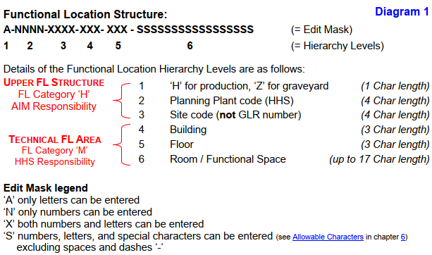
Figure 4: Functional Location Naming
    - Asset grouping
Queensland Health categorises assets into one of six asset groups. If any BIM object falls into one of these groups, it shall be treated as an asset and the relevant data shall be captured. For the relationships of these groups and their descriptions, refer to Figure 5 and the summaries below. This should be read in conjunction with the Queensland Health Asset Equipment Lists.
- Building – asset data captured for the whole building/model (not against individual objects). Refer to Table 14: Parameters for Assets (Buildings and Spaces). All Building parameters should be mapped to the QH_Building user defined IFC PropertySet - applies to IfcBuilding elements.
- Spaces – asset data captured for each room/space. Refer to Table 14: Parameters for Assets (Buildings and Spaces). All Spaces (room) parameters should be mapped to the QH_Space user defined IFC PropertySet - applies to IfcSpace elements.
- Systems – asset data captured once for each system (not sub-components) on the provided Systems sheet of the Queensland Health Asset Equipment Lists only. Refer to Table 15: Parameters for Assets (System, Equipment, Miscellaneous). All System parameters should be mapped to the QH_System user defined IFC PropertySet - applies to IfcSystem.
- Major Equipment – asset data captured for each piece of equipment/plant on the provided Major Equipment sheet of the Queensland Health Asset Equipment Lists only. Refer to Table 15: Parameters for Assets (System, Equipment, Miscellaneous). All equipment asset parameters should be mapped to the QH_Asset user defined IFC PropertySet - applies to IfcElement.
- Minor Equipment – asset data captured for each piece of equipment on the provided Minor Equipment sheet of the Queensland Health Asset Equipment Lists only. Refer to Table 15: Parameters for Assets (System, Equipment, Miscellaneous). All equipment asset parameters should be mapped to the QH_Asset user defined IFC PropertySet - applies to IfcElement.
- Miscellaneous – asset data captured for each item on the provided Miscellaneous sheet of the Queensland Health Asset Equipment Lists only. Refer to Table 15: Parameters for Assets (System, Equipment, Miscellaneous). All equipment asset parameters should be mapped to the QH_Asset user defined IFC PropertySet - applies to IfcElement.

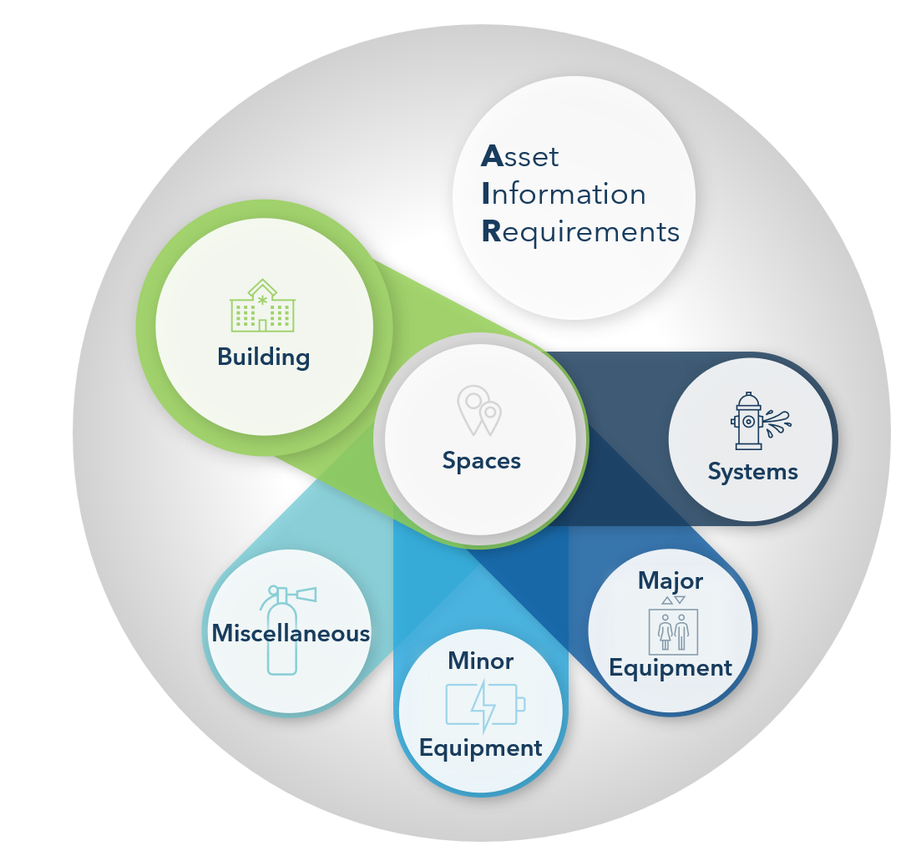
Figure 5: Queensland Health Asset Grouping
    - Queensland health equipment lists
Systems, Major Equipment, Minor Equipment and Miscellaneous assets are itemised in the Queensland Health Asset Equipment Lists, with assets listed under the relevant sheet for each group, as seen in Figure 6.
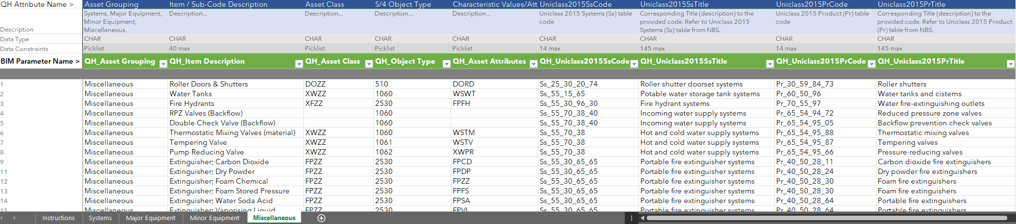
Figure 6: Example of the Equipment List
This Equipment List defines whether an item is treated as an asset - any item on these lists shall be considered an asset and the data relevant to the grouping shall be captured against the asset in BIM.
Asset data should only be entered once against each asset.
System data should only be entered once at the system level – not at the component level. Any item not on these lists does not require asset data.
However, this doesn’t mean other BIM requirements do not apply. For example, all model elements appearing in the AusHFG shall be populated with the relevant AusHFG code, Group number and FLC, etc, as specified elsewhere in this PIR.
Refer to the tables in the following sections for the specific asset parameters required for each asset group.
    - Asset attributes (BIM parameters)
The list of parameters used in BIM is detailed in this section. Queensland Health has prefixed all parameter names with QH_ as they relate directly to Queensland Health's needs. These parameters are available preconfigured for the project environment in Autodesk Revit 2021. It is understood that not all designers use this BIM authoring tool and it is hoped that future versions may provide preconfigured parameters for other applications if requested.
Schedules for each asset group have been provided in the Queensland Health Project Schedules (Revit)_2021 file and should be copied into each model using the instructions contained in the file (refer to Figure 7).
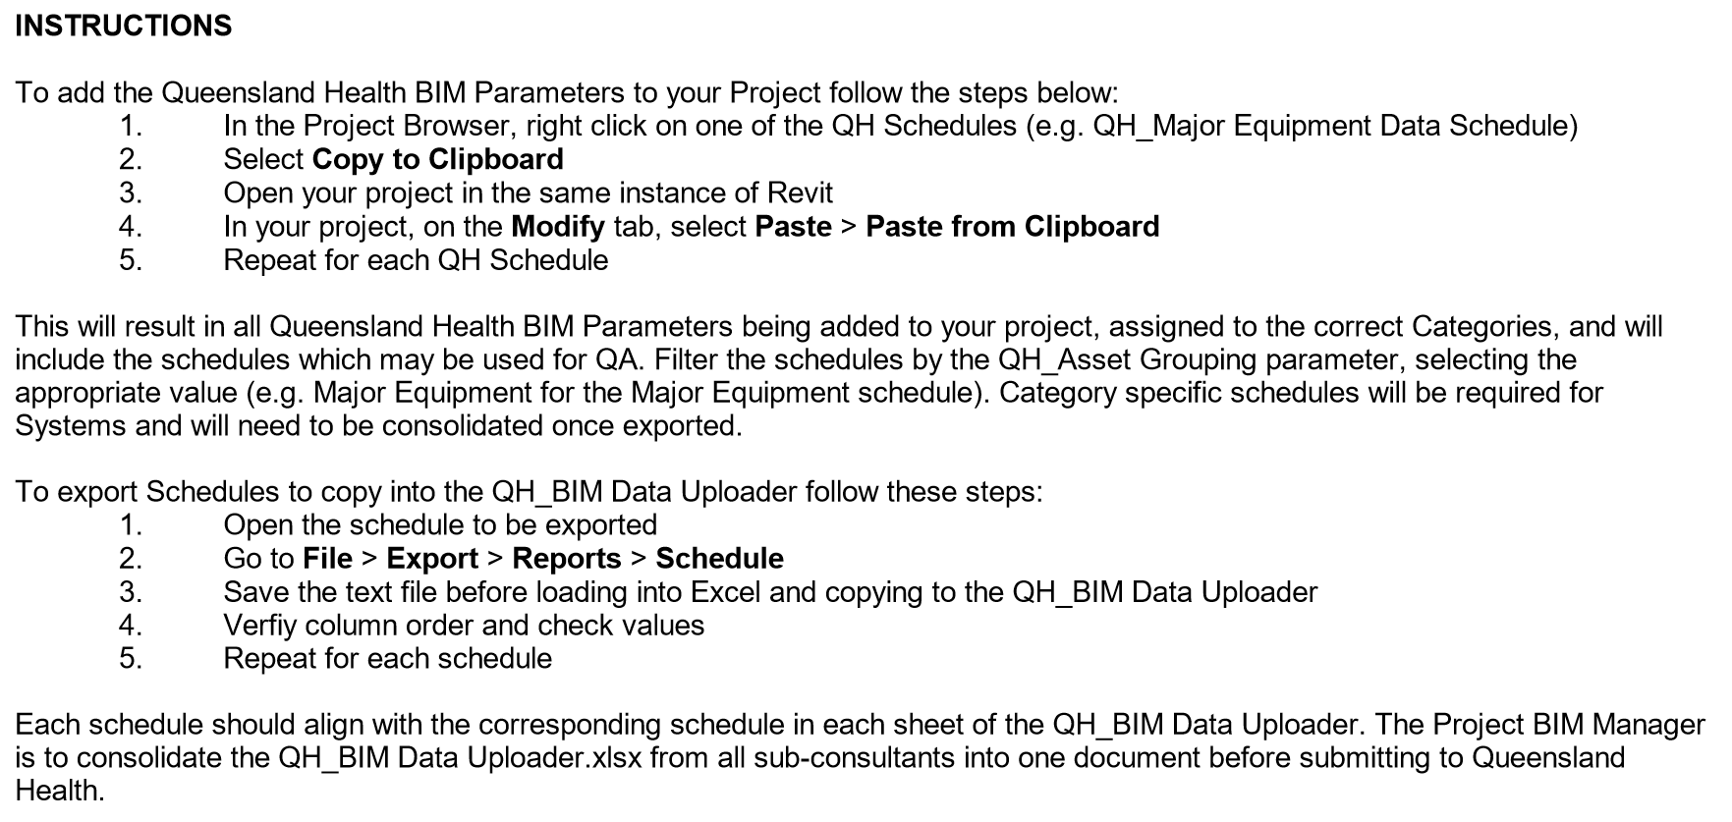
Figure 7: Adding parameters and exporting asset schedules
Refer Queensland Health BIM Shared Parameters.txt available from September 2022
Refer Queensland Health Project Schedules (Revit).rvt available from September 2022

If these documents aren’t compatible with selected BIM authoring tools, use the lists provided below to configure the parameters.
How to read the tables
The arrows under the abbreviated project stages columns indicate the direction of information flow at each project stage.
◄ Indicates information required from Queensland Health to enable the population of this field
► Indicates information being exchanged by the Delivery Team to Queensland Health
Where the Required? field is Mandatory, a value must be provided
Where the Required? field is Conditional, a value must be provided if one exists. (E.g. if a room has an AusHFG code it must be populated. If no AusHFG code exists for that room type then no value is required.)
Refer to the Queensland Health BIM Data Uploader Template.xlsx for data types and field constraints.
Refer to the PIR for additional information.

      - Building and space (room) parameters
Table 14: Parameters for Assets (Buildings and Spaces)
Asset Attribute Details |  | Asset Group |  | Project Stages |  |  |  |  |  | Required? | Reference
Parameter Name | Description | BLD | SPC | SD | DD | TN | CD | CON | AB
QH_Facility Name | Name of site |  |  | ◄► | ► | ► | ► | ► | ► | Mandatory | Project design brief
QH_Building Name | Name of building |  |  | ◄► | ► | ► | ► | ► | ► | Mandatory | Project design brief
QH_Building FLC | Building Functional Location Code |  |  | ◄► | ► | ► | ► | ► | ► | Mandatory | FLC standard or PM
QH_Discipline | BIM authoring design or trade discipline, as per Uniclass Ro_50_XX_XX Design roles |  |  | ► | ► | ► | ► | ► | ► | Mandatory | -
QH_No. of Levels | Number of building floor levels |  |  | ► | ► | ► | ► | ► | ► | Mandatory (Arch only) | -
QH_Floor Area | Total floor area (rounded to whole metres) in m2 |  |  | ► | ► | ► | ► | ► | ► | Mandatory (Arch only) | -
QH_Facade Type | External building materials used. Select all applicable from provided QH list |  |  | ◄► | ► | ► | ► | ► | ► | Mandatory (Arch only) | Queensland Health BIM Data Uploader Template.xlsx
QH_Building Expected Useful Life | In years |  |  | ► | ► | ► | ► | ► | ► | Mandatory (Arch only) | -
QH_AusHFG Room Code | AusHFG Room Number |  |  | ◄► | ► | ► | ► | ► | ► | Mandatory (Arch only) | Design brief /AusHFG
QH_Room Name | Name of room aligned to AusHFG where applicable |  |  | ◄► | ► | ► | ► | ► | ► | Mandatory (Arch only) | Design brief /AusHFG
QH_Room FLC | Room Functional Location Code |  |  | ◄► | ► | ► | ► | ► | ► | Mandatory (Arch only) | FLC standard or PM
QH_Level Name | Name of building floor level |  |  | ◄► | ► | ► | ► | ► | ► | Mandatory (Arch only) | HHS level naming requirements
QH_Room Description | Description of service / use of room |  |  | ◄ | ► | ► | ► | ► | ► | Mandatory (Arch only) | Design brief /AusHFG
QH_Plant Section | Select from provided Plant Section values (description with hierarchy) |  |  | ◄ | ► | ► | ► | ► | ► | Mandatory (Arch only) | Queensland Health BIM Data Uploader Template.xlsx
QH_Room Department | Department room belongs to |  |  | ◄► | ► | ► | ► | ► | ► | Mandatory (Arch only) | Design brief /AusHFG
QH_Room floor area | Room floor area - enter whole number (no decimals) in m2 |  |  | ◄► | ► | ► | ► | ► | ► | Mandatory (Arch only) | Design brief /AusHFG
QH_Ceiling Height | Minimum ceiling height in mm |  |  | ◄ | ► | ► | ► | ► | ► | Mandatory (Arch only) | Design brief /AusHFG
QH_Floor Material | Floor material finish. Use Uniclass description e.g. Resilient sheet floor covering systems |  |  | ◄ | ► | ► | ► | ► | ► | Mandatory (Arch only) | Section or Object level of Uniclass Ss_30_42.
      - System and equipment parameters
Table 15: Parameters for Assets (System, Equipment, Miscellaneous)
Asset Attribute Details |  | Asset Group |  |  |  | Project Stage |  |  |  |  |  | - Required? | Reference
Parameter Name | Description | SYS | MJR | MIN | MSC | SD | DD | TN | CD | CON | AB
QH_Asset Grouping | Either: Systems, Major Equipment, Minor Equipment, Miscellaneous |  |  |  |  | ◄ | ► | ► | ► | ► | ► | Mandatory | Queensland Health Asset Equipment Lists
QH_Item Description | Item / Sub-Code Description from provided Equipment lists |  |  |  |  | ◄ | ► | ► | ► | ► | ► | Mandatory | Queensland Health Asset Equipment Lists
QH_Functional Location Code | Asset Functional Location Code |  |  |  |  | ◄ | ► | ► | ► | ► | ► | Mandatory | FLC standard or PM
QH_Equipment SAID Number | Single Asset Identifier (SAID) |  |  |  |  |  |  |  |  | ◄ | ► | Mandatory | QH PM or SAID QH-GDL-354-1-1:2017
QH_Asset Class | Asset Class from provided Equipment lists |  |  |  |  |  |  | ◄ |  | ► | ► | Mandatory | Queensland Health Asset Equipment Lists
QH_Object Type | S/4 Object Type from provided Equipment lists |  |  |  |  |  |  | ◄ |  | ► | ► | Mandatory | Queensland Health Asset Equipment Lists
QH_Asset Attributes | Characteristic Values/Attributes (if available) from provided Equipment lists |  |  |  |  |  |  | ◄ |  | ► | ► | Conditional | Queensland Health Asset Equipment Lists
QH_AusHFG Code | Applies to all AusHFG standard components |  |  |  |  | ◄ | ► | ► | ► | ► | ► | Conditional | AusHFG
QH_Uniclass2015SsCode | Uniclass 2015 Systems (Ss) table code from QH equipment lists |  |  |  |  |  |  | ◄ |  | ► | ► | Mandatory | Queensland Health Asset Equipment Lists
QH_Uniclass2015SsTitle | Uniclass 2015 Systems (Ss) table title from QH equipment lists |  |  |  |  |  |  | ◄ |  | ► | ► | Mandatory | Queensland Health Asset Equipment Lists
QH_Uniclass2015PrCode | Uniclass 2015 Products (Pr) table code from QH equipment lists |  |  |  |  |  |  | ◄ |  | ► | ► | Mandatory | Queensland Health Asset Equipment Lists
QH_Uniclass2015PrTitle | Uniclass 2015 Products (Pr) table title from QH equipment lists |  |  |  |  |  |  | ◄ |  | ► | ► | Mandatory | Queensland Health Asset Equipment Lists
QH_Is Medical Equipment | Is this asset considered a medical device or equipment? Y/N |  |  |  |  |  | ► | ► | ► | ► | ► | Conditional (populate with Y only) | -
QH_Equipment Manufacturer | Manufacturer of asset. Refer to approved manufacturer list if relevant |  |  |  |  |  |  | ◄ |  | ► | ► | Mandatory | Check HHS for approved manufacturer list
QH_Equipment Model | Manufacturer model number of asset |  |  |  |  |  |  | ◄ |  | ► | ► | Mandatory | Check HHS for approved equipment list
QH_Manufacturer Serial Number | Serial number of asset |  |  |  |  |  |  |  |  |  | ► | Mandatory | -
QH_Install Date | Date of asset installation |  |  |  |  |  |  |  |  |  | ► | Mandatory | -
QH_Start Up date | Date of commissioning or first start-up |  |  |  |  |  |  |  |  |  | ► | Mandatory | -
QH_Design/Service Life | Expected life in months |  |  |  |  |  |  |  |  |  | ► | Mandatory | -
QH_Mandatory Service Provider | For assets requiring servicing by manufacturer or QH authorised provider |  |  |  |  |  |  | ◄ |  |  | ► | Conditional | QH PM / HHS
QH_Operating and Maintenance Manual | O&M document reference as agreed with QH. Includes spare parts list and OEM drawings |  |  |  |  |  |  |  |  |  | ► | Mandatory | -
QH_Warranty Start Date | Start date of product warranty |  |  |  |  |  |  |  |  |  | ► | Mandatory | -
QH_Warranty Finish Date | End date of product warranty |  |  |  |  |  |  |  |  |  | ► | Mandatory | -
QH_Warranty Documents | Document references as agreed with QH |  |  |  |  |  |  |  |  |  | ► | Mandatory | QH PM / HHS

    - BIM data uploader
All populated asset data is to be exported at each project stage from Detailed Design onwards, as indicated with the arrows in the tables of Section 6.5.4, and provided to Queensland Health in the Queensland Health BIM Data Uploader Template.xlsx.
The data uploader from each discipline is to be consolidated into a single document by the Delivery Team BIM Manager prior to delivery at each project stage. There should only be one row per asset.
This data is used to ensure suitable testing and compliance checks can be undertaken throughout project delivery and that the final handover will be fully compatible with Queensland Health’s SAP and individual HHS needs.
The Queensland Health BIM Data Uploader Template.xlsx is structured to align with the asset grouping (refer to Section 6.5.2), with one sheet for each asset group. Only the relevant parameter columns are present on each sheet, meaning all cells should be populated for each row (except for non-applicable conditional values). This makes it easier for the Delivery Team to export schedules from their BIM authoring tool that are filtered and grouped by asset group type.
  - 2 Documentation
PIR Section 2 (c). Appointed Parties to document any 2D documentation not derived from BIM e.g. typical details.
The following 2D documentation is not derived from BIM.
Table 16: 2D documentation external to BIM
Discipline | Documentation type | Comments
Structure | Typical reo details | Typical reinforcement details are documented in CAD
Architecture | Railing details | 1:5 Railing details
- | Specifications | [enter]
  - Schedules
PIR Section 2 and 2 (c). Appointed Parties are to generate all schedules as extractions from the discipline/trade BIM/s and/or space planning tool. Any schedule not produced by these means must be documented here. The approach for coordinating these detached schedules with other information containers (BIM, space planning database etc) must be documented and approved by the Queensland Health representative prior to undertaking this work.
[list schedules not from BIM and detail the approach to coordinating these schedules with BIM here]
  - Room data sheets
Refer to the DBEP.
  - Operation and maintenance manuals
Document the approach to how operation and maintenance manuals will be delivered to Queensland Health.
[enter here]
  - Federated model and coordination
PIR Section 4.5. Hard clashes; construction tolerances; safe working/maintenance zones; responsibilities and accountabilities; clash detection priorities; tolerance strategy; and outputs (e.g. clash reports, excel, dashboarding etc.)
    - General
The Delivery Team are to use automated conflict checking/clash detection software during the delivery of the project to determine geometric clashes in each discipline/trade BIM and then in the Federated Model. Once issues are identified, each discipline/trade shall resolve the model elements within the BIM/s they are responsible for.
The coordination issue identification and reporting should be held regularly (e.g. weekly or fortnightly) during Construction. Identified issues should be reported, tracked, and closed out. These reports should show any outstanding coordination issues between the Delivery Team members.
Queensland Health expects the coordination to be appropriate to the stage of the project (e.g. reduced coordination issues as the project progresses). Major space planning coordination issues between Architecture, Structure, Mechanical and other relevant services should be resolved during design. Construction coordination issues should be resolved before construction begins on site. As-built models should be well coordinated.
    - Tolerances
The Delivery Team must set minimum tolerances for clash detection for project stage deliverables. These tolerances may vary between stages for example moving from a 100mm tolerance during design to a 25mm tolerance during Construction. Consider the differences between coordination tolerances and as-built tolerances.
[enter tolerances here]
    - Clash tests
[All information required to undertake clash tests must be documented in the CBEP]
Consider which stage of the project various clash tests are most appropriate for, e.g. focussing on Architectural vs Structural earlier, before introducing larger services. Consider the use of tiers or priorities to group and define clash tests.
[enter clash test strategy here]
    - All other clashes
While the above clashes have been assigned priorities, other clashes will exist within the BIM/s. These other clashes are not ignorable, nor should they be discarded. The intention is to have a Federated Model that has minimal coordination issues prior to completion of each project stage. There must be documented proof that the Delivery Team has addressed the coordination issues, where identified.
    - Co-ordination responsibilities
- The Delivery Team BIM Manager facilitates the overall co-ordination and management of clashes during the design phases
- The Services Consultants are responsible for discovering, managing and resolving clashes between services disciplines prior to the issue of models to the BIM Manager for clash detection
    - Clash resolution meetings during design phases
Refer to the DBEP.
    - Clash detection meetings during construction phase
The Contractor is responsible for arranging similar clash detection meetings during the construction stages.
Consider what outcomes are expected from clash meetings – are trade engineers attending to resolve issues or are BIM coordinators attending to prioritise identified issues in the issue tracking software, etc. What is the approach to hosting productive clash meetings?
[enter the approach for clash resolution meetings here]
  - Quality assurance and control
PIR Section 4.7. Quality assurance/control procedures; retaining data integrity/accuracy in BIM; and integration approach with cost planning, construction staging/sequencing, SoA, space planning and resulting 2D drawing and schedule outputs.
The below outlines the model and data quality control approaches, including responsible parties and frequency/timeframes.
[enter response/table here]

- Appendices
  - Appendix A – BIM manager
    - BIM manager experience
The BIM Manager appointed by the Delivery Team and named in Table 7: Key Project team members have the following experience.
      - Experience
PIR Section 4.2. State the experience of the named individual (or individuals) performing BIM management roles including:
number of years
projects delivered
technical competencies
communication abilities
      - Resource allocation
State the estimated time of the named individual (or individuals) performing BIM management roles for the project.

Table 17: BIM Management
Stage | Named Resource | BIM and information management tasks | Time allocation per week

  - Appendix B – QS requirements or model content plan
Refer to AIQS guidance material

https://www.healthfacilityguidelines.com.au/
https://www.healthfacilityguidelines.com.au/content/bim-resources
https://uniclass.thenbs.com/

