Food handler health and hygiene | Food Act 2006

Under the Australia New Zealand Food Standards Code Food Safety Standard 3.2.2 Food Safety Practices and General Requirements, food handlers and food businesses have specific legal responsibilities related to health and hygiene.
A food handler must take all reasonable measures not to handle food or surfaces likely to come into contact with food in a way that is likely to compromise the safety and suitability of food.

What is a food handler?
A food handler is anyone who works for a food business and handles food or surfaces that are likely to come into contact with food, such as cutlery, plates, bowls, or chopping boards.

Food handler responsibilities

Health of food handlers
          - A food handler who has a symptom of a foodborne disease, knows he or she is suffering from a foodborne disease, or is a carrier of a foodborne disease, must, if at work:
            - report that he or she is or may be suffering from the disease, or knows that he or she is carrying the disease, to his or her supervisor, as the case may be;
            - not engage in any handling of food where there is a reasonable likelihood of food contamination as a result of the disease; and
            - if continuing to engage in other work on the food premises - take all practicable measures to prevent food from being contaminated as a result of the disease.
          - A food handler who suffers from a condition (an infected skin lesion or ear, nose or eye discharge) must, if at work:
            - if there is a reasonable likelihood of food contamination as a result of suffering the condition – report that he or she is suffering from the condition to his or her supervisor; and
            - if continuing to engage in the handling of food or other work – take all practicable measures to prevent food being contaminated as a result of the condition.
          - A food handler must notify his or her supervisor if the food handler knows or suspects that they may have contaminated food whilst handling food.

Personal hygiene
A food handler must:
- do whatever is reasonable to avoid unnecessary contact with ready-to-eat foods, such as salads or cooked meat.
- take all practical measures to prevent contamination of food or surfaces that are likely to come into contact with food, by anything:
- from their body e.g. hair, bodily secretions and fingernails; or
- they are wearing e.g. clothes, jewellery, hair accessories, bandages.
- wear clean outer clothing, appropriate for the type of work they do
- make sure bandages or dressings on any exposed parts of the body are covered with a waterproof covering
- not eat over unprotected food or surfaces likely to come in contact with food
- not sneeze, blow or cough over unprotected food or surfaces likely to come into contact with food
- not spit, smoke or use tobacco or similar preparations where food is handled.

Hand washing
Food handlers must wash their hands whenever their hands are reasonably likely to contaminate food. This includes washing their hands:
- immediately before working with ready-to-eat food after handling raw food
- immediately after handling raw meat or processed (or cut) fruit or vegetables
- immediately after using the toilet
- before starting to handle food or returning to handling food after other work
- immediately after smoking, coughing, sneezing, using a handkerchief or disposable tissue, eating, drinking or using tobacco or similar substances
- after touching hair, scalp or a body opening.

How to wash hands effectively
Food handlers must use the hand washing facilities provided by the business. Sinks used to prepare food or wash dishes must not be used to wash hands.
- Thoroughly clean hands using soap and warm running water
- Thoroughly dry hands using a single use towel or another way that is not likely to transfer bacteria onto the hands (e.g. a tea towel used to dry dishes should not be used to dry hands).
Five steps should be followed when washing hands:
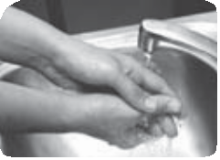
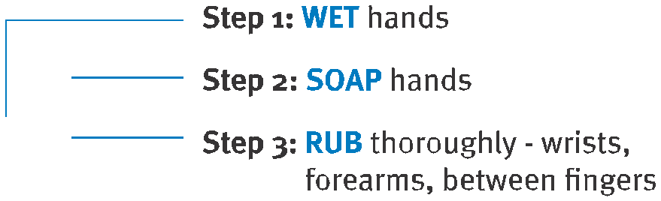
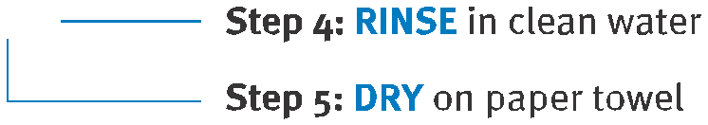

Courtesy of Cormorant Technical Services P/L.

Food business responsibilities
A food business must:
          - inform all food handlers working for the food business of their health and hygiene obligations under as specified above.
          - ensure that any information provided by a food handler in relation to their health, as per the requirements specified above, is not disclosed to any person without the consent of the food handler, except the proprietor or an authorised officer, and that the information is not used for any purpose other than addressing the risk of food contamination.
          - take all practicable measures to ensure all people on the food premises of the food business–
            - do not contaminate food
            - do not have unnecessary contact with ready-to-eat food
            - do not spit, smoke, or use tobacco or similar preparations in areas where there is unprotected food or surfaces likely to come into contact with food.

Health of food handlers
          - A food business must ensure the following persons do not engage in the handling of food for the food business where there is a reasonable likelihood of food contamination–
- a person known to be suffering from a foodborne disease, or who is a carrier of a foodborne disease
- a person known or reasonably suspected to have a symptom that may indicate he or she is suffering from a foodborne disease.
          - A food business must ensure that a person who is known or reasonably suspected to be suffering from a condition (an infected skin lesion or ear, nose or eye discharge) and who continues to engage in the handling of food for the food business, takes all practicable measures to prevent food contamination.
          - A food business may permit a person excluded from handling food in accordance with (1)(a), above, to resume handling food only after receiving advice from a medical practitioner that the person no longer is suffering from, or is a carrier of, a foodborne disease.

Personal hygiene
A food business must:
          - Maintain easily accessible hand washing facilities.
          - Maintain, at or near each hand washing facility, a supply of–
            - warm running water;
            - soap; or
            - other items that may be used to thoroughly clean hands.
          - Ensure hand washing facilities are only used for the washing of hands, arms and face.
          - Provide, at or near each hand washing facility–
            - single-use towels or other means of effectively drying hands that are not likely to transfer pathogenic microorganisms to the hands; and
            - a container for used towels, if needed.
Requirement 3, above, does not apply in relation to hand washing facilities at food premises that are used principally as a private dwelling if the proprietor of the food business has the approval in writing of the relevant local government.
With the approval in writing of the relevant local government, a food business that operates from temporary food premises does not have to comply with any of the requirements of 2(a) or 4, above, that are specified in the written approval.

For further information
Queensland Health have a variety of fact sheets with detailed information on food safety. These fact sheets can be accessed at www.health.qld.gov.au.
If you have any further questions relating to the health and hygiene requirements for food handlers, contact the local government for the area where you are located. Contact details can be found in the White Pages or at www.dilgp.qld.gov.au/local-government-directory.

